Unit 2: Age of Contact

Lesson 6:

The First Contact

Voices of Texas History

Day 1
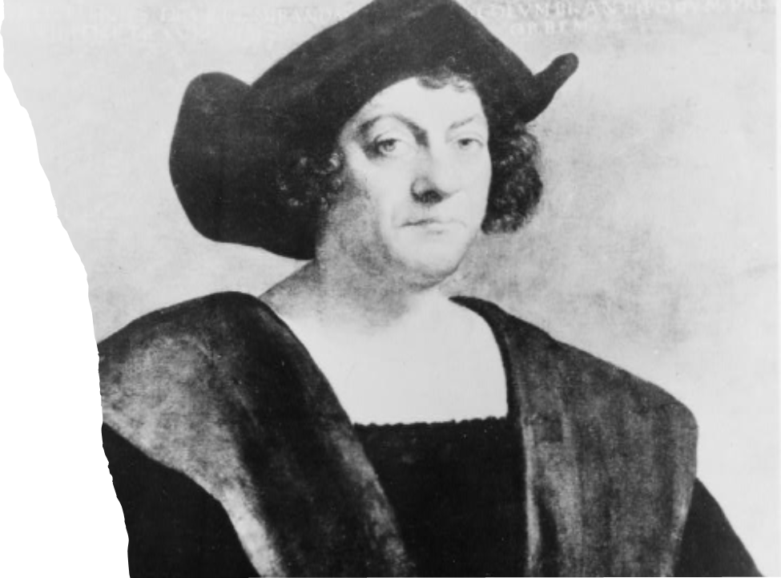

Warm-up
Follow the directions below to complete your warm-up
Today we will read two different excerpts from the Spanish point of view showing interactions between the conquistadors and the American Indians in the Caribbean.
Write your expectations about the primary sources on your warm-up.
Discuss with a partner.

Share with the class:
One thing I expect to see in the excerpts is (blank)
One thing I don’t expect to see in the excerpts is (blank)

Share with the class:
I think these excerpts will show us the whole picture because (blank)
I think these excerpts won’t show us the whole picture because (blank)

Essential Questions
1. How does each author characterize the relationship between the conquistadors and American Indians?
2. How might each author’s bias and point of view affect his story?

In Today’s Lesson
1. We will read primary source excerpts from two different Spanish points of view demonstrating how the conquistadors treated the American Indians.
2. I will read each excerpt for context, main ideas, and assess for bias. I will answer comprehension questions about each excerpt.
What do you notice about this image?
What do you think is happening here?
What are three words that could describe this image?
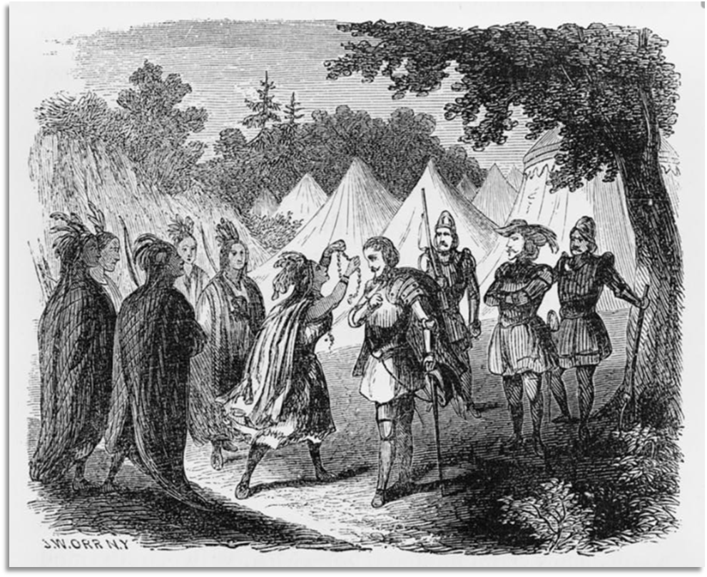
What do you notice about this image?
What do you think is happening here?
What are three words that could describe this image?
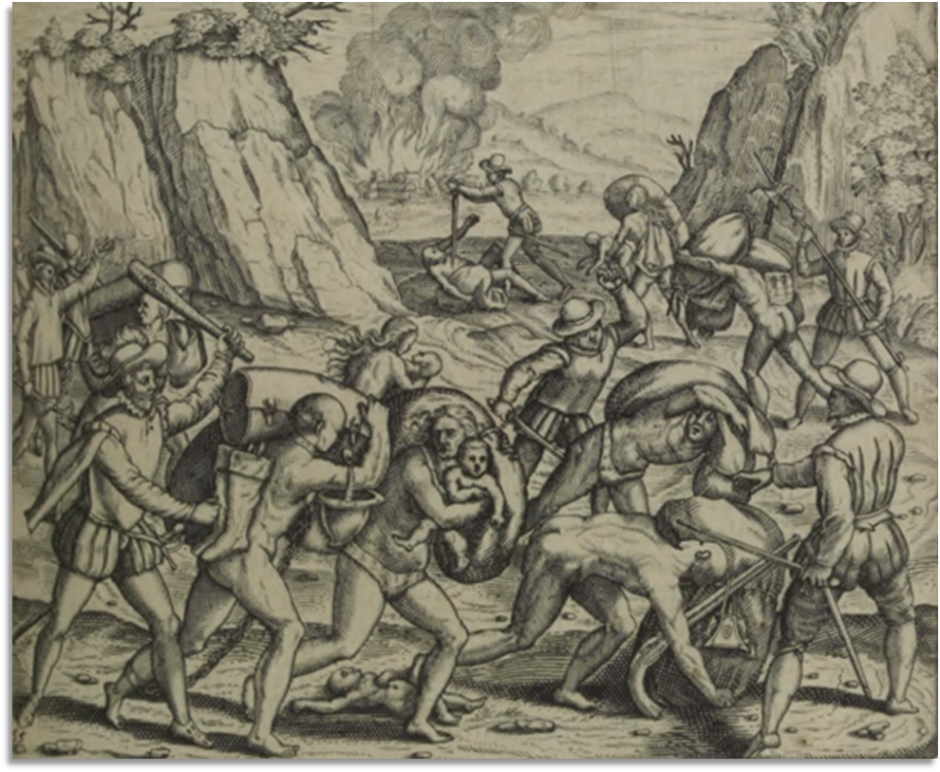

What are the similarities and differences between the two images?
Do you think both representations could be true? Explain.
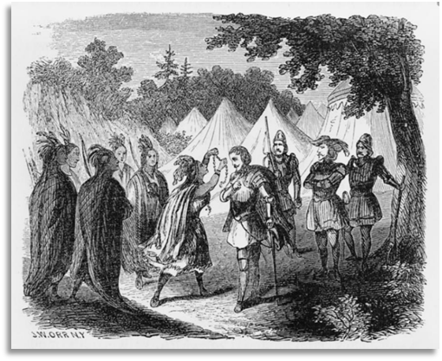
A painting by John William Orr. “An Indian Princess presenting a necklace of pearls to de Soto.” Library of Congress.
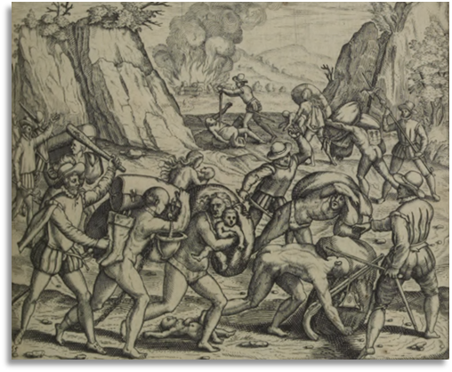
An image from Las Casas book describing the Spanish treatment of American Indians in the Caribbean. Library of Congress.

Excerpt 1
The Context – Christopher Columbus wrote in his journal about how his men would trade items they considered useless with the American Indians in order to get more valuable resources like gold. Read the excerpt below to see how Columbus states he felt about this trade and how he says he handled this issue.

In the Words of Christopher Columbus
“No request of anything from [the American Indians] is ever refused, but they rather invite acceptance of what they possess, and manifest such a generosity that they would give away their own hearts… I forbade my men to purchase their goods with such worthless things as bits of platters and broken glass, or thongs of leather, although when they got possession of one of these, they estimated it as highly as the greatest jewel in the world… The whole of an Indian's property might be purchased of him for a few [coins.] … I thought such traffic unjust, and therefore forbade it… I presented them with a variety of things, in order to secure their affection, and that they may become Christians, and enter into the service of their Highnesses and the Castilian nation, and also aid us in procuring such things as they possess, and we stand in need of.”
Excerpt of a letter from Columbus to Luis de Santangel, the treasurer for the king and queen of Spain. Personal narrative of the first voyage of Columbus to America. Library of Congress.

Excerpt 2
The Context – The following excerpt was written by a Catholic religious leader named Bartolomé de las Casas. Las Casas accompanied Columbus and his men on their third voyage to the Caribbean in 1498. He lived there for a number of years. He wrote about the treatment that he witnessed of American Indians by Spanish explorers.

In the Words of Bartolomé de las Casas
“Over the twelve years of which we are speaking, and during the course of what they term ‘conquest’ (which is really nothing other than a series of violent incursions into the territory by these cruel tyrants: incursions condemned not only in the eyes of God but also by law…), the Europeans have, throughout these four hundred and fifty leagues, butchered, burned alive or otherwise done to death four million souls, young and old alike, men, women and children. . . Indeed, they invented so many new methods of murder that it would be quite impossible to set them all down on paper and, however hard one tried to chronicle them, one could probably never list a thousandth part of what actually took place.”
Excerpt of Las Casas’ book, “A Short Account of the Destruction of the Indies” translated into English. From the Library of Congress.

Exit Ticket
Follow the directions below to complete your warm-up
Look back at your expectations you wrote in your warm-up.
Finish the sentence stem explaining whether your expectations were right or wrong.
Share with a partner.

Share with the class:
My expectations were correct because (blank)
My expectations were incorrect because (blank)

