God, Gold, and Glory Advanced
Unit 2: Age of Contact

Name: |  | Date: |  | Period:

The Reconquista

Key Information: | Significance:
Essential Question – Your Response: | Color the Location of the Moors and the land they conquered.  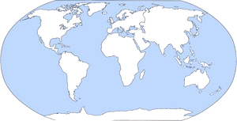

Christopher Columbus

Key Information: | Significance:
Essential Question – Your Response: | Trace Columbus’ Route on your map

The Columbian Exchange

Key Information: | Significance:
Essential Question – Your Response: | Natural Resources Being Traded  The Americas Europe / Africa

Reasons for Exploration

Key Information: | Significance:
Essential Question – Your Response: | Where did Spain find the most gold?  Circle, highlight, or color in the areas

