God, Gold, and Glory: Advanced

Unit 2: Age of Contact
The Reconquista
Key Information: (blank)
Significance: (blank)
Essential Question – Your Response: (blank)
Color the location of the Moors and the land they conquered.
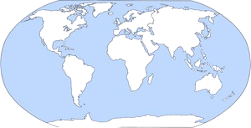
Christopher Columbus
Key Information: (blank)
Significance: (blank)
Essential Question – Your Response: (blank)
Trace Columbus’ Route on your map
The Columbian Exchange
Key Information: (blank)
Significance: (blank)
Essential Question – Your Response: (blank)
Natural Resources Being Traded Between
The Americas and Europe / Africa
(blank)
Reasons for Exploration
Key Information: (blank)
Significance: (blank)
Essential Question – Your Response: (blank)
Where did Spain find the most gold?
Circle, highlight, or color in the areas

