Unit 2: Age of Contact

Lesson 5:

God, Gold, and Glory!

Guided Notes

Day 1
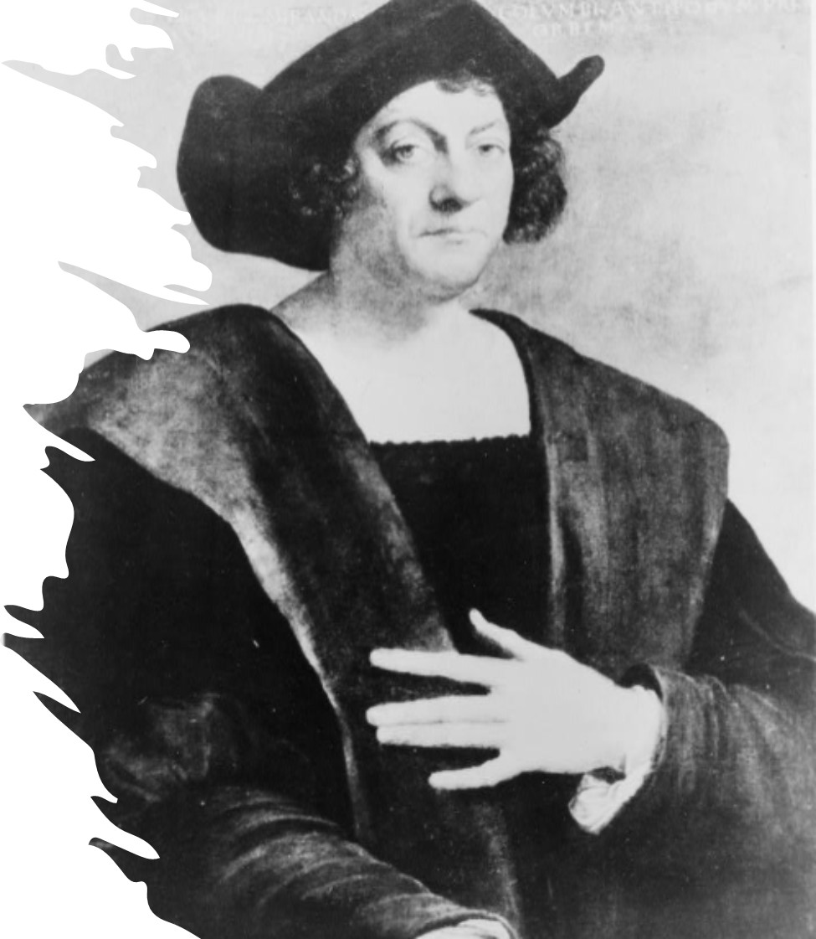

Warm-up
Follow the directions below to complete your warm-up
Would you take the job advertised on your warm-up?
Why or why not?
Share with a partner.

Share with the class:
I would / wouldn’t take the job because (blank)

Essential Questions
1. What motivated Spanish conquistadors to explore the new world?
2. What were the positive and negative results of their exploration?

In Today’s Lesson
1. We will examine the goals, causes, and effects of Spanish exploration. We will also identify the key events that began the Age of Contact.
2. I will complete my guided notes by summarizing the key points and significance of each topic. I will answer a comprehension question on each topic and, when applicable, label my maps.

The Reconquista
In the 8th Century, or the 700s, a group from Africa called the Moors invaded what is now Spain. The Moors took control of the land and its people, ruling over Spain for nearly 800 years.
The Spanish defeated the Moors in 1492 and united their lands under two monarchs: King Ferdinand and Queen Isabella. The king and queen took immediate steps to strengthen their new country and gain wealth by getting involved in global exploration.
Key Information:
Spain’s 800-year power struggle with the African Moors.
Significance:
Spain’s victory against the Moors allowed Spain to take part in the Era of Exploration.
Essential Question:
Why does Spain want to be involved in global exploration?
How does this image relate to the Reconquista?
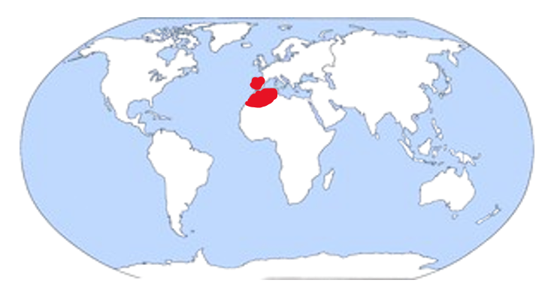

Christopher Columbus
King Ferdinand and Queen Isabella hired an Italian explorer named Christopher Columbus to attempt to find a water route to the profitable markets in Asia in 1492.
Though Columbus didn’t make it to Asia, he did unintentionally find different profitable lands: the Americas. Columbus made several voyages to what is now the Caribbean. He and his men became wealthy by seizing resources like gold. His success drove other Spanish explorers to make expeditions to the new world to seek their fortunes.
Key Information:
An Italian explorer who sailed for Spain.
Arrived in the Americas, 1492.
Significance:
His journeys inspired other explorers to travel to America for wealth.
Essential Question:
What was Columbus’ original goal on his voyage?
What route did Christopher Columbus take?
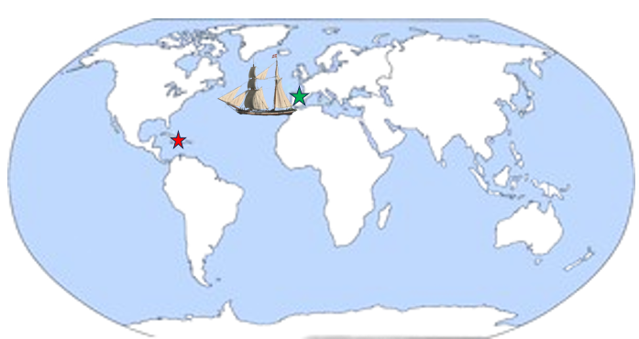

The Columbian Exchange
Columbus’ journeys across the Atlantic to the Americas began a system of trade known as the Columbian Exchange. This trade transported new fruits, vegetables, grains, animals, and diseases between Europe and the Americas.
Through this system of trade, Europeans and American Indians gained access to a wider variety of food sources. The arrival of horses changed life for many American Indian tribes who could now hunt and travel more easily. The introduction of Spanish diseases like smallpox tragically caused the death of millions of American Indians who had no immunity to the foreign illnesses.
Key Information:
A system of trade across the Atlantic Ocean that began with Columbus’ voyages.
Significance:
New items were introduced into Europe and America.
Essential Question:
What was one positive and one negative outcome of the Columbian Exchange?
What items were traded in the Columbian Exchange?
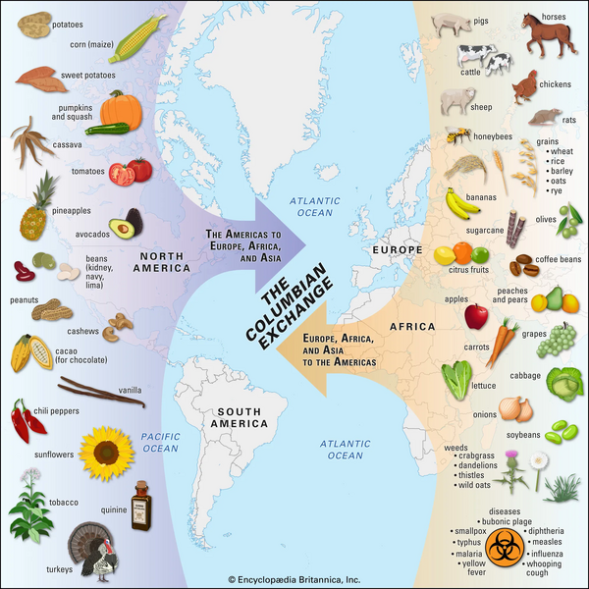

Reasons for Exploration
The journey from Spain to the Americas, and the expeditions in the new lands were often dangerous. People got lost, ran out of supplies, and even died during expeditions. Why would anyone take such a risk?
There were three reasons for Spanish exploration; we call them “The 3 Gs: God, Gold, and Glory.” They claimed to want to spread their religion. They wanted fame and power. But, more than anything, they wanted to become incredibly, wildly, unbelievably wealthy. Spanish conquistadors often seized gold and resources from American Indians. Spanish exploration and conquest of the Americas made Spain very wealthy.
Key Information:
Spanish explorers had three goals: God, Gold, and Glory.
Gold was most important!
Significance:
Spain became incredibly wealthy exploring and claiming land and resources in the Americas.
Essential Question:
How do you think Spain’s quest gold affected relationships between the Spanish and American Indians?
Where does Spain find the most gold in the Americas?
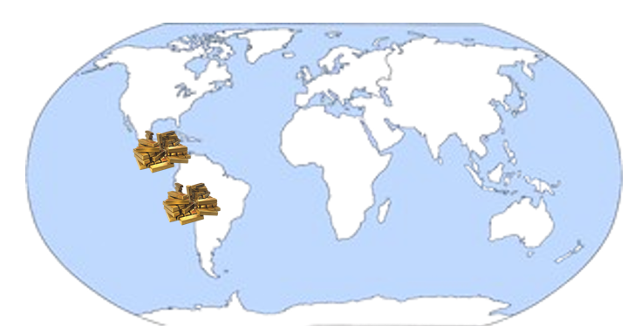

Exit Ticket
Follow the directions below to complete your warm-up
“This day I launched the ship and made ready to depart in the name of God, next Thursday, for the southeast in quest of gold and spices, as well as to discover the country.”
-Personal narrative from the first voyage of Columbus to America: from a manuscript recently discovered in Spain. Library of Congress
Read the quote by Christopher Columbus and answer the question that follows.
Discuss with a partner.

