Unit 2:
Age of Contact

Lesson 2:

How do we know what we know?
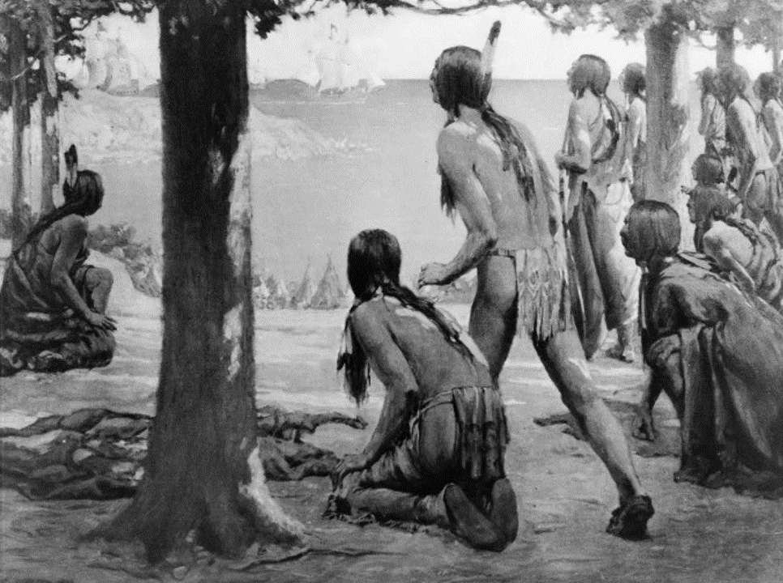

How do we know what we know?
Warm-up

Warm-up
Read the scenario on your warm-up.
Give your response to the scenario in the space provided.
Share your response with a shoulder partner.

Share your response
I believe everything my classmates say about the new student because (blank)
I don’t believe everything my classmates say about the new student because (blank)

Essential Question
How do we know what we know about the encounters between the Spanish and the American Indians during the Age of Contact?

In today’s lesson…
1. We will examine primary source documents from the Age of Contact that present information about several American Indians tribes in Texas from a Spanish point of view.
2. I will match primary source excerpt cards with cards that offer modern translations. I will summarize each excerpt and answer comprehension questions about them.

How do we know what we know? Lesson
“Think Back”- consider question.
Write your response in the box.

Think back…
We learn a lot about the people of the past by studying the artifacts and records they left behind. Think back to Unit 1: Natural Texas and its People. What do you remember about why it is often difficult for people today to study the lives and stories of the early American Indians of Texas?
Much of what we believe to be true about early American Indians in Texas, we have learned from the European explorers who encountered them. These accounts have been useful at providing information we would not have otherwise. It is important to recognize, however, that they provide only one side of the story.
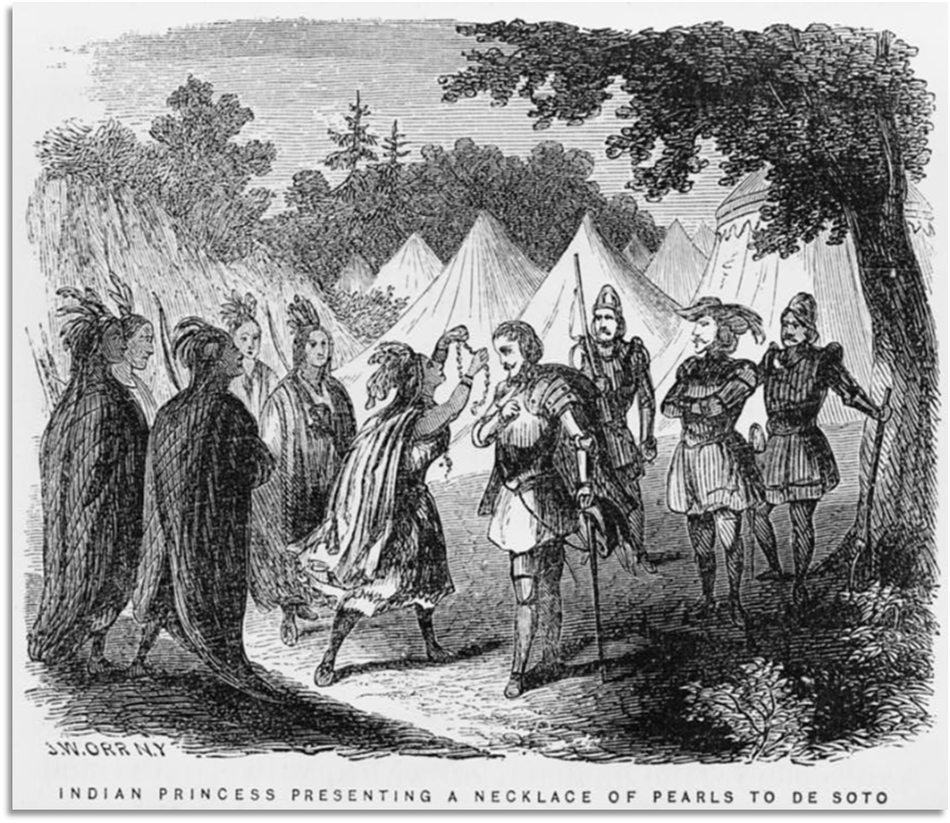
A painting by John Orr of an Indian Princess presenting a necklace to a Spanish explorer. Library of Congress.

First Contact in Texas
Let’s take a look at one account written by the first known explorer to encounter American Indians in Texas – a Spanish man named Álvar Núñez Cabeza de Vaca.
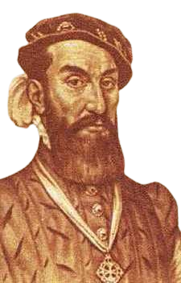
A portrait of Cabeza de Vaca

A little background information:
Cabeza de Vaca was a Spanish explorer who traveled with several hundred others to the Americas in the early 1500s. Like many Spanish explorers, their primary goal was to search for gold and riches.
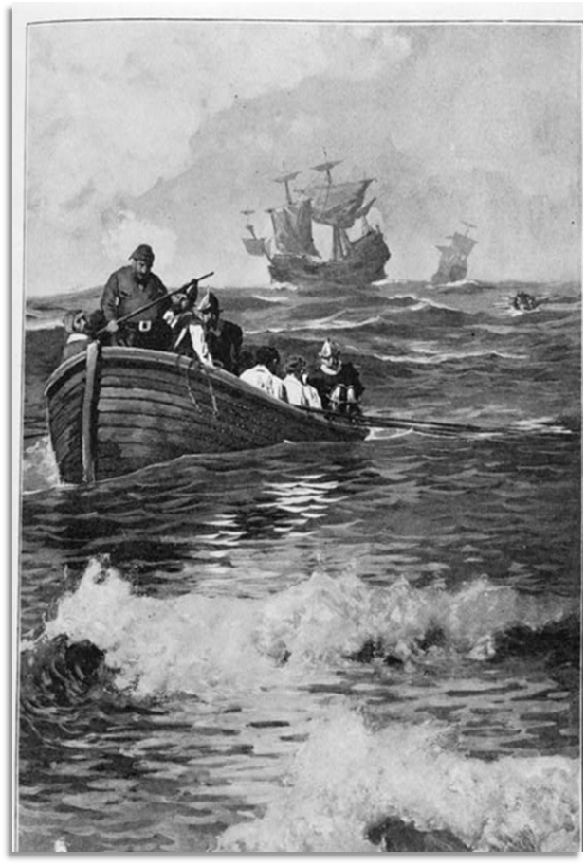
Spanish caravels (small, fast ships) arriving in the Americas

Cabeza de Vaca: Where did they go?
They started out in the Caribbean on their way to Mexico but got so lost they ended up in Florida and eventually even Texas! Can you imagine being that lost? They experienced disease, starvation, capture by various American Indian tribes, and even hurricanes. They lived among several American Indian tribes in Texas for years.
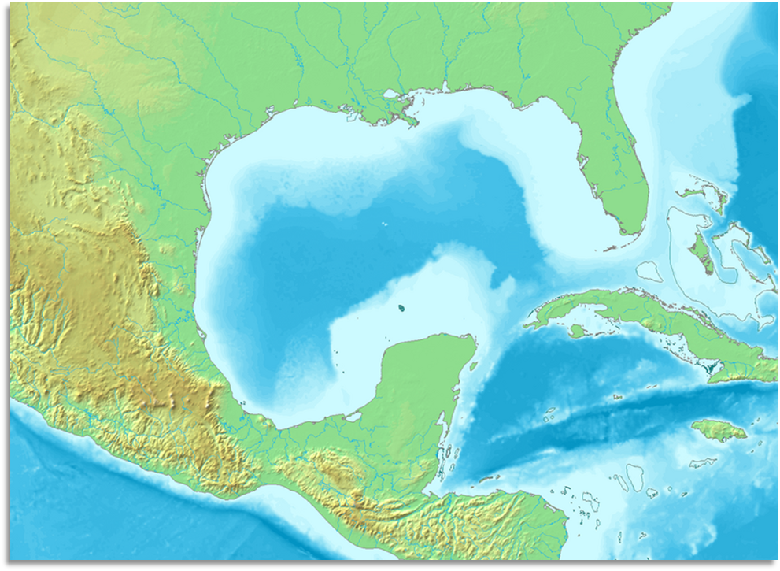
Gulf of Mexico
Mexico
Florida
Texas
Mexico City
Cuba

The route of Cabeza de Vaca and his men, from modern-day Cuba to Mexico City.

Cabeza de Vaca’s story
Finally, eight years after they had set out, the few who survived made it to their destination of present-day Mexico City, where they knew they would find many other Spaniards. Cabeza de Vaca wrote a book about his experiences. In English, it is called “The Narrative of Cabeza de Vaca.” The excerpts in your activity are from his book.
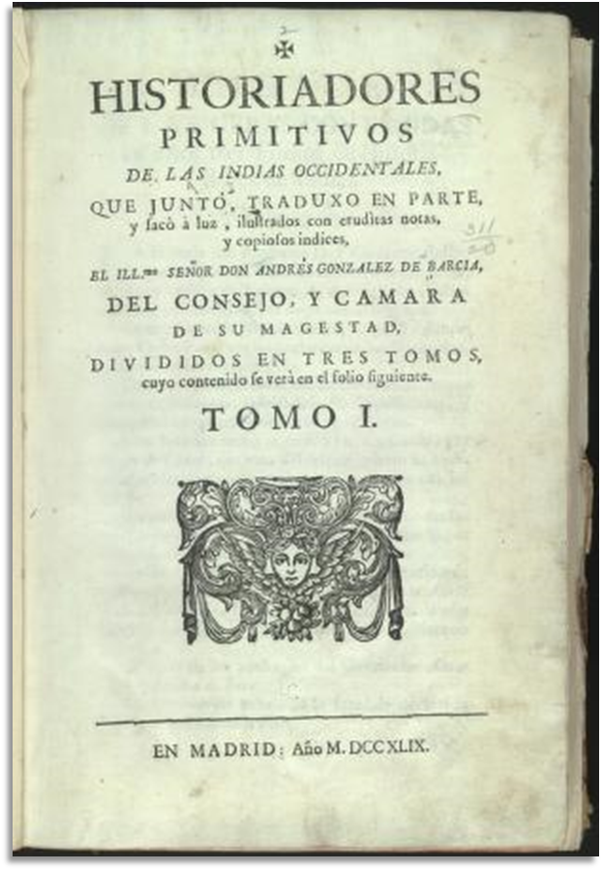
A printing of Cabeza de Vaca’s book in the original Spanish.

Primary Source Activity

Directions: Part I
Match each Excerpt Card with the Translation card that best restates the excerpt in modern language.

Directions: Part II
Complete the chart that follows using your excerpt and translation cards.

Directions: Part III
Using the excerpt and translation cards, and the information on your chart, answer the comprehension questions that follow.

How do we know what we know?
Exit Ticket

Follow the directions to complete your Exit Ticket
Think back to the new “strange” student from your warm-up. Consider that scenario and what we have talked about today to complete your exit ticket.
How could you get the most accurate information about this new student? (blank)
What might be the result if you continue to base your opinion only on what these 2 classmates have said? (blank)

Share your response 2
I could get the most accurate information about the new student by (blank)
If I base my opinion only what others have said, the result might be that (blank)

