Unit 2:
Age of Contact

Lesson 10:

Extension:

Spanish Exploration

The Arrival of the French!
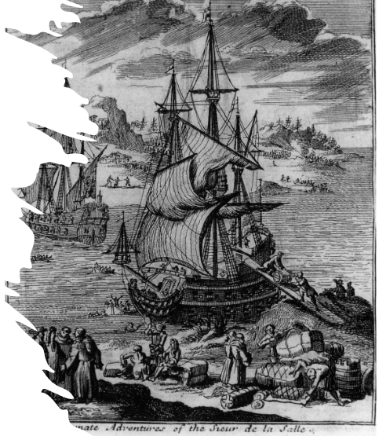

Extension: Spanish Exploration

The Arrival of the French!

Warm-up

Warm-up:
Follow the directions to complete your warm-up
Read the question prompts on your warm-up.
Write your response on your warm-up.
Discuss with a partner

Share with the class
In general, the relationship between the Spanish and the American Indians was (blank)
An example to support this is (blank)

Share with the class 1
I think the relationship between the French and the American Indians might be (blank)

Essential Question
What are the similarities and differences between how Spain and France interact with American Indian people, based on the primary source excerpts in class today?

In today’s lesson…
1. We will read primary source excerpts from the expeditions of Hernando de Soto, Luis de Moscoso Alvarado, and La Salle to compare their experiences with American Indians.
2. I will read each excerpt, using my prior knowledge and context clues to answer comprehension questions.

Observe the Image
What do you notice about this image?
What do you think is happening here?
What are three words that could describe this image?
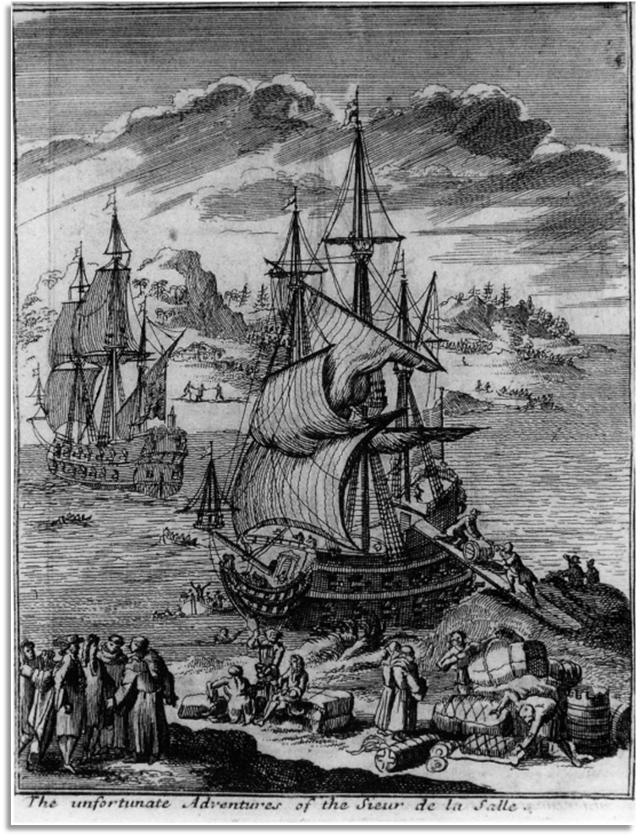
The primary source excerpts related to Hernando de Soto’s expedition were taken from “Spanish Explorers in the Southern United States, 1528 – 1543.”
Excerpts related to the expedition of La Salle were taken from “The Journeys of Rene Robert Cavelier Sieur de la Salle.”
These works are accessible online at the Portal to Texas History with the University of North Texas

Primary Source Set I:

De Soto’s and Moscoso’s Expedition

Primary Source Set 1:

De Soto’s & Moscoso’s Expedition 2
Hernando de Soto’s expedition was documented by “the Gentleman of Elvas,” who was most likely a Spaniard named Alvaro Fernandez. Fernandez wrote about the journey, the land they explored, and the American Indians they encountered from Florida to Texas and back.
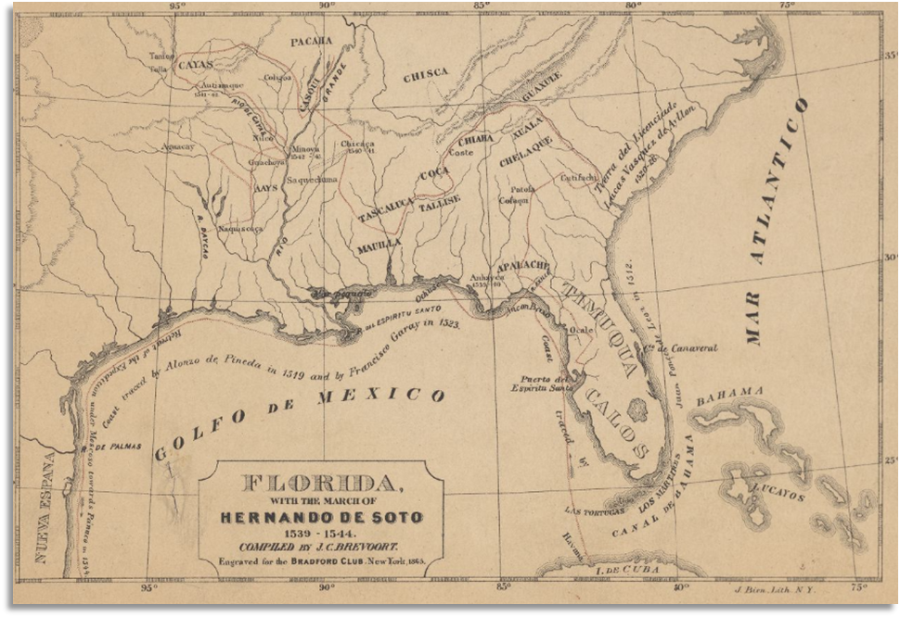
Florida, with the march of Hernando de Soto 1539-1544
The New York Public Library Digital Collections

De Soto:

Excerpt 1 Context
De Soto, and other conquistadors, often took American Indians captive along their expeditions as guides through the land. The first two excerpts are about one of the guides, who was often simply called “the youth.” He guided them through the Carolinas.
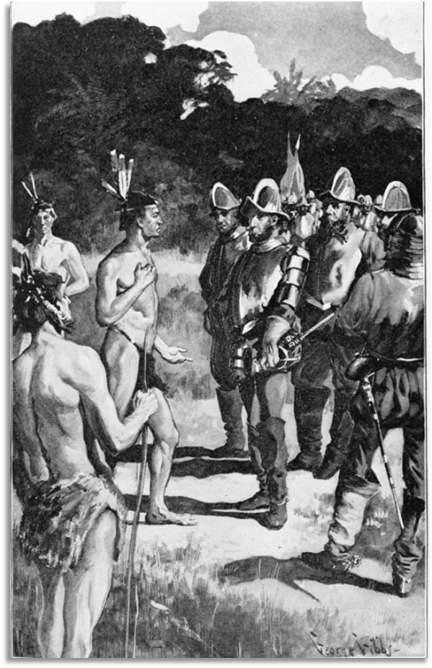
“De Soto and Vitachuco.”
Library of Congress

De Soto: Excerpt 1
“[De Soto] menaced the youth, motioning that he would throw him to the dogs for having lied to him in saying that it was four days’ journey, whereas they had travelled nine…The youth declared that he knew not where he was. Fortunately for him, at the time, there was not another whom Juan Ortiz understood, or he would have been cast to the dogs.”

De Soto: Excerpt 1 part 2
“[The youth] wished to become a Christian, and asked to be baptized, which was done, he receiving the name Pedro; and [De Soto] commanded the chain to be struck off that he had carried until then.”

Moscoso:

Excerpt 2 Context
After Moscoso took over the expedition, he and his men entered Texas in a region inhabited by the Caddo. A violent conflict broke out between some Naguatex Caddo and the Spaniards.
The Spaniards outnumbered the Caddo, defeated the small group, and even took one man captive, cutting off his nose and arm to send to the Caddo leader. The following day, the leader of the Naguatex arrived with a message as recorded by Alvaro Fernandez. An excerpt of the message is on the following page.
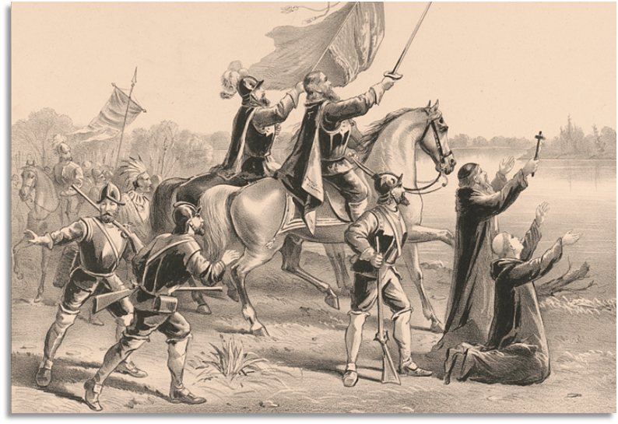
De Soto and Moscoso crossing the Mississippi River.
Library of Congress.

Moscoso: Excerpt 2
“I believe that you and yours must be immortal; that you are the master of the things of nature; since you subject them all, and they obey you, even the very hearts of men. Witnessing the slaughter and destruction of my men in battle, which came of my ignorance and the counsel of a brother of mine who fell in the action, from my heart did I repent the error that I committed.”

Primary Source Set 2:

La Salle’s Expedition

La Salle: Excerpt 1 Context
By the time the French explorer La Salle arrived in Texas, the Spanish had been exploring the region for nearly 150 years. The arrival of this new group of Europeans brought with it new goals, and new interactions with the Indigenous people.
The excerpt below was written by a priest named Father Anastasius Douay who traveled with La Salle. He wrote here about the Kironas people somewhere in East Texas.
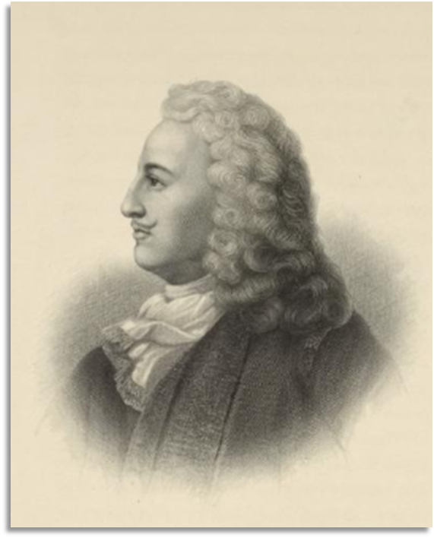
A portrait of La Salle
New York Public Library

La Salle: Excerpt 1 part 1
“Here we were agreeably surprised to find a party of Indians come out to meet us with ears of corn in their hands and a polished, honest air. They embraced us, inviting us most pressingly to go and visit their villages. The Sieur de la Salle, seeing their sincerity, agreed.”

La Salle: Excerpt 1 part 2
“Among other things, these Indians told us that they knew whites toward the west, a cruel wicked nation, who de-peopled the country around them. (These were the Spaniards.)”

La Salle: Excerpt 1 part 3
“We told them that we were at war with that people. When the news of this spread through the village, called that of the Kironas, all vied with each other in welcoming us, pressing us to stay and go to war with the Spaniards of Mexico.”

La Salle: Excerpt 1 part 4
“We put them off with fair words, and made a strict alliance with them, promising to return with more numerous troops. Then after many feasts and presents, they carried us over the river in periaguas [dug-out canoes].”

Extension: Spanish Exploration

The Arrival of the French!

Exit Ticket

Exit Ticket:
Follow the directions to complete your warm-up
Read the list of possibilities that could occur now that the French and Spanish are both interested in claiming land in Texas
Place a checkmark next to the three that you predict are most likely to occur next.
Discuss with a partner

Share with the class 2
One of the things that I predict is most likely to occur next is (blank)

