The Last Conquistadors & the French Arrive: Advanced
Unit 2: Age of Contact

Name: |  | Date: |  | Period:

Hernando de Soto

Key Information: | Significance:
Essential Question – Your Response: | Trace de Soto’s route. Circle the approximate location where he died.  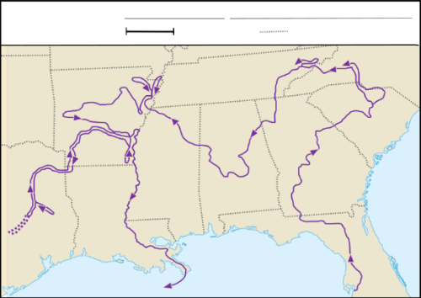

Luis de Moscoso Alvarado

Key Information: | Significance:
Essential Question – Your Response: | Trace Moscoso’s part of the expedition.  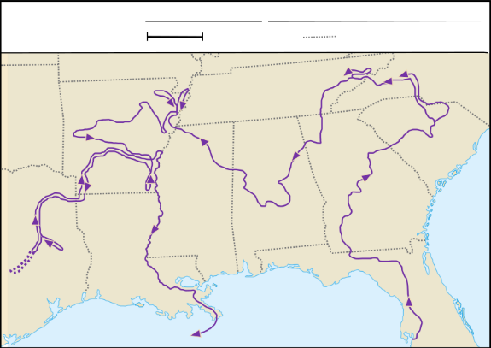

Juan de Oñate

Key Information: | Significance:
Essential Question – Your Response: | Juan de Oñate’s Expedition  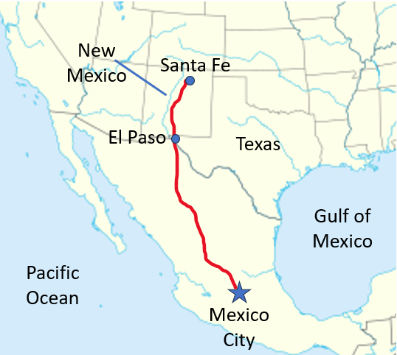

René-Robert Cavalier, Sieur de La Salle

Key Information: | Significance:
Essential Question – Your Response: | Map of Fort Saint Louis  