The Last Conquistadors & the French Arrive: Grade Level
Unit 2: Age of Contact

Name: |  | Date: |  | Period:

Hernando de Soto

Key Information: | Significance:
Essential Question – Your Response:  I predict that Moscoso will / will not find gold in Texas because _______________________ ________________________________________________ ________________________________________________ | Trace de Soto’s route. Circle the approximate location where he died.  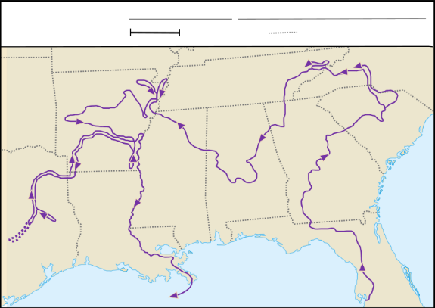

Luis de Moscoso Alvarado

Key Information: | Significance:
Essential Question – Your Response:  This information supports / does not support what we learned about the region in Unit 1 because ____________________________ ________________________________________________ | Trace Moscoso’s part of the expedition.  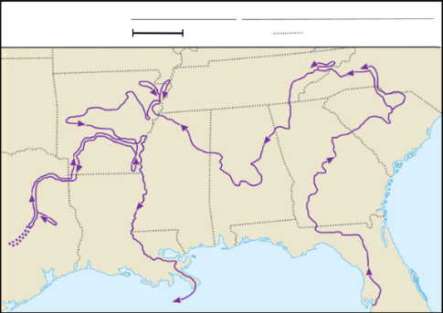

Juan de Oñate

Key Information: | Significance:
Essential Question – Your Response:  Oñate might have encountered _____________ _________________________________________________ _________________________________________________ in the Mountains and Basins region, based on what we learned in Unit 1. | Juan de Oñate’s Expedition  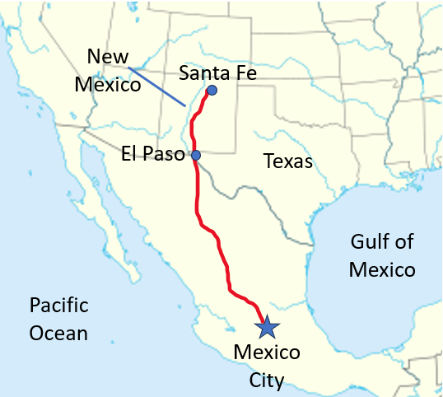

René-Robert Cavalier, Sieur de La Salle

Key Information: | Significance:
Essential Question – Your Response:  I think Spain will focus on God / Gold / Glory in Texas next because ________________ ________________________________________________ ________________________________________________ | Map of Fort Saint Louis  