The Last Conquistadors & the French Arrive: Advanced

Unit 2: Age of Contact
Hernando de Soto
Key Information: (blank)
Significance: (blank)
Essential Question – Your Response: (blank)
Trace de Soto’s route. Circle the approximate location where he died.
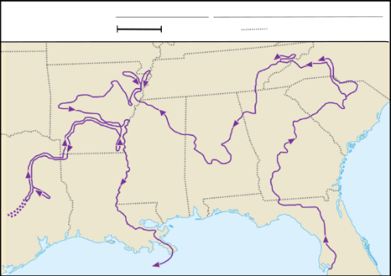
Luis de Moscoso Alvarado
Key Information: (blank)
Significance: (blank)
Essential Question – Your Response: (blank)
Trace Moscoso’s part of the expedition.
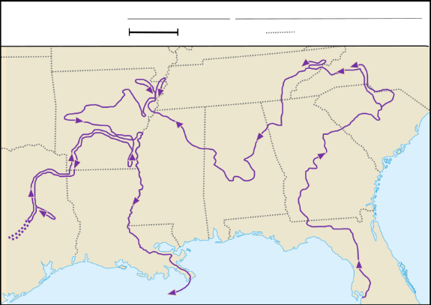
Juan de Oñate
Key Information: (blank)
Significance: (blank)
Essential Question – Your Response: (blank)
Juan de Oñate’s Expedition
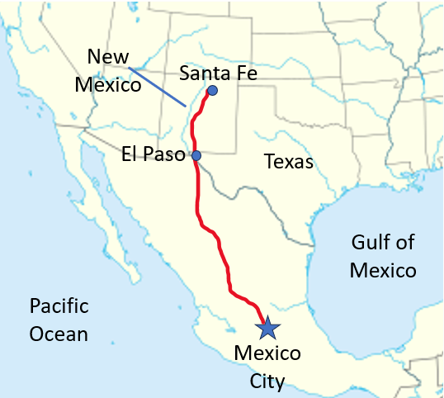
René-Robert Cavalier, Sieur de La Salle
Key Information: (blank)
Significance: (blank)
Essential Question – Your Response: (blank)
Map of Fort Saint Louis
