The Last Conquistadors & the French Arrive Foundations

Unit 2: Age of Contact
Hernando de Soto
Key Information:
- Explored the American southeast
- No (blank)
- (blank) near Texas
Significance:
First known European to explore the (blank) part of North America.
Essential Question – Your Response:
I predict that Moscoso will / will not find gold in Texas because (A) there is no gold there (B) all the gold has already been taken (C) the American Indians hid it.
Trace de Soto’s route. Circle the approximate location where he died.
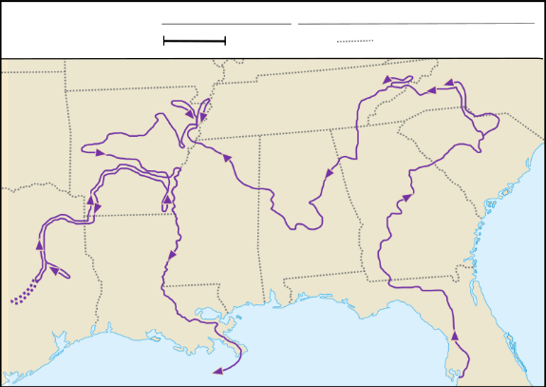
Luis de Moscoso Alvarado
Key Information:
- Encountered the (blank) people
- Struggled in (blank) TX
- Left with no (blank)
Significance:
His expedition in Texas (blank) to find any (blank)
Essential Question – Your Response:
This information supports / does not support what we learned about the region in Unit 1.
Trace Moscoso’s part of the expedition.
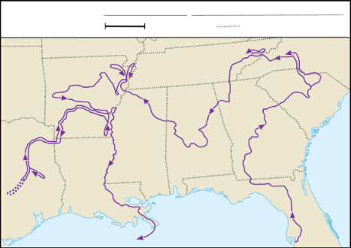
Juan de Oñate
Key Information:
- Established a settlement at (blank) (blank)
- Founded (blank) NM
- Claimed New Mexico
Significance:
His expedition in Texas (blank) to find any (blank)
Essential Question – Your Response:
Oñate might have encountered (A) Crocodiles and heavy rains (B) flat, grassy prairies (C) high elevation and an arid climate in the Mountains and Basins region, based on what we learned in Unit 1.
Juan de Oñate’s Expedition
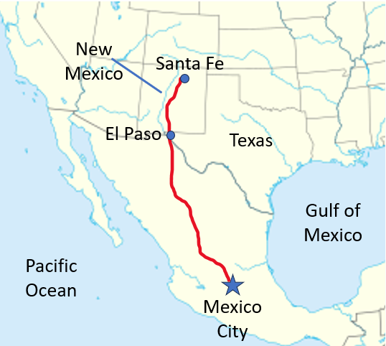
René-Robert Cavalier, Sieur de La Salle
Key Information:
- Mexican (blank) and gold made Spain (blank)
- Spain ignored (blank)
- (blank) Fort Saint Louis in TX
Significance:
Spain wanted to keep (blank) out of (blank) hands.
Essential Question – Your Response:
I think Spain will focus on God / Gold / Glory in Texas next.
Map of Fort Saint Louis
