The Last Conquistadors & the French Arrive: Grade Level

Unit 2: Age of Contact
Hernando de Soto
Key Information: (blank)
Significance: (blank)
Essential Question – Your Response:
I predict that Moscoso will / will not find gold in Texas because (blank)
Trace de Soto’s route. Circle the approximate location where he died.
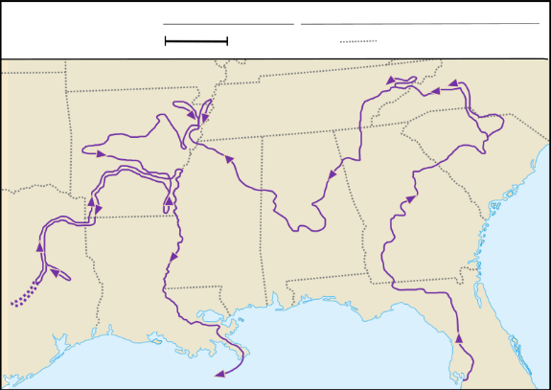
Luis de Moscoso Alvarado
Key Information: (blank)
Significance: (blank)
Essential Question – Your Response:
This information supports / does not support what we learned about the region in Unit 1 because (blank)
Trace Moscoso’s part of the expedition.
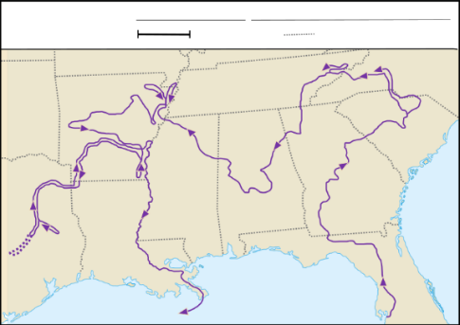
Juan de Oñate
Key Information: (blank)
Significance: (blank)
Essential Question – Your Response:
Oñate might have encountered (blank) (blank) (blank) in the Mountains and Basins region, based on what we learned in Unit 1.
Juan de Oñate’s Expedition
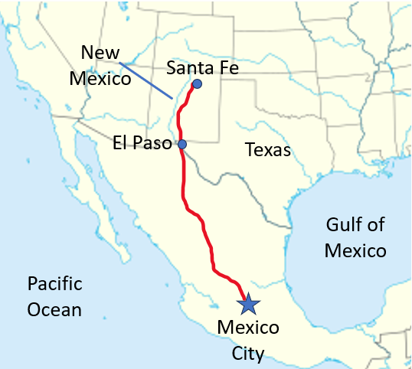
René-Robert Cavalier, Sieur de La Salle
Key Information: (blank)
Significance: (blank)
Essential Question – Your Response:
I think Spain will focus on God / Gold / Glory in Texas next because (blank) (blank) (blank)
Map of Fort Saint Louis
