Unit 2:
Age of Contact

Lesson 9:

The French Arrive!
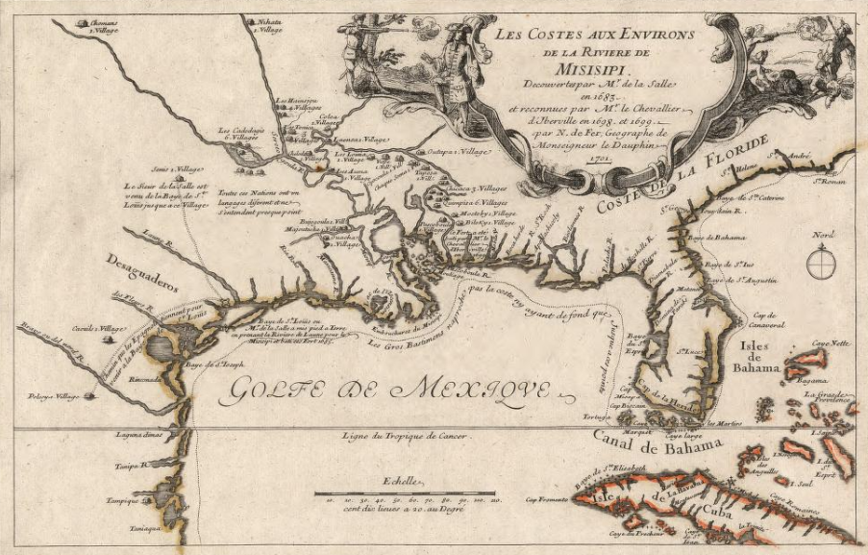

Guided Notes: The French Arrive!
Warm-up

Warm-up: Follow the directions to complete your warm-up
Lesson 9:
The French Arrive!
Read each scenario and provide your opinion in the response.
Share with a partner.

Share with the class
When a child sees another kid playing with a toy that they had first, the first child often (blank)
If two countries are exploring the same land that one of them claimed first, I think (blank)

Essential Questions
1. How successful was Spain at accomplishing its goals of “God, Gold, and Glory” in Texas?
2. What does Spain do as a result?
3. How does the arrival of the French change Spain’s response?

In today’s lesson…
1. We will examine the significance of the last Spanish conquistadors to explore Texas and the first French explorer to arrive in Texas.
2. I will complete my guided note-taking chart including writing key information, the significance of each topic, and responding to an essential question about each topic.

Hernando de Soto
Even though neither Cabeza de Vaca nor Francisco Coronado had any success acquiring gold in North America, other conquistadors still tried their luck in the lands north of Mexico.
A man named Hernando de Soto led an expedition that began in Florida. He and his men traveled through present-day Georgia, North and South Carolina, Tennessee, Alabama, Mississippi, Arkansas, and Louisiana.
De Soto and his men were the first known Europeans to explore much of the American southeast. Unfortunately, he came down with a severe fever and died at the Mississippi River in May of 1542.
Before he died, he left another conquistador named Luis de Moscoso Alvarado in charge of his expedition. Moscoso would go on to explore Texas.
Key Information
- Explored the American southeast
- No gold
- Died near Texas
Significance
First known European to explore the southeastern part of North America.
Essential Question
Do you predict Moscoso will have any luck finding gold in Texas? Why or why not?

Hernando de Soto’s Expedition
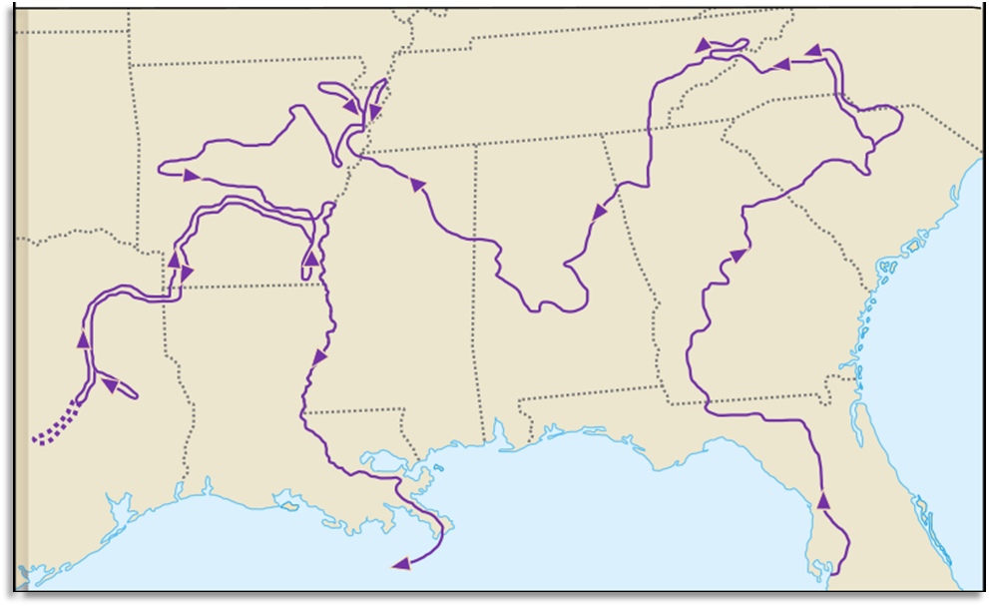

Luis de Moscoso Alvarado
After de Soto’s death in 1542, Moscoso continued into Texas. He led the expedition into northeastern Texas – part of the rich and fertile Coastal Plains. This area was populated primarily by different tribes within the Caddo Confederacy.
Moscoso encountered several groups of Caddo people, including the Naguatex, Hacanac, and Maye people. A member of Moscoso’s expedition kept a journal in which he documented many encounters with the Caddo and other Indigenous people of the Coastal Plains.
As Moscoso’s expedition made its way toward the southern portion of the Coastal Plains, they encountered difficulties resulting from the harsher climate and environment, and the lack of food and other resources there. Moscoso and his men decided to leave Texas because of these hardships.
Key Information
- Encountered the Caddo people
- Struggled in south TX
- Left with no gold.
Significance
His expedition in Texas failed to find any gold.
Essential Question
Does this information about the Coastal Plains support what we learned about the region in Unit 1? Why or why not?

Luis de Moscoso Alvarado’s Expedition

Juan de Oñate
Despite the fact that the expeditions of Cabeza de Vaca, Coronado, de Soto, and Moscoso all failed to find gold north of Mexico, another conquistador set out in search of riches. His name was Juan de Oñate. His expedition took place in 1598, more than 50 years after Moscoso passed through the Coastal Plains.
Oñate decided to search in the west. He established a settlement in the Mountains and Basins region at a place called El Paso del Norte. Does that sound familiar? It is modern-day El Paso, Texas!
He continued into present day New Mexico and claimed all the land there in the name of Spain. He is also credited with founding Santa Fe, New Mexico.
There were claims that Oñate was harsh and cruel to both American Indian people and his own men. After his expedition failed to find gold, he was put on trial for crimes including cruelty. He was found guilty and exiled, though his conviction was later overturned.
Key Information
- Established a settlement at El Paso.
- Founded Santa Fe, NM
- Claimed New Mexico
Significance
His expedition in Texas failed to find any gold.
Essential Question
Think back to the Mountains and Basins region of Texas. Based on your knowledge, what might Oñate have encountered there?

Juan de Oñate’s Expedition
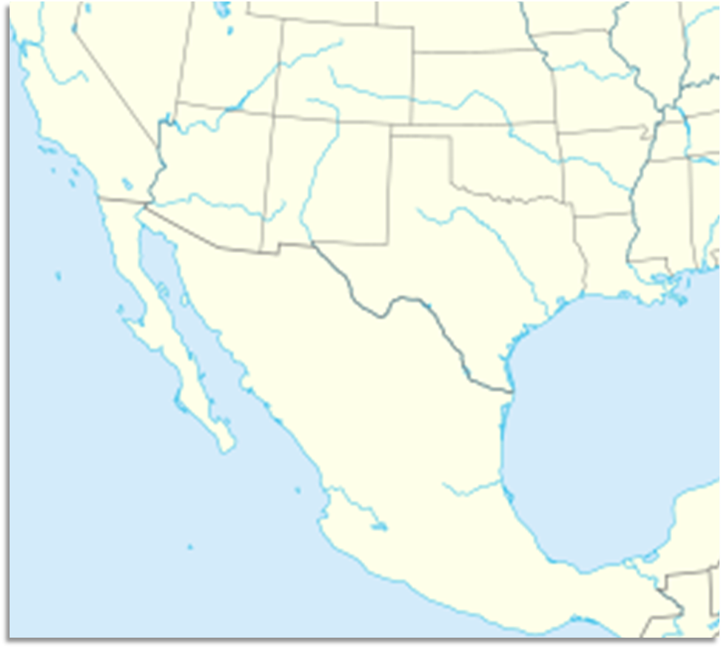
Mexico City
Pacific Ocean
Gulf of Mexico
Texas
Santa Fe
New Mexico

El Paso

René-Robert Cavelier, Sieur de La Salle
Spain had been growing extremely wealthy from resources like gold, and especially silver, in Mexico. In contrast, Texas had brought Spain no wealth at all. As a result, Spain essentially began to ignore its northern frontier and focus its attention mostly on Mexico.
Then, 87 years after Oñate and nearly 150 years after Moscoso, on a cold February day in 1685, a French man named Robert La Salle arrived with more than 100 other French people in Matagorda Bay, Texas. He built a fort he called Fort Saint Louis. He and his men quickly began exploring Texas, planning to take part in the fur trade with American Indians. This was a huge problem for Spain.
Spain and France had been enemies for hundreds of years. Spain might have lost interest in Texas, but the Spanish definitely didn’t want the French to have it! La Salle’s expedition was a failure. He even ended up being killed by his own men. Even so, La Salle’s arrival still made Spain worried enough to turn its attention back to Texas.
Key Information
- Mexican silver and gold made Spain rich.
- Spain ignored Texas.
- French Fort Saint Louis in TX
Significance
Spain wanted to keep Texas out of French hands.
Essential Question
Considering Spain’s goals of “God, Gold, and Glory,” what do you think Spain will focus on next in Texas?

La Salle’s Expedition
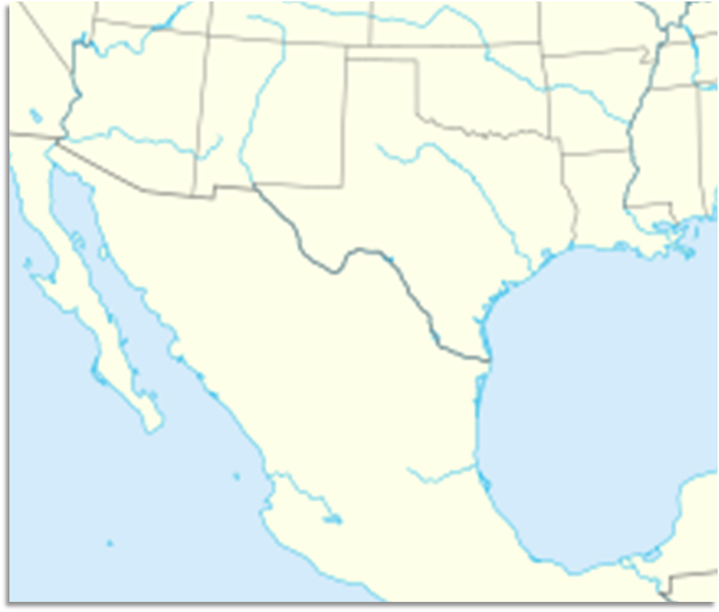
Mexico City
Gulf of Mexico
Pacific Ocean
Texas
Fort Saint Louis, 1685
La Salle Killed, 1687

Guided Notes: The French Arrive!
Exit Ticket

Exit Ticket:
Follow the directions to complete your warm-up
Read each box showing Spain’s possible response to France’s arrival in Texas.
Highlight or circle which three you think are most likely.
Share with a partner.

Share with the class 2
One thing I think the Spanish might do in response to the arrival of the French is (blank)

