The Last Conquistadors & the French Arrive Foundations
Unit 2: Age of Contact

Name: |  | Date: |  | Period:

Hernando de Soto

Key Information:  - Explored the American southeast  - No _____________________  - _________________ near Texas | Significance:  First known European to explore the ___________________________________ part of North America.
Essential Question – Your Response:  I predict that Moscoso will / will not find gold in Texas because (A) there is no gold there (B) all the gold has already been taken (C) the American Indians hid it. | Trace de Soto’s route. Circle the approximate location where he died.  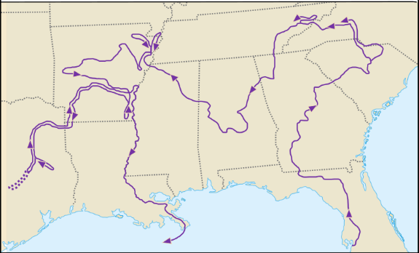

Luis de Moscoso Alvarado

Key Information:  - Encountered the ___________________ people  - Struggled in _____________________ TX  - Left with no __________________ | Significance:  His expedition in Texas _____________________ to find any _____________________.
Essential Question – Your Response:  This information supports / does not support what we learned about the region in Unit 1. | Trace Moscoso’s part of the expedition.  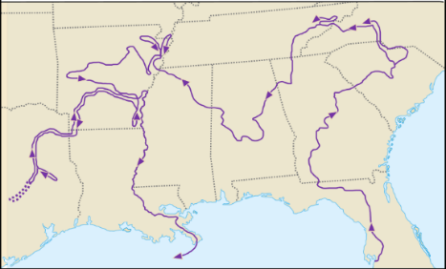

Juan de Oñate

Key Information:  - Established a settlement at ________ _____________________.  - Founded _____________________, NM  - Claimed New Mexico | Significance:  His expedition in Texas _____________________ to find any _____________________
Essential Question – Your Response:  Oñate might have encountered (A) Crocodiles and heavy rains (B) flat, grassy prairies (C) high elevation and an arid climate in the Mountains and Basins region, based on what we learned in Unit 1. | Juan de Oñate’s Expedition  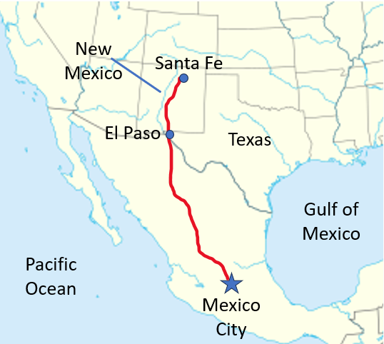

René-Robert Cavalier, Sieur de La Salle

Key Information:  - Mexican __________________ and gold made Spain ___________________.  - Spain ignored ____________________.  - ________________ Fort Saint Louis in TX | Significance:  Spain wanted to keep _____________________ out of ___________________________ hands.
Essential Question – Your Response:  I think Spain will focus on God / Gold / Glory in Texas next. | Map of Fort Saint Louis  