Unit 2:
Age of Contact

Lesson 12:

Looking Ahead
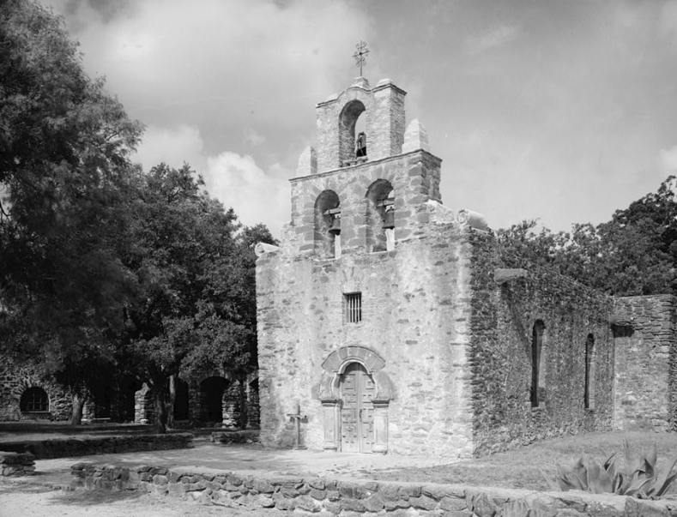
Lesson 12:
Looking Ahead

Looking Ahead
Warm-up

Warm-up:
Follow the directions to complete your warm-up
Observe the image on your warm-up and write your observations in the space provided.
Explain how you think this image connects to the Spanish in Texas.
Discuss your response with a partner.
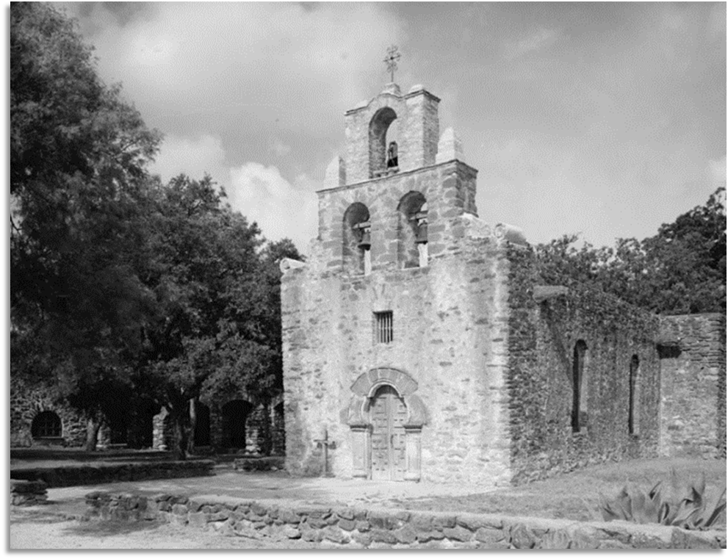

Share with the class 1
One thing I observed about the image is (blank)
This image might relate to the Spanish in Texas because (blank)

Essential Question
How did Spain attempt to keep Texas out of the hands of the French, and what challenges did the Spanish face in carrying out this goal?

In today’s lesson…
1. We will examine Spain’s new goal in Texas, why they chose to pursue this goal, and the challenges they face.
2. I will read 3 primary source excerpts about Spain’s new goal in Texas, answer comprehension questions, and make predictions about the next unit.

Looking Ahead
Lesson

Part I: Transitioning to a New Era
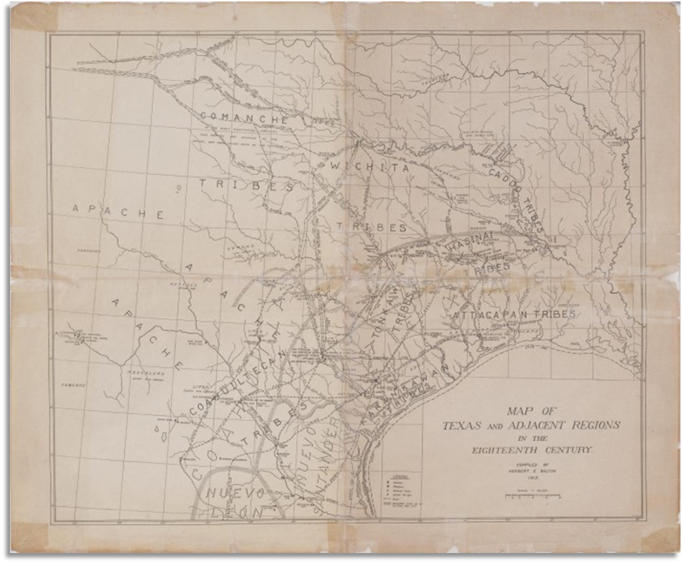
A map of Texas, 18th Century
University of North Texas Libraries, The Portal to Texas History

Part II: A New Approach to Texas
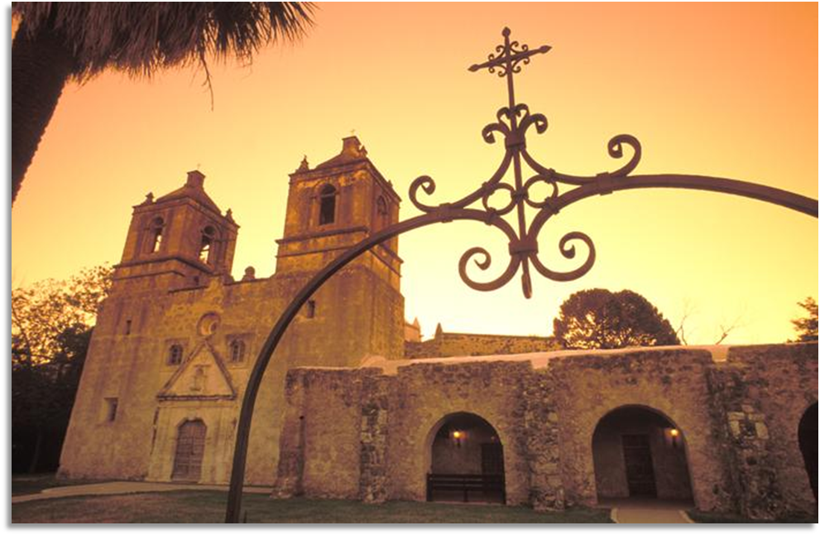
Mission Concepción in San Antonio, Texas
University of North Texas Libraries, The Portal to Texas History

Excerpt I: The French Threat
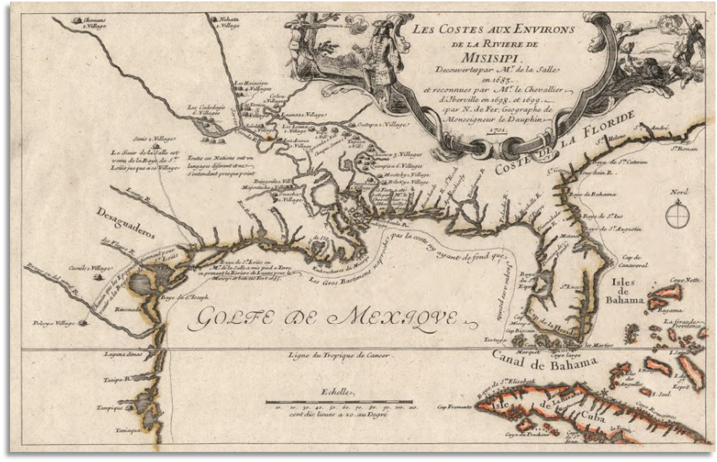
A map of French exploration, including in Texas, 1698
Library of Congress

Excerpt II: Insufficient Support
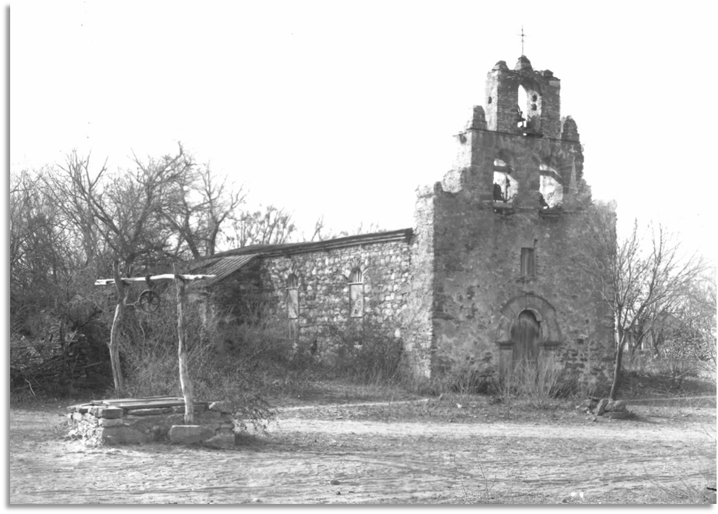
Mission Espada, San Antonio Texas
University of North Texas Libraries, The Portal to Texas History

Excerpt III: American Indian Resistance to Religious Conversion
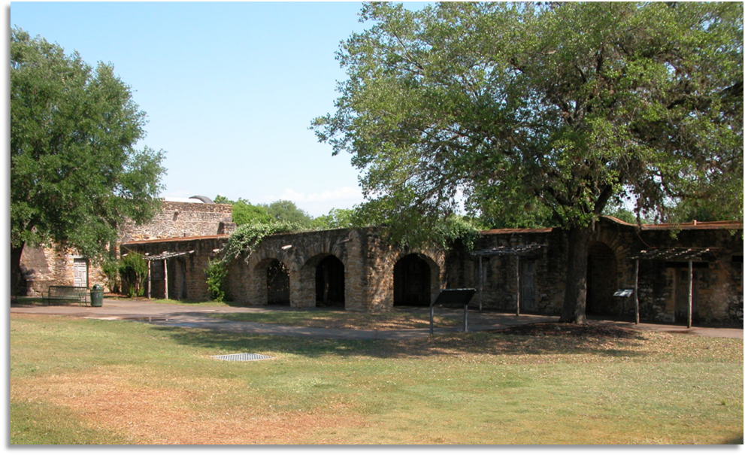
Mission San Jose, San Antonio Texas
University of North Texas Libraries, The Portal to Texas History

Looking Ahead
Exit Ticket

Exit Ticket:
Follow the directions to complete your warm-up
In which approximate location on the map was Fray Hidalgo attempting to establish missions?
Why was he attempting to establish missions in that area?
Discuss your response with a partner.
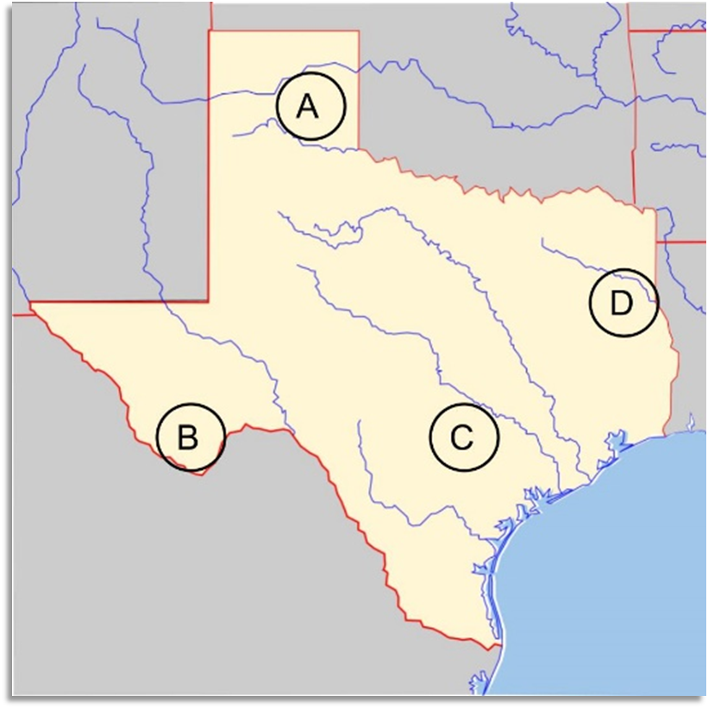

Share with the class 2
Fray Hidalgo was attempting to establish missions at the location labeled letter (blank)
He was attempting to establish missions in this area because (blank)

