 Warm-up: Looking Ahead
Unit 2: The Age of Contact
Name: |  | Date: |  | Period:

Directions: Use your observations about the image below to answer your warm-up question.
What do you notice about the image to the right? List any observations you have.  How do you think this image might relate to the Spanish in Texas? | 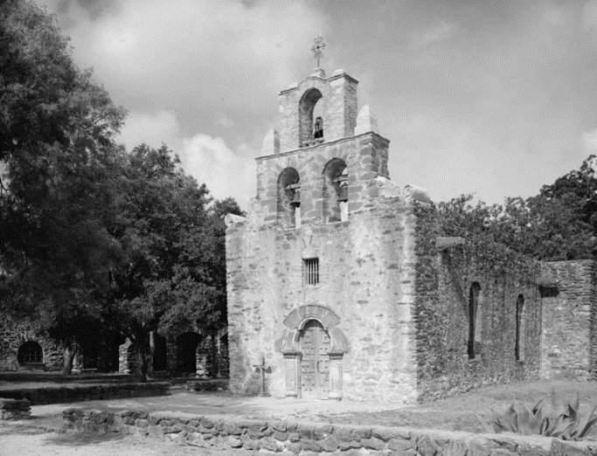

Warm-up: Looking Ahead
Unit 2: The Age of Contact
Name: |  | Date: |  | Period:

Directions: Use your observations about the image below to answer your warm-up question.
What do you notice about the image to the right? List any observations you have.  How do you think this image might relate to the Spanish in Texas? | 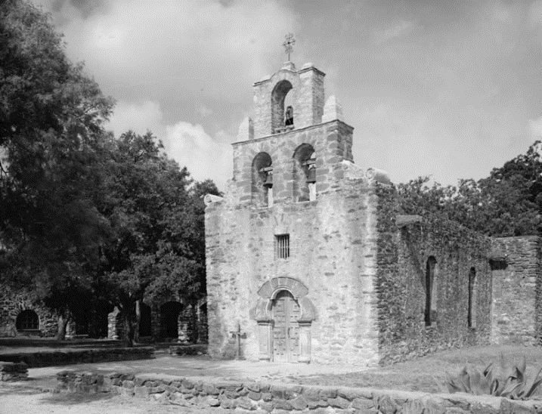


Exit Ticket: Looking Ahead

Think back to the excerpts we discussed today. In which approximate location on the map was Fray Hidalgo attempting to establish missions?  Why was he attempting to establish missions in that area? | 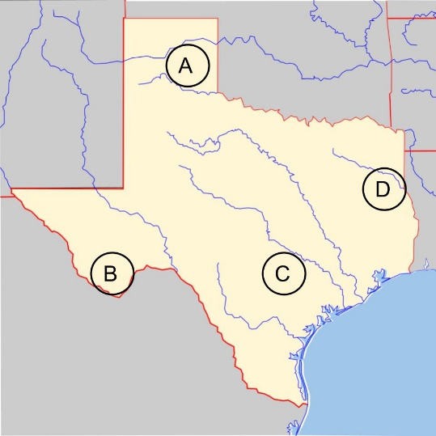

Exit Ticket: Looking Ahead

Think back to the excerpts we discussed today. In which approximate location on the map was Fray Hidalgo attempting to establish missions?

Why was he attempting to establish missions in that area?

