 Warm-up: Mind Map Review
Unit 2: Age of Contact
Name: |  | Date: |  | Period:

Look at the word bank below. Complete the mind map diagram by putting each term where you think it fits best.

- Causes  - Spanish Exploration  - Columbian Exchange  - Effects  - God, Gold, and Glory | 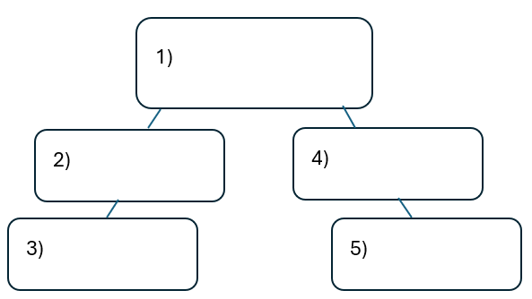

Warm-up: Mind Map Review
Unit 2: Age of Contact
Name: |  | Date: |  | Period:

Look at the word bank below. Complete the mind map diagram by putting each term where you think it fits best.

- Causes
- Spanish Exploration
- Columbian Exchange
- Effects
- God, Gold, and Glory


Mind Map Review Exit Ticket

Directions: Complete the sentence by choosing the best answer for each blank from the chart below.

The (1)____________ is primarily characterized by (2)____________

Answer choices for blank (1)  Circle the best answer | Answer choices for blank (2)  Circle the best answer

- Conquistadors  - Columbian Exchange  - Age of Contact  - Reconquista | - conflict between American Indians and the French and Spanish explorers.  - the founding of significant settlements in the Americas including Santa Fe and El Paso.  - Spain’s total failure to find any gold in the Americas.  - changes and conflict brought about in the Americas as a result of Spanish exploration.

Mind Map Review Exit Ticket

Directions: Complete the sentence by choosing the best answer for each blank from the chart below.

The (1)____________ is primarily characterized by (2)____________

Answer choices for blank (1)  Circle the best answer | Answer choices for blank (2)  Circle the best answer

- Conquistadors  - Columbian Exchange  - Age of Contact  - Reconquista | - conflict between American Indians and the French and Spanish explorers.  - the founding of significant settlements in the Americas including Santa Fe and El Paso.  - Spain’s total failure to find any gold in the Americas.  - changes and conflict brought about in the Americas as a result of Spanish exploration.

