Unit 2 :
Age of Contact

Lesson 13 :

Study Guide
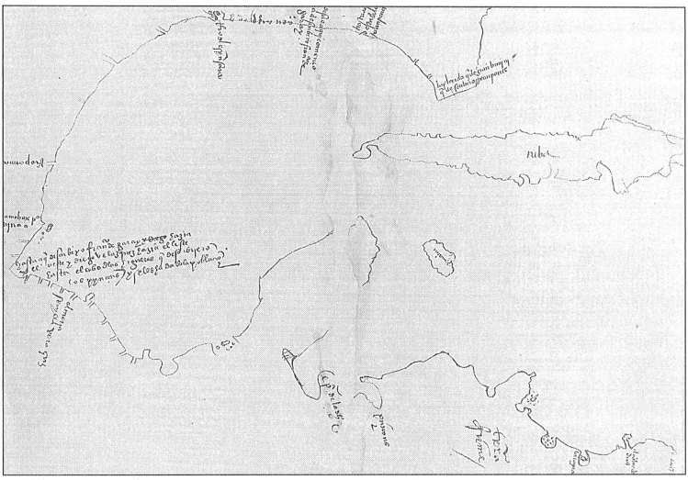

Study Guide Review
Warm-up

Warm-up:
Follow the directions to complete your warm-up
Read the list of social studies topics in the chart.
Circle or highlight any items that you think are likely to be on the unit 2 test.
Share with a partner.

Share with the class
One thing that I think is likely to be on the unit 2 test is (blank)

Essential Question
What significant information do we need to know in order to be successful on the unit 2 test?

In today’s lesson…
1. We will identify and review significant information for our upcoming test.
2. I will use my previous work and notes to complete my study guide. I will match information, create short answer responses, and answer practice test questions.

Part I: Key Terms and Definitions
Choose the correct term for each definition in the chart.

Part II: Matching
Match the term on the left with its correct significance on the right.
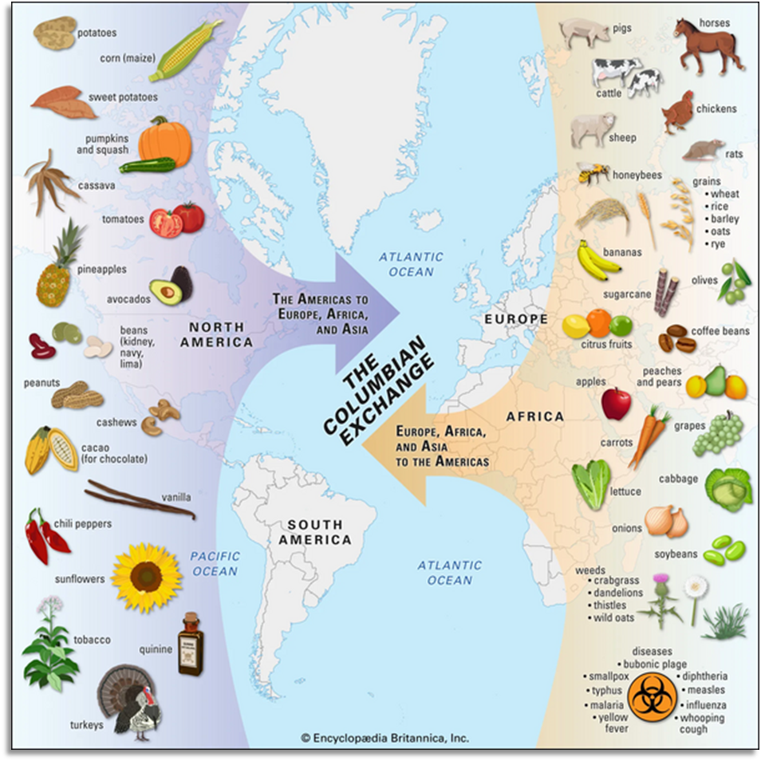

Part III: Practice Questions
Practice answering the following questions to prepare for the types of questions you may see on the exam. These questions are based on the new 8th grade social studies STAAR question types.
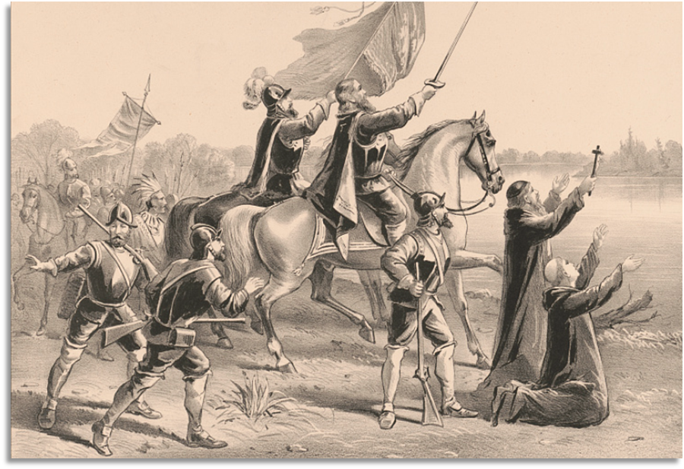

Study Guide Review
Exit Ticket

Exit Ticket:
Follow the directions to complete your warm-up
Assess your knowledge and preparation for the test
Respond to the prompts about your knowledge of unit 2 content.
Share with a partner.

Share with the class 2
One thing the study guide helped me remember or understand is: (blank)
One thing I still have a question about is (blank)
One thing I will do to prepare for this test is (blank)

