Texas Today Grade Level
Unit 2: Age of Contact

Name: |  | Date: |  | Period:

The Spanish and Indigenous people we have been studying lived over 500 years ago. Even though it’s been centuries since they walked the land we now call Texas, we can still see remnants of their influence on the world around them just by looking at some of the geographic names on a current Texas map.
Directions: Read the short passages about six Texas locations on the following page. Use the information and clues in each passage to label the map below. Write three facts from the readings next to each location on the map.

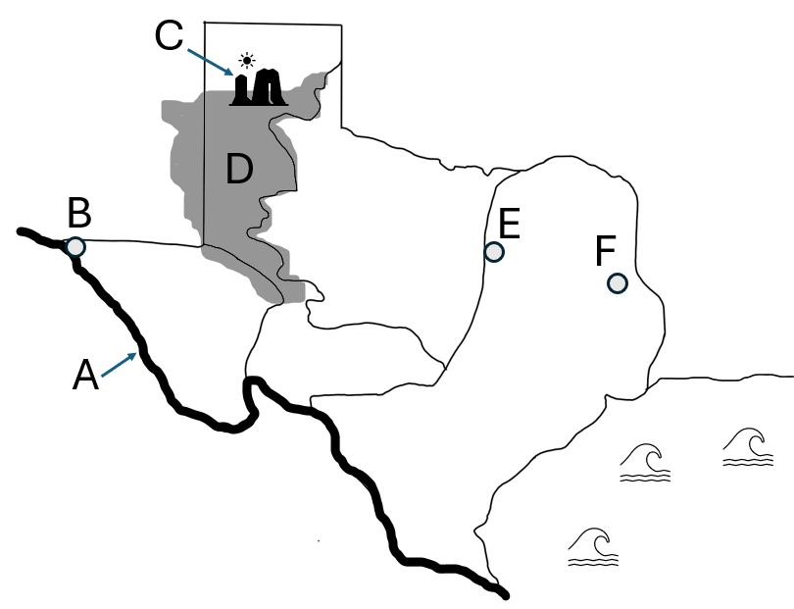

The Llano Estacado
The Llano Estacado is a geographic landform that contains primarily grasslands and mesas, or flat-topped hills with steep sides. This area covers a large portion of the Great Plains of Texas. Francsico Vazquez de Coronado is credited with naming the Llano Estacado, which, at the time would have translated to the “palisaded plains” or “stockaded plains.” The mesas likely appeared to provide protection from outside threats, similar to a palisade or stockade. In contemporary Spanish, llano estacado translates to “the staked plains.”

The Palo Duro Canyon
The Palo Duro Canyon is a geographic landform that is also located in the Great Plains in the Panhandle of Texas. It is the second largest canyon in the United States, after the Grand Canyon. The term palo duro means “hard wood” in Spanish. The Palo Duro Canyon received its name from Spanish explorers who passed through the area and took notice of the abundant mesquite and juniper trees that grow there.

The Rio Grande & El Paso
The large river that forms the border between Texas and Mexico has had many names over the centuries. The name that has continued to the present day – Rio Grande – simply means “big river” in Spanish. This designation was first given by the conquistador Juan de Oñate in the year 1598 as he crossed the river near the present-day west-Texas city of El Paso. Oñate is also credited with giving El Paso its original name – El Paso del Norte – or the pass of the north. He and other Spaniards traveled through El Paso del Norte on their way north into present-day New Mexico. Today, El Paso has grown into a large city with more than 678,000 people.

Waxahachie
Waxahachie today is a small city of approximately 50,000 people, just south of the Dallas-Fort Worth metroplex. It was officially founded as a Texas city in the year 1850, however, Waxahachie had been inhabited by American Indians for thousands of years before that. The name Waxahachie is likely derived from an American Indian word meaning “buffalo creek,” however the exact meaning and origin isn’t certain.

Nacogdoches
Nacogdoches, (na-kuh-doh-chus) is another small city of approximately 32,000 people in the Coastal Plains region of Texas. It is located near the border of Louisiana in the Piney Woods Forest. Nacogdoches was founded in 1779 by the Spanish and is considered to be one of the oldest towns in Texas. Before the Spanish ever arrived, however, it had been home to various American Indian tribes including the Nacogdoche band of the Caddo Confederacy.

