Unit 2:
Age of Contact

Lesson 11:

Texas Today
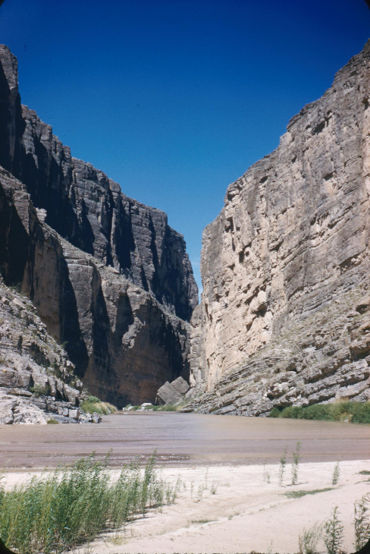
The Rio Grande River
The Portal to Texas History

Warm-up
Follow the directions below to complete your warm-up
- Look at the map of some present-day geographic locations in Texas.
- What evidence do you see of Spanish or American Indian history, life, or culture based only on this map
- Discuss with a partner.
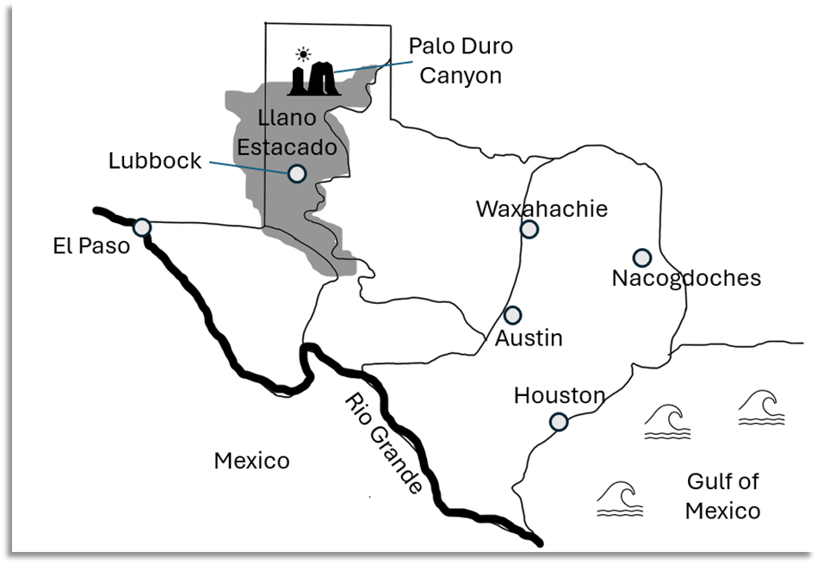

Share with the class: day 1
I think (blank) might show evidence of Spanish culture because (blank)
I think (blank) might show evidence of American Indian culture because (blank)

Essential Question
What evidence can we see today of Spanish or American Indian culture and influence on Texas geography?

In Today’s Lesson
We will read short passages about various natural and human geographic features of Texas to identify Spanish and American Indian influence in modern Texas.
I will use the clues and information in each passage to correctly label significant geographic features on a map of Texas.

Llano Estacado
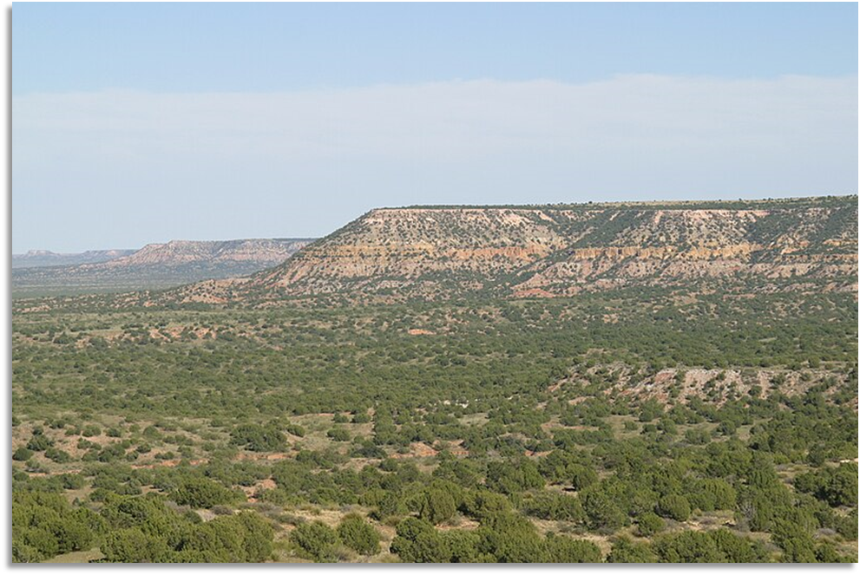
The northern edge of the Llano Estacado

Palo Duro Canyon
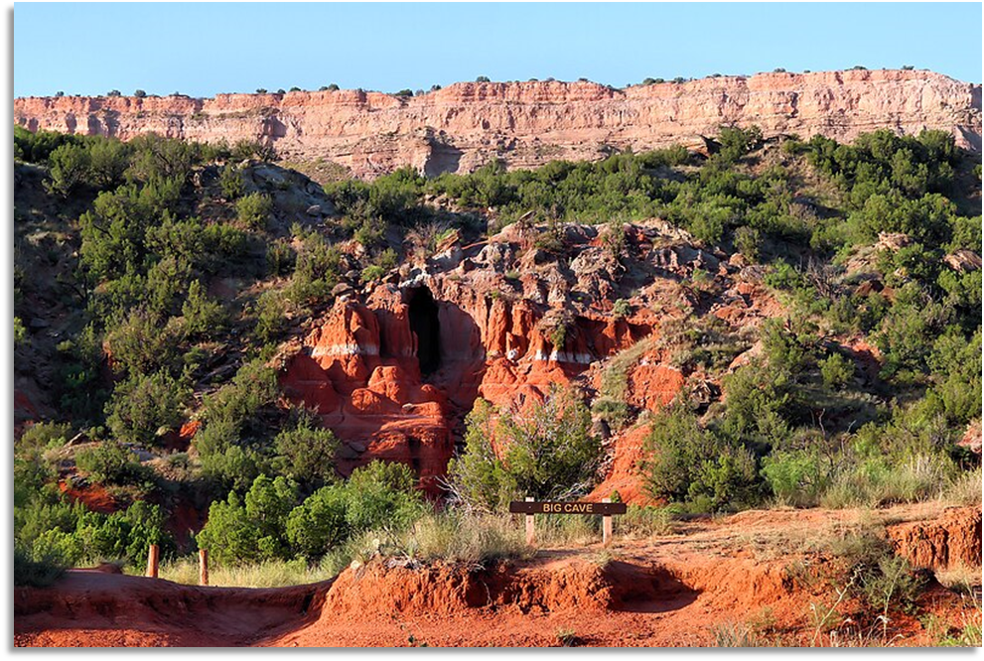
The entrance to Big Cave in Palo Duro Canyon
Larry D. Moore Photograph

The Rio Grande
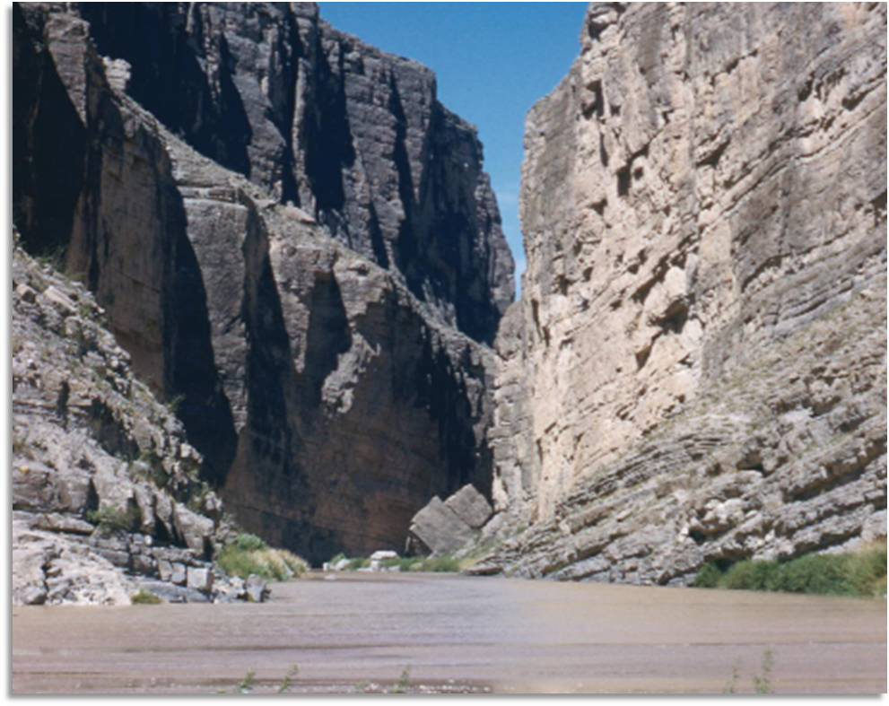
The Rio Grande River in Santa Elena Canyon
Photograph by Evelyn Streng
The Portal to Texas History

El Paso
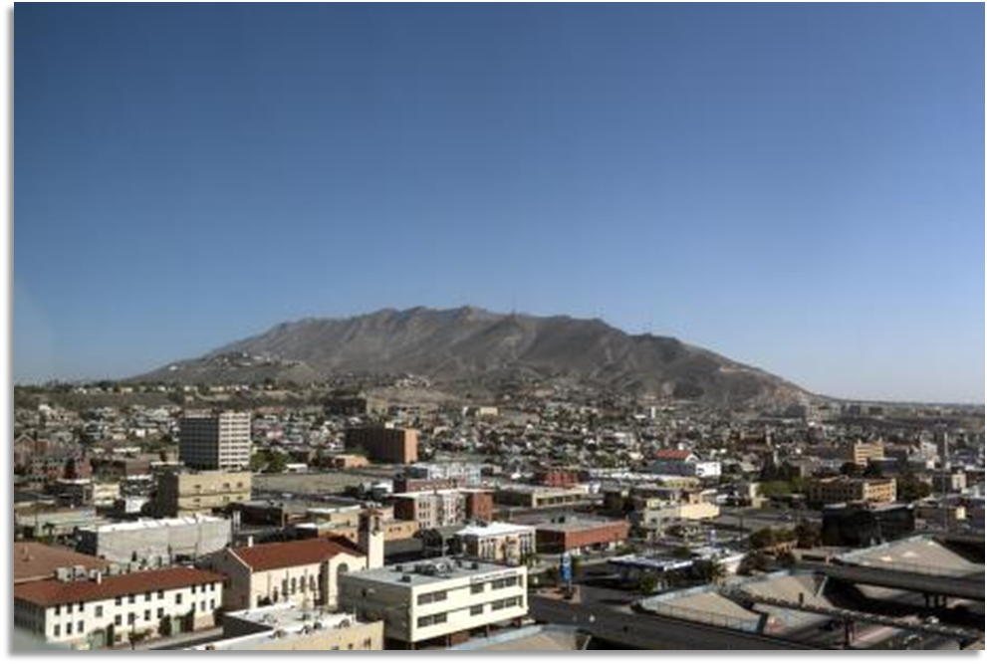
Skyline view of El Paso, Texas by Carol Highsmith
Library of Congress

Waxahachie
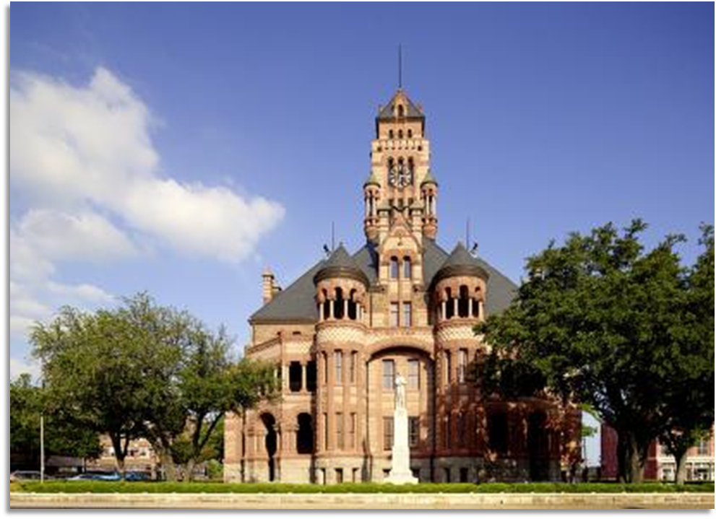
The 1897 Ellis County Courthouse in Waxahachie, Texas
Library of Congress

Nacogdoches
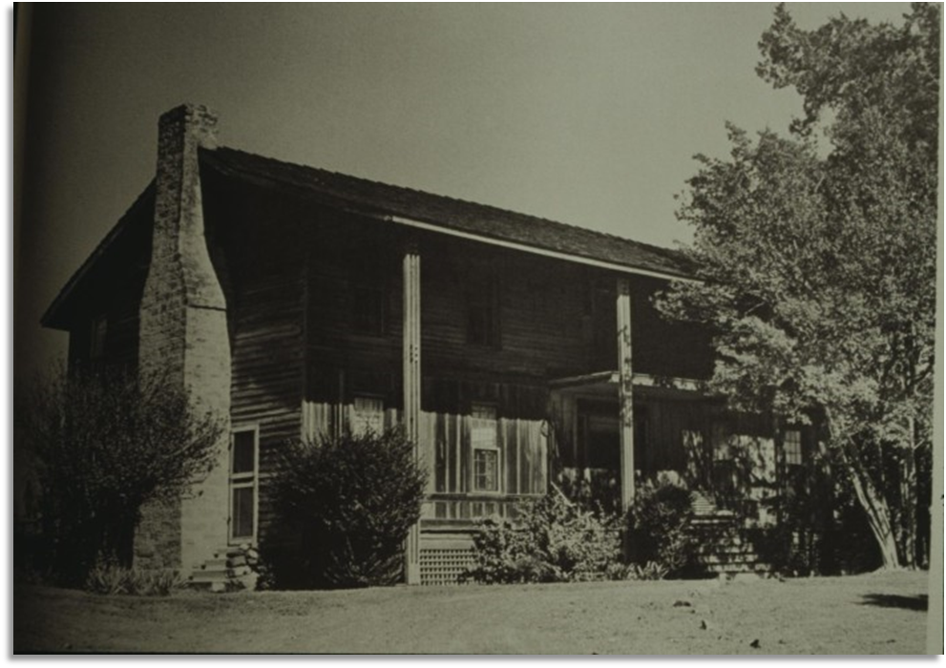
A photograph of the Stagecoach Inn founded in 1838
The Portal to Texas History

Exit Ticket
Follow the directions below to complete your warm-up
- Read the question to determine which TWO answers provide the most accurate response.
- Discuss with a partner.

Share with the class: 2 day 1
One example of Spanish influence on Texas today is (blank)
One example of American Indian influence on Texas today is (blank)

