Texas Today Advanced

Unit 2: Age of Contact
The Spanish and Indigenous people we have been studying lived over 500 years ago. Even though it’s been centuries since they walked the land we now call Texas, we can still see remnants of their influence on the world around them just by looking at some of the geographic names on a current Texas map.
Part I Directions: Read the short passages about six Texas locations on the following page. Use the information and clues in each passage to label the map below. Write three facts from the readings next to each location on the map.
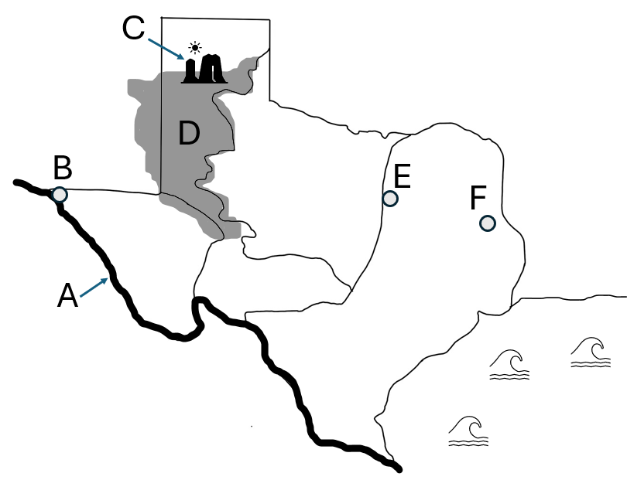

The Llano Estacado
The Llano Estacado is a geographic landform that contains primarily grasslands and mesas, or flat-topped hills with steep sides. This area covers a large portion of the Great Plains of Texas. Francsico Vazquez de Coronado is credited with naming the Llano Estacado, which, at the time would have translated to the “palisaded plains” or “stockaded plains.” The mesas likely appeared to provide protection from outside threats, similar to a palisade or stockade. In contemporary Spanish, llano estacado translates to “the staked plains.”

The Palo Duro Canyon
The Palo Duro Canyon is a geographic landform that is also located in the Great Plains in the Panhandle of Texas. It is the second largest canyon in the United States, after the Grand Canyon. The term palo duro means “hard wood” in Spanish. The Palo Duro Canyon received its name from Spanish explorers who passed through the area and took notice of the abundant mesquite and juniper trees that grow there.

The Rio Grande & El Paso
The large river that forms the border between Texas and Mexico has had many names over the centuries. The name that has continued to the present day – Rio Grande – simply means “big river” in Spanish. This designation was first given by the conquistador Juan de Oñate in the year 1598 as he crossed the river near the present-day west-Texas city of El Paso. Oñate is also credited with giving El Paso its original name – El Paso del Norte – or the pass of the north. He and other Spaniards traveled through El Paso del Norte on their way north into present-day New Mexico. Today, El Paso has grown into a large city with more than 678,000 people.

Waxahachie
Waxahachie today is a small city of approximately 50,000 people, just south of the Dallas-Fort Worth metroplex. It was officially founded as a Texas city in the year 1850, however, Waxahachie had been inhabited by American Indians for thousands of years before that. The name Waxahachie is likely derived from an American Indian word meaning “buffalo creek,” however the exact meaning and origin isn’t certain.

Nacogdoches
Nacogdoches, (na-kuh-doh-chus) is another small city of approximately 32,000 people in the Coastal Plains region of Texas. It is located near the border of Louisiana in the Piney Woods Forest. Nacogdoches was founded in 1779 by the Spanish and is considered to be one of the oldest towns in Texas. Before the Spanish ever arrived, however, it had been home to various American Indian tribes including the Nacogdoche band of the Caddo Confederacy.
Part I Directions: Answer the following questions about the readings and the influence of Spanish and American Indian culture on Texas today.
1. Determine whether each geographic feature is of a primarily Hispanic or American Indian origin. Select the correct answer in each row by placing a check mark in the correct box. Then write the name of the person or group who gave each feature its name.
Geographic Feature
The Llano Estacado
American Indian Origin
Hispanic Origin
Write the name of the person or group from whom the name originated
Geographic Feature
El Paso
American Indian Origin
Hispanic Origin
Write the name of the person or group from whom the name originated
Geographic Feature
Waxahachie
American Indian Origin
Hispanic Origin
Write the name of the person or group from whom the name originated
Geographic Feature
The Rio Grande
American Indian Origin
Hispanic Origin
Write the name of the person or group from whom the name originated
Geographic Feature
The Palo Duro Canyon
American Indian Origin
Hispanic Origin
Write the name of the person or group from whom the name originated
Geographic Feature
Nacogdoches
American Indian Origin
Hispanic Origin
Write the name of the person or group from whom the name originated
2. Look at the location of the Llano Estacado on your map. What role does the Llano Estacado play in the division of Texas into its four distinct regions?
3.Which statement below provides the best summary of the significance of the material we covered today?
a. There are many places in Texas today that have Spanish or American Indian names, like Waxahachie, El Paso, and the Palo Duro Canyon.
b. Many human and natural features of Texas today that bear Hispanic and Indigenous names provide evidence of the diverse cultural history of the state.
c. Whenever Spanish explorers led expeditions through the area now known as Texas, they often gave places Spanish names that we use today.
d. Although the origin of some geographic names is unknown, there are many Indigenous and Spanish names of places in Texas.

