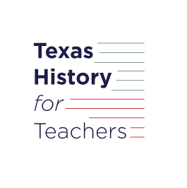 ***Warm-up:*** The Big Picture

*Unit 2: The Age of Contact*

|  |  |  |  |  |  |
| --- | --- | --- | --- | --- | --- |
| Name: |  | Date: |  | Period: |  |

When the Europeans learned about North and South America in the 1400s, they were really excited about this land that was so new to them. They returned over and over to explore the Americas. The Spanish, in particular, had three specific goals for their exploration.

There are six goals listed below. Three of them were not primary goals of the Spanish. Place an X in the blanks of the three that you think were **not** Spanish goals. Then, put the remaining three goals in the order that you think would have been most important to the Spanish. For example, write a 1 next to the goal that you think was most important to the Spanish.

______ Spread their religious faith ______ Bring glory to themselves and their country

______ Establish trade with Indigenous people ______ Form alliances with other European nations

______ Gain wealth and resources ______ See how much land they can discover

 ***Warm-up:*** The Big Picture

*Unit 2: The Age of Contact*

|  |  |  |  |  |  |
| --- | --- | --- | --- | --- | --- |
| Name: |  | Date: |  | Period: |  |

When the Europeans learned about North and South America in the 1400s, they were really excited about this land that was so new to them. They returned over and over to explore the Americas. The Spanish, in particular, had three specific goals for their exploration.

There are six goals listed below. Three of them were not primary goals of the Spanish. Place an X in the blanks of the three that you think were **not** Spanish goals. Then, put the remaining three goals in the order that you think would have been most important to the Spanish. For example, write a 1 next to the goal that you think was most important to the Spanish.

______ Spread their religious faith ______ Bring glory to themselves and their country

______ Establish trade with Indigenous people ______ Form alliances with other European nations

______ Gain wealth and resources ______ See how much land they can discover

The Big Picture ***Exit Ticket***

Based on the reading passage from the lesson, what are three things we will learn about in Unit 2: Age of Contact? Write your response in complete sentences.

|  |
| --- |
|  |

The Big Picture ***Exit Ticket***

Based on the reading passage from the lesson, what are three things we will learn about in Unit 2: Age of Contact? Write your response in complete sentences.

|  |
| --- |
|  |