Unit 2:
The Age of Contact

Lesson 1:

The Big Picture
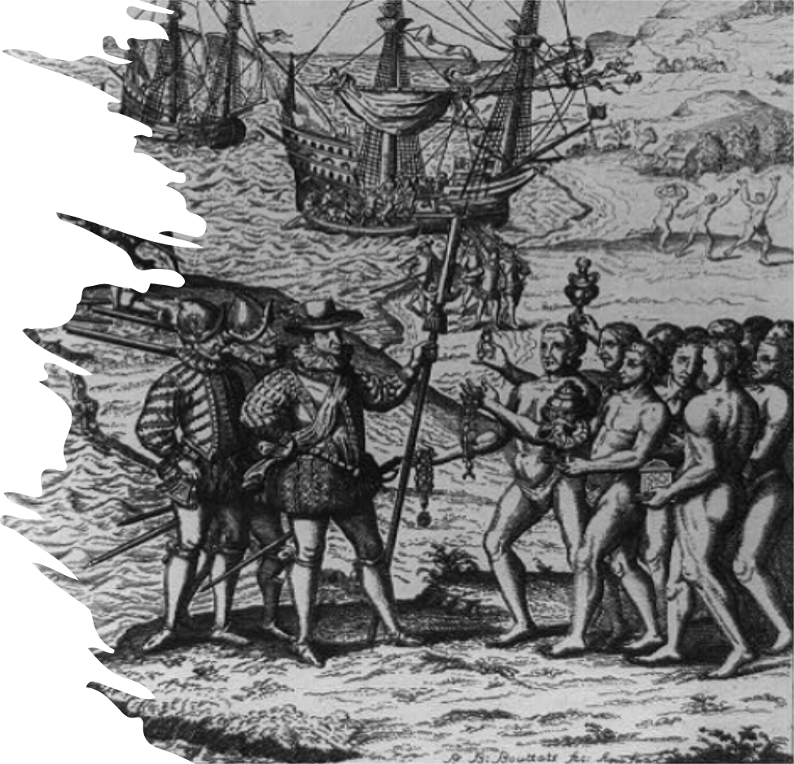

Warm-up:
Follow the directions below to complete your warm-up
Read the introductory passage.
Choose the three items that you think were the primary goals of the Spanish.
Place a 1, 2, and 3 next to each goal based on how important you think each was.
Draw an X next to the items that you think were not primary goals for the Spanish.
Discuss with a shoulder partner.

Share with the class: day 1
I think the most important goal for the Spanish was probably (blank)
I think the second most important goal for the Spanish was probably (blank)
I think the third most important goal for the Spanish was probably (blank)

Essential Question
What are the defining characteristics and key concepts of Unit 2: The Age of Contact?

In Today’s Lesson
1. We will identify key people, events, and concepts of Unit 2: Age of Contact.
2. I will read a passage about the unit, summarize each paragraph, and provide evidence to support claims about the passage.

Part I:

Analyze an Image
Look at the image on your worksheet, or enlarged here, to answer the questions.
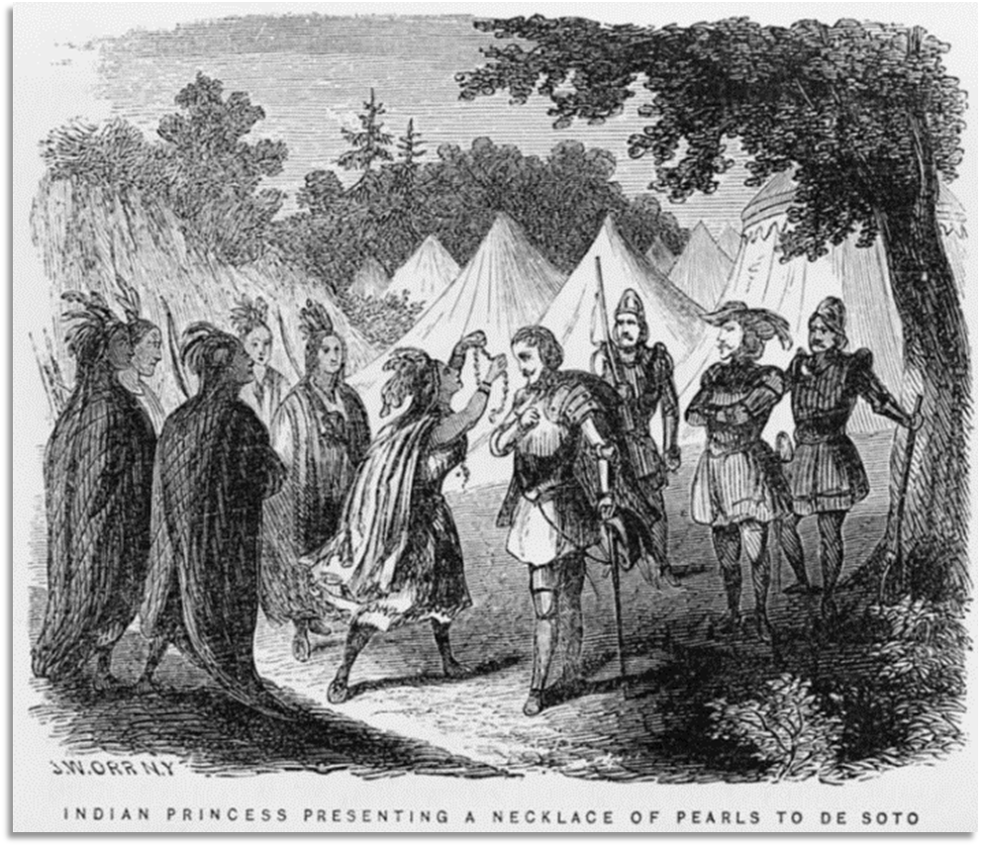

Part II: Essential Ideas Reading Passage
Before you read the passage:
Read each statement here.
Predict whether the answer will be TRUE (T) or FALSE (F)
Write T or F in the pre-reading prediction box

Essential Ideas Reading

Image to accompany paragraph 1
1. Circle or highlight key words
2. Three-word summary in the margin
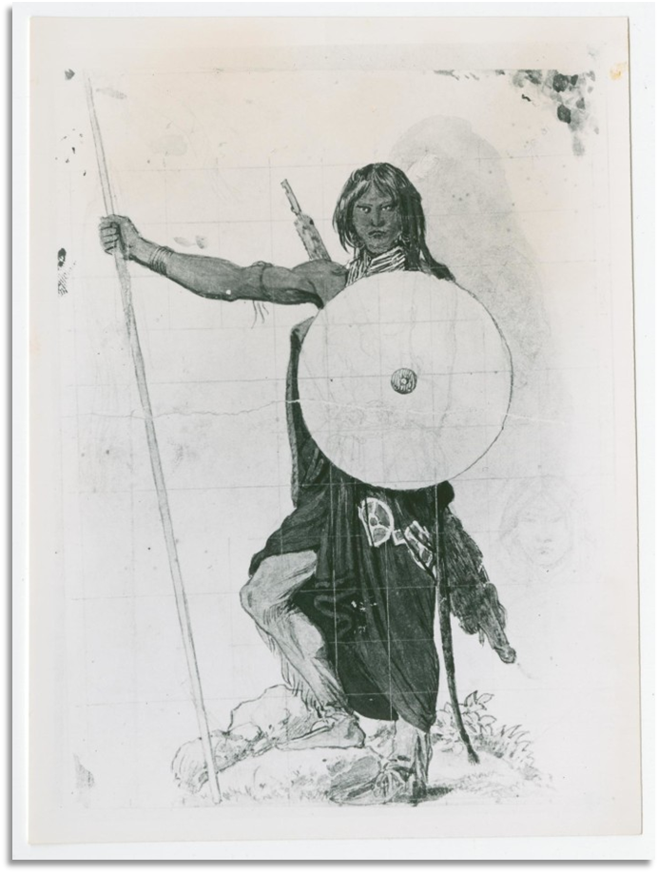
Drawing of an American Indian man with a shield and a spear.
Portal to Texas History

Essential Ideas Reading

Image to accompany paragraph 2
1. Circle or highlight key words
2. Three-word summary in the margin
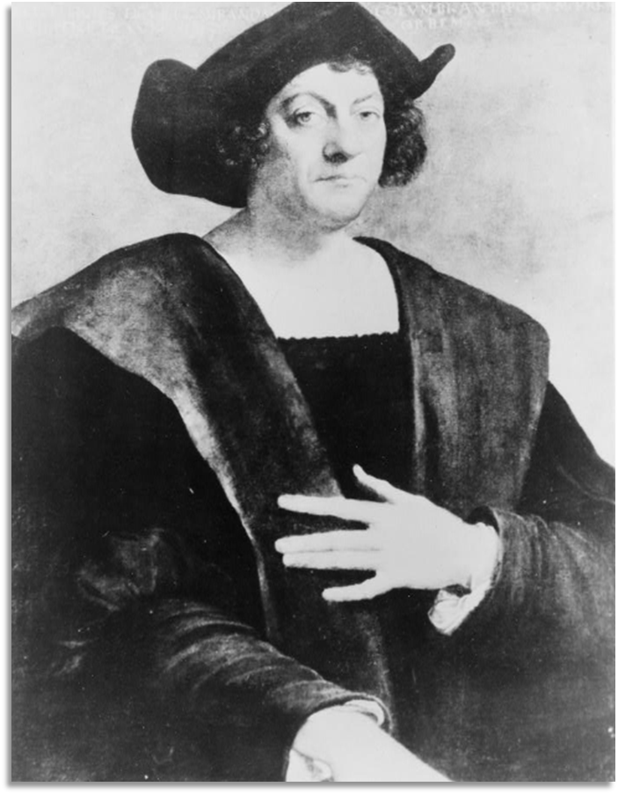
Portrait of Christopher Columbus.
Library of Congress

Essential Ideas Reading

Image to accompany paragraph 3
1. Circle or highlight key words
2. Three-word summary in the margin
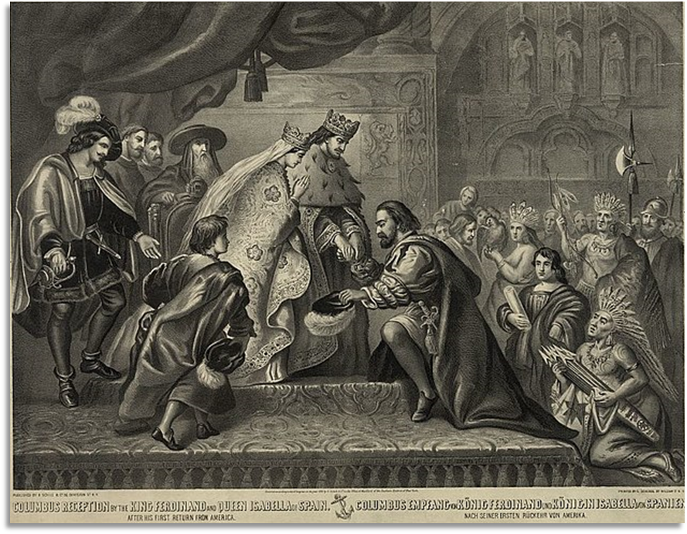
Painting of the king and queen of Spain receiving Christopher Columbus after his first voyage to America.
Library of Congress.

Essential Ideas Reading

Image to accompany paragraph 4
1. Circle or highlight key words
2. Three-word summary in the margin

Spain’s greatest goal for exploration: GOLD!

Essential Ideas Reading

Image to accompany paragraph 5
1. Circle or highlight key words
2. Three-word summary in the margin
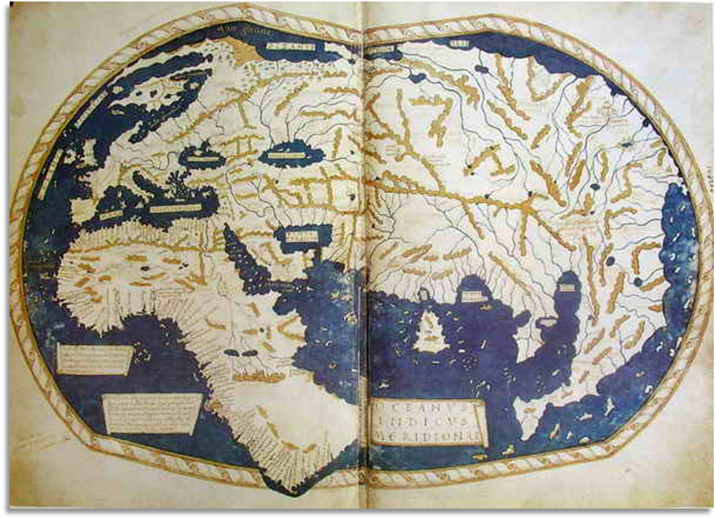
Map of the known world according to most Europeans in 1488.

Essential Ideas Reading

Image to accompany paragraph 6
1. Circle or highlight key words
2. Three-word summary in the margin
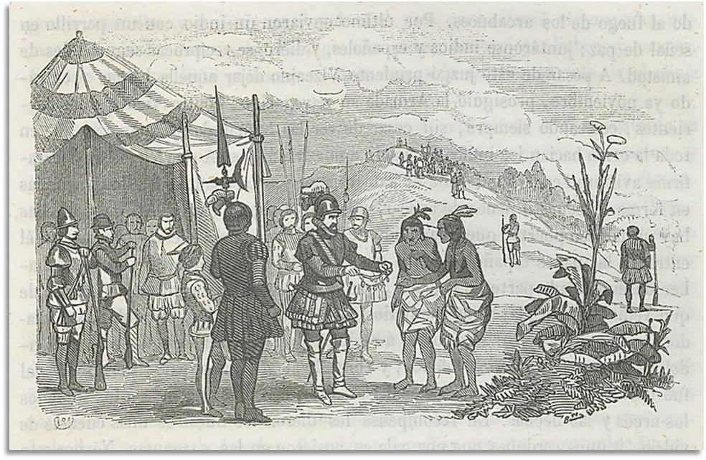
Artwork depicting the Royal Marina Hispaniola Conquistadors encountering Indigenous American people

Essential Ideas Reading

Image to accompany paragraph 7
1. Circle or highlight key words
2. Three-word summary in the margin
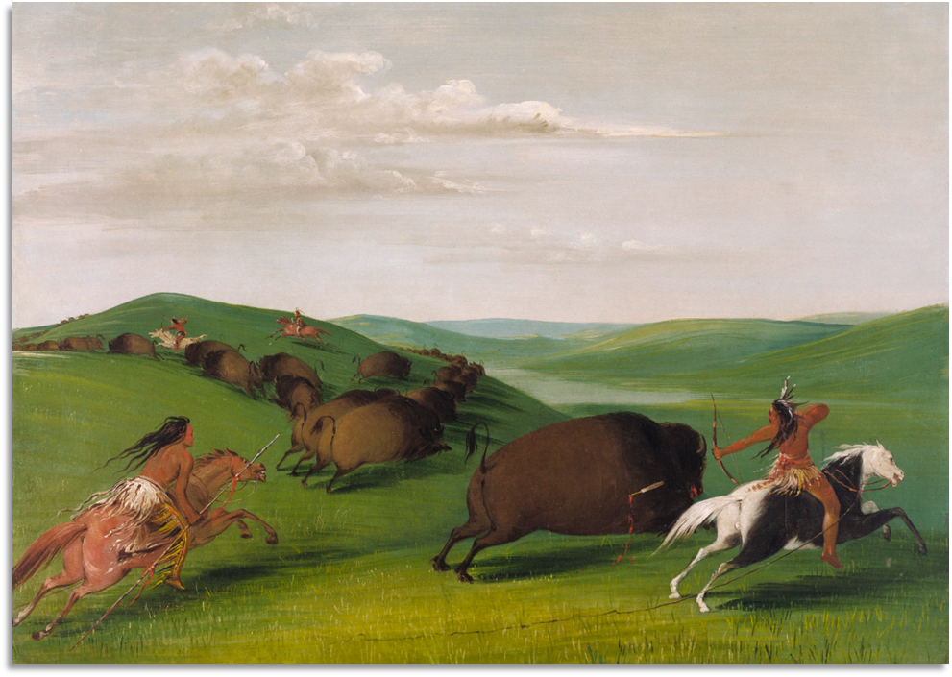
A painting showing American Indian men hunting a herd of buffalo on horseback.
Smithsonian American Art Museum.

Essential Ideas Reading

Image to accompany paragraph 8
1. Circle or highlight key words
2. Three-word summary in the margin
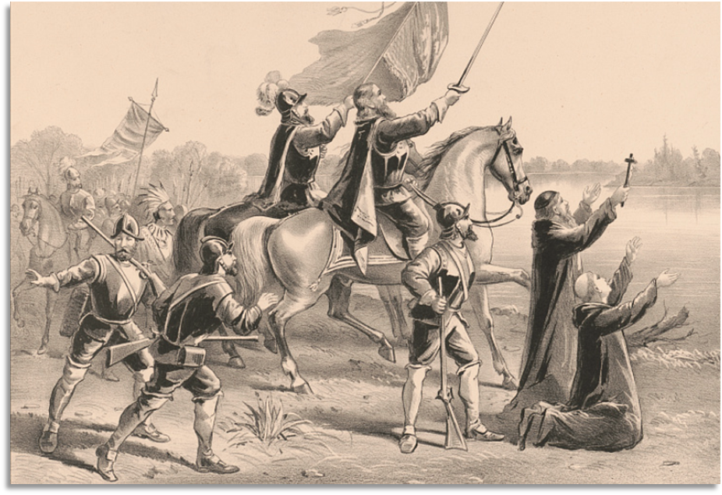
Artwork titled “The Discovery of the Mississippi by De Soto and his Followers.”
Library of Congress

Part III: Return to the Reading Guide in Part II
After you read the passage:
Re-read each statement here.
Provide the correct True / False answer.
Justification: Provide text evidence for your answer.

Exit Ticket
Based on the reading passage today, what are three things that we will learn about in Unit 2: Age of Contact.
Write in complete sentences.
Share with a partner

Share with the class 2
One thing we will learn about in Unit 2: the Age of Contact is (blank)

