The Big Picture Foundations

Unit 2: The Age of Contact

Part I: Analyze an Image

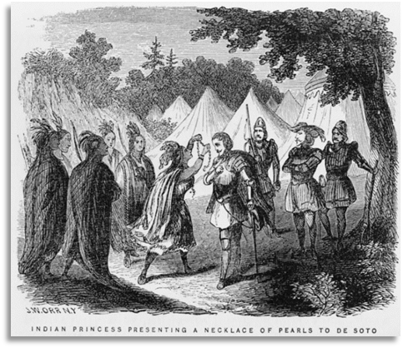
Figure 1 A painting by John William Orr. " Indian Princess presenting a necklace of pearls to De Soto." 1858. The Library of Congress.
1. Describe one thing you notice about the image.
2. Based on the image, what do you think we will learn about in this unit?
3. Who do you think the people in the image are? Circle or highlight the possibilities that you think are most likely to be correct.
American Indians
The Spanish king
Spanish conquistadors
French explorers

Part II: Essential Ideas Reading Passage

Reading Guide
Directions: Before you read, predict whether each statement is true or false. Circle a T for True and an F for false. As you read, listen for the information that relates to each question. After you read, return to this chart and give your post-reading answers. Use evidence from the passage to choose the best answer.
Pre-Reading Prediction
T / F
Post-Reading Answer
T / F
Statement
1. Christopher Columbus was searching for new continents to establish trade with.
Justification
Circle or highlight the answer that best supports each statement.
A) Columbus was searching for a water route to Asia.
B) Columbus sailing for Spain
Pre-Reading Prediction
T / F
Post-Reading Answer
T / F
Statement
2. The Spanish were the first Europeans to explore the Americas.
Justification
Circle or highlight the answer that best supports each statement.
A) Portugal explored Africa.
B) The Vikings arrived in America 500 years earlier.
Pre-Reading Prediction
T / F
Post-Reading Answer
T / F
Statement
3. Spain’s goals for exploring the world included spreading their faith and acquiring wealth.
Justification
Circle or highlight the answer that best supports each statement.
A) Spain’s goals were God, Gold, and Glory.
B) Spain wanted a water route to Asia.
Pre-Reading Prediction
T / F
Post-Reading Answer
T / F
Statement
4. Many European explorers viewed the Americas as a great opportunity to gain new resources and riches.
Justification
Circle or highlight the answer that best supports each statement.
A) Europeans wanted American land and resources.
B) Europeans brought horses, food, and disease.
Pre-Reading Prediction
T / F
Post-Reading Answer
T / F
Statement
5. Spanish exploration had very little effect on the land or people in the Americas.
Justification
Circle or highlight the answer that best supports each statement.
A) Spanish explored lands in North and South America.
B) Resources, trade, horses, and disease brought changes.

Essential Ideas Reading Passage
(1) For thousands of years, Indigenous People in the Americas lived almost entirely without any contact with people from other parts of the world. Then in 1492, the arrival of an Italian explorer named Christopher Columbus set off a chain of events that would change history forever.
(2) Columbus was not the first non-American to land in the Americas. Nearly 500 years before his expedition, a group of ancient Scandinavians known as the Vikings had established a few small settlements in North America. Though Columbus and his men were not the first non-Americans to arrive, his voyages to the Americas were the first to inspire generations of others to follow in his footsteps.
(3) Columbus was hired by the king and queen of Spain – which had just won back its independence after 800 years of occupation by the African Moors. After this victory, Spain was intent on exploring the world like several other powerful European nations had already been doing. At the time, countries like the Netherlands and Portugal were acquiring great wealth from their global exploration. Naturally, Spain wanted to get in on the action!

(4) Spain had several goals for its exploration. The Spanish wanted to gain wealth and riches, spread their religious beliefs, and achieve great accomplishments for their country. Today, we refer to these three goals as “God, Gold, and Glory.” Much like for many people throughout history, gaining wealth was Spain’s most important goal.
(5) Initially, Columbus was searching for a water route to the markets in Asia. He and his men were actually unaware that there were two entire continents blocking their way. When they landed in what is now the Caribbean, they mistakenly believed they had landed in India – even incorrectly calling the local people “Indians.” Eventually, it became clear to them that they were somewhere completely new. The Spanish were intrigued by all the possibilities that this new land presented.
(6) For the next 200 years, during the Age of Contact and the Era of Exploration, Spanish and other European explorers set off on expeditions across modern-day North and South America. They encountered many different groups of American Indians, explored lands never before seen by Europeans, and began claiming much of that land and its resources for themselves.
(7) The Age of Contact and Exploration is significant for a number of reasons. First, Spain became a wealthy country by seizing resources like gold and silver from the Americas. They established plantations which grew cash crops like sugar using enslaved American Indian laborers. Additionally, trade between the people of the Americas and Europe began the transfer of new plants, animals, and food between the continents. Tragically, it also brought new diseases that were incredibly deadly to the Indigenous people of the Americas. Finally, when American Indians gained access to Spanish horses, life changed dramatically for many tribes across America.
(8) In this unit, we will identify the people, events, and characteristics of Spanish exploration in the Americas. We will evaluate Spain’s success in achieving its goals of “God, Gold, and Glory” by studying individual Spanish explorers. We will examine the relationship between the Spanish and the American Indians they encountered. We will identify the significance of this era in history, especially as it relates to Texas.

Part III: Return to your Reading Guide from Part II and complete the final step.

