The Big Picture Advanced
Unit 2: The Age of Contact

Name: |  | Date: |  | Period:

Part I: Analyze an Image

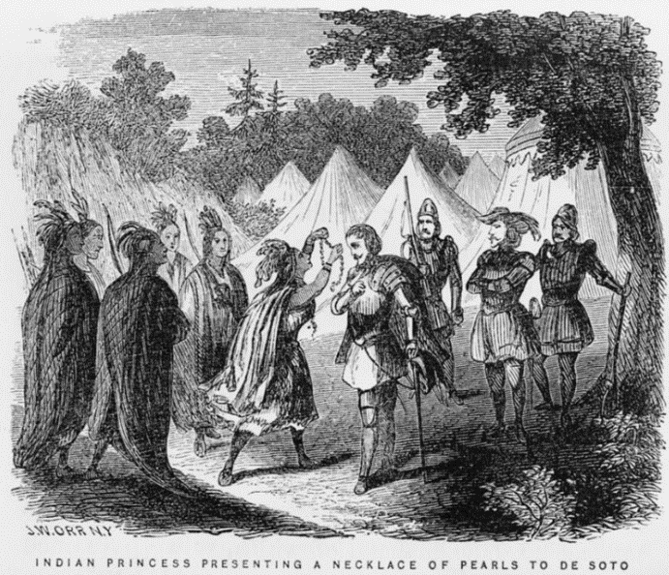
Figure 1 A painting by John William Orr. " Indian Princess presenting a necklace of pearls to De Soto." 1858. The Library of Congress.
- Describe three things you notice about the image.

- Based on the image, what do you think we will learn about in this unit?

- Who do you think the people in the image are?

- Do you think there is any bias from the artist evident in this image? Explain your answer.

Part II: Essential Ideas Reading Passage

Reading Guide

Directions: Before you read, predict whether each statement is true or false. Write a T for True and an F for false. As you read, listen for the information that relates to each question. After you read, return to this chart and give your post-reading answers. Use evidence from the passage to justify, or support, your answers.

Pre-Reading Prediction | Post-Reading Answer | Statement | Justification  Provide evidence to support your answer
 |  | - Christopher Columbus was searching for new continents to establish trade with.
 |  | - The Spanish were the first Europeans to explore the Americas.
 |  | - Spain’s goals for exploring the world included acquiring wealth and spreading their faith.
 |  | - Many European explorers viewed the Americas as a great opportunity to gain new resources and riches.
 |  | - Spanish exploration had very little effect on the land or people in the Americas.

Essential Ideas Reading Passage Note: each paragraph is numbered.

(1) For thousands of years, Indigenous People in the Americas lived almost entirely without any contact with people from other parts of the world. Then in 1492, the arrival of an Italian explorer named Christopher Columbus set off a chain of events that would change history forever.
(2) Columbus was not the first non-American to land in the Americas. Nearly 500 years before his expedition, a group of ancient Scandinavians known as the Vikings had established a few small settlements in North America. Though Columbus and his men were not the first non-Americans to arrive, his voyages to the Americas were the first to inspire generations of others to follow in his footsteps.

(3) Columbus was hired by the king and queen of Spain – which had just won back its independence after 800 years of occupation by the African Moors. After this victory, Spain was intent on exploring the world like several other powerful European nations had already been doing. At the time, countries like the Netherlands and Portugal were acquiring great wealth from their global exploration. Naturally, Spain wanted to get in on the action!

(4) Spain had several goals for its exploration. The Spanish wanted to gain wealth and riches, spread their religious beliefs, and achieve great accomplishments for their country. Today, we refer to these three goals as “God, Gold, and Glory.” Much like for many people throughout history, gaining wealth was Spain’s most important goal.

(5) Initially, Columbus was searching for a water route to the markets in Asia. He and his men were actually unaware that there were two entire continents blocking their way. When they landed in what is now the Caribbean, they mistakenly believed they had landed in India – even incorrectly calling the local people “Indians.” Eventually, it became clear to them that they were somewhere completely new. The Spanish were intrigued by all the possibilities that this new land presented.

(6) For the next 200 years, during the Age of Contact and the era of Exploration, Spanish and other European explorers set off on expeditions across modern-day North and South America. They encountered many different groups of American Indians, explored lands never before seen by Europeans, and began claiming much of that land and its resources for themselves.

(7) The Age of Contact and Exploration is significant for a number of reasons. First, Spain became wealthy by seizing resources like gold and silver from the Americas. The Spanish established plantations which grew cash crops like sugar using enslaved American Indian laborers. Additionally, trade between the people of the Americas and Europe began the transfer of new plants, animals, and food between the continents. Tragically, it also brought new diseases that were incredibly deadly to the Indigenous people of the Americas. Finally, when American Indians gained access to Spanish horses, life changed dramatically for many tribes across America.
(8) In this unit, we will identify the people, events, and characteristics of Spanish exploration in the Americas. We will evaluate Spain’s success in achieving its goals of “God, Gold, and Glory” by studying individual Spanish explorers. We will examine the relationship between the Spanish and the American Indians they encountered. We will identify the significance of this era in history, especially as it relates to Texas.

Part III: Return to your Reading Guide from Part II to complete the post-reading questions.
Part IV: Comprehension Questions
- The Vikings landed in the Americas hundreds of years before Columbus, so why is his arrival in America typically considered more historically significant?

- Circle or highlight all of the boxes below that demonstrate an effect of the Age of Contact, according to the reading passage.

New trade between continents is initiated. | Spain became wealthy and powerful. | Spain is conquered by the African Moors for 800 years.
Spanish horses change life drastically for American Indians. | There is increased interest in Asian markets. | European diseases were incredibly deadly to American Indians.

- What was Spain’s biggest goal or motivation for exploring the Americas?

- Which answer provides the best summary of Unit 2: The Age of Contact?
  - The Spanish hoped to spread their religion to Indigenous people of America, gain wealth, and bring glory to themselves and their country.
  - The Spanish began exploring the Americas in pursuit of wealth and resources and brought about significant changes for Europe.
  - Europeans discovered North and South America as part of their search for routes to markets in Asia.
  - Europeans raced to gain the most land, wealth, and resources in the Americas.

Bias: When someone’s personal point of view influences how they present information.

