God, Gold, and Glory Advanced

Unit 2: Age of Contact
Alonso Álvarez de Pineda
Key Information: (blank)
Essential Question – Your Response: (blank)
Significance: (blank)
Image of Pineda’s Map
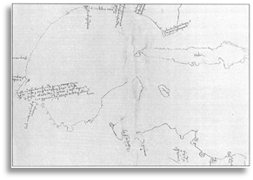
Hernán Cortés
Key Information: (blank)
Essential Question – Your Response: (blank)
Significance: (blank)
Label the Map of Cortés’ Expedition
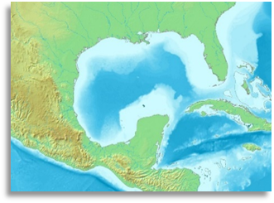
Cabeza de Vaca
Key Information: (blank)
Essential Question – Your Response: (blank)
Significance: (blank)
Trace Cabeza de Vaca’s route through TX
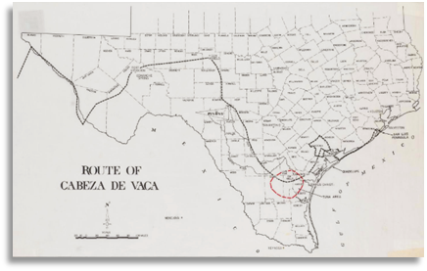
Francisco Vázquez de Coronado
Key Information: (blank)
Essential Question – Your Response: (blank)
Significance: (blank)
Map of Coronado’s Route through the Southwest
