The Search for Gold: Foundations

Unit 2: Age of Contact
Alonso Álvarez de Pineda
Key Information:
- (blank)
- Created the 1st known (blank) of the (blank)
Essential Question – Your Response:
Without modern technology like GPS, I think Pineda made his map by (blank)
Significance:
Provides more information about the (blank) of the Americas.
Image of Pineda’s Map
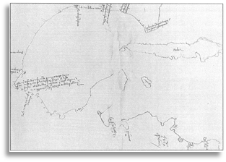
Hernán Cortés
Key Information:
- Conquered the (blank) – 1519
- Established (blank)
- Claimed the land for Spain: “(blank) (blank)”
Essential Question – Your Response:
Cortés was / was not successful at accomplishing Spain’s primary goal for exploration because (blank) (blank) (blank)
Significance:
Aztec gold made Cortés and (blank) wealthy. Other conquistadors want the same (blank)
Label the Map of Cortés’ Expedition
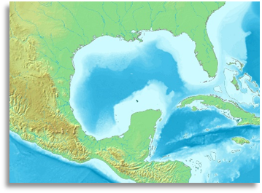
Cabeza de Vaca
Key Information:
- Lost from Florida to (blank)
- Lived with (blank) for 8 years
- Explored and escaped to (blank)
Essential Question – Your Response:
I think / I don’t think it was reasonable for the conquistadors to believe there were “Cities of Gold” in Texas because (blank) (blank) (blank) (blank)
Significance:
Cabeza de Vaca’s claims of (blank) (blank) inspired more conquistadors to explore (blank)
Trace Cabeza de Vaca’s route through TX
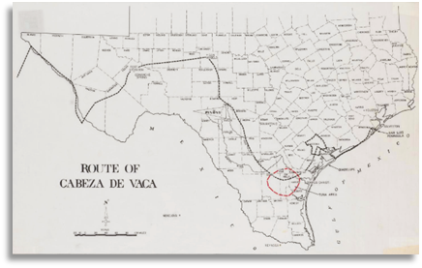
Francisco Vázquez de Coronado
Key Information:
- Explored the American southwest in search of (blank)
- 1st European to see the (blank)
Essential Question – Your Response:
One possible reasons an American Indian might lead the Spanish in search of gold is (blank) (blank) (blank) (blank)
Significance:
His expedition was considered a (blank) because of he found no (blank)
Map of Coronado’s Route through the Southwest
