The Search for Gold: Grade Level

Unit 2: Age of Contact
Alonso Álvarez de Pineda
Key Information: (blank)
Essential Question – Your Response: (blank)
Without modern technology like GPS, I think Pineda made his map by (blank) (blank) (blank)
Significance: (blank)
Image of Pineda’s Map
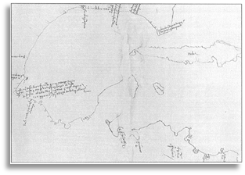
Hernán Cortés
Key Information: (blank)
Essential Question – Your Response: (blank)
Cortés was / was not successful at accomplishing Spain’s primary goal for exploration because (blank) (blank) (blank)
Significance: (blank)
Label the Map of Cortés’ Expedition
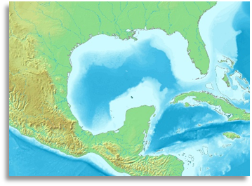
Cabeza de Vaca
Key Information: (blank)
Essential Question – Your Response: (blank)
I think / I don’t think it was reasonable for the conquistadors to believe there were “Cities of Gold” in Texas because (blank) (blank) (blank) (blank)
Significance: (blank)
Trace Cabeza de Vaca’s route through TX
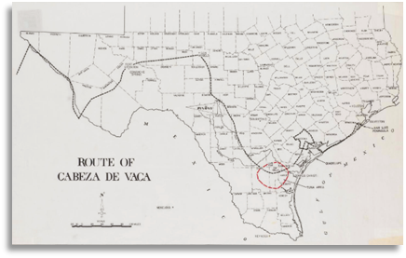
Francisco Vázquez de Coronado
Key Information: (blank)
Essential Question – Your Response: (blank)
One possible reason an American Indian might lead the Spanish in search of gold is (blank) (blank) (blank) (blank)
Significance: (blank)
Map of Coronado’s Route through the Southwest
