Unit 2:
Age of Contact

Lesson 7:

The Search for Gold

Guided Notes

Day 2
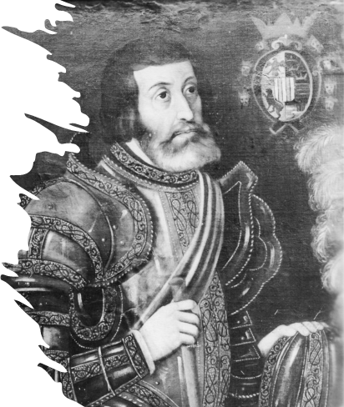
Hernán Cortés

Warm-up
Follow the directions to complete your warm-up
Consider items that help you travel today compared to in the 1400s
Write your response on your warm-up.
Discuss with a partner

Share with the class
An item that helps people travel today is (blank), while an item that might have helped people travel in the 1400s was (blank).

Share with the class 2
An item they would not have had access to in the 1400s is (blank). This could have made travel more difficult because (blank).

Essential Question
What were some of the difficulties of the first Spanish explorers in the Americas, and were they successful at achieving their goals?

In today’s lesson…
1. We will examine four of the first significant Spanish explorers to the Americas. We will be able to explain their significance in history and if they were success at achieving their goals.
2. I will complete my guided note-taking chart including writing key information, the significance of each topic, and responding to an essential question about each topic.

Alonso Álvarez de Pineda
When the Spanish conquistadors first began exploring North and South America, one of the biggest obstacles they faced was that they had no idea where they were going or what they might find in these new lands.
In 1519, a man named Álonso Alvarez de Pineda helped overcome this obstacle in one part of the Americas by creating the first known map of the Gulf of Mexico.
Explorers who came after him would have a better point of reference, and at least some knowledge of where they were headed and what they might find there as a result.
Key Information
- 1519
- Created the 1st known map of the Gulf of Mexico
Significance
Provides more information about the geography of the Americas
Essential Question
Without modern technology like GPS, how do you think Pineda made his map?

How does Pineda’s map on the left compare with the actual geography of the coast?
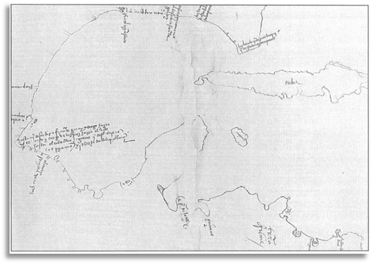
Pineda’s Map
The Portal to Texas History
University of North Texas
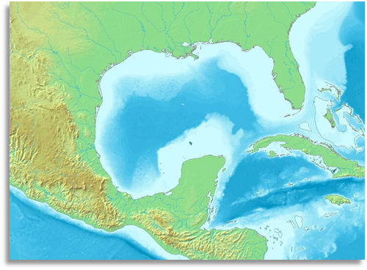
Contemporary map of the Gulf of Mexico

Hernán Cortés
In 1519, a Spanish conquistador named Hernán Cortés traveled with more than 800 other conquistadors to what is now Mexico. There was a large American Indian civilization called the Aztecs who ruled much of the region.
The Aztecs were often viewed as cruel and oppressive by the people they had conquered. For this reason, thousands of American Indians in the region worked with Cortés to defeat the Aztecs and conquer their capital city of Tenochtitlan.
By 1821, Cortés and his men had taken control of Tenochtitlan, seizing enormous wealth and gold from the Aztecs. Cortés established a new city in place of Tenochtitlan – Mexico City. He claimed the region for Spain, calling it “New Spain.”
Key Information
- Cortés conquered the Aztecs – 1519
- Established Mexico City
- Claimed the land for Spain: “New Spain”
Significance
Aztec gold made Cortés and Spain wealthy. Other conquistadors want the same success.
Essential Question
Was Cortés successful accomplishing Spain’s primary goal for exploration? Explain.

Map of Cortés’ Expedition
1519
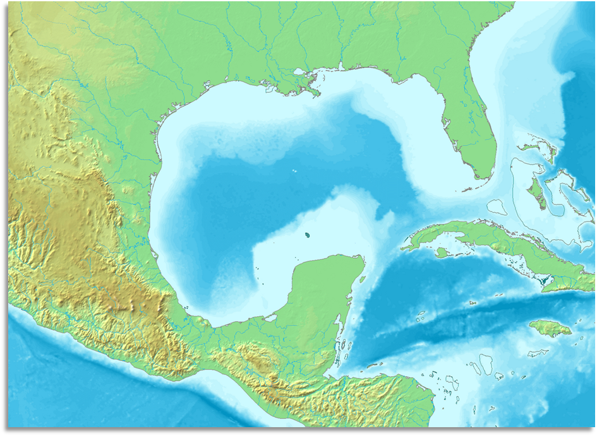
Tenochtitlan
Present-day Texas
Gulf of Mexico
Present-day Mexico
Aztec Empire

Present-day Florida

Cortés’ Route

1521
Present-day Florida
Cortés’ Route
Mexico City
Present-day Texas
Gulf of Mexico
Present-day Mexico
New Spain
What significant differences do you observe between the two maps? What caused these changes?

Cabeza de Vaca
In 1528, another group of conquistadors set sail for Mexico City, hoping to follow in Cortés’ footsteps. They became lost almost immediately, landing in Florida rather than New Spain. They quickly found themselves stranded and starving in Florida.
They made rafts, hoping to sail south to other Spanish settlements. Instead, the few survivors including de Vaca, and an African man called Estevanico, eventually landed in Texas. Over the course of the next eight years, Cabeza de Vaca and Estevanico lived among various Texas Indian tribes, even at times being held captive.
Cabeza de Vaca and Estevanico eventually escaped and made it to Mexico City in 1536. He wrote a book called La Relación about his time as the first European explorer in Texas. In it, he included tales of Cíbola: the seven cities of gold.
Key Information
- Lost from Florida to Texas.
- Lived with Texas Indians for 8 years
- Explored and escaped to Mexico City
Significance
Cabeza de Vaca’s claims of cities of gold inspired more conquistadors to explore Texas.
Essential Question
Do you think it was reasonable for the conquistadors to believe there were “Cities of Gold” in Texas? Why or why not?

Cabeza de Vaca’s Approximate Route through Texas, 1528 – 1536
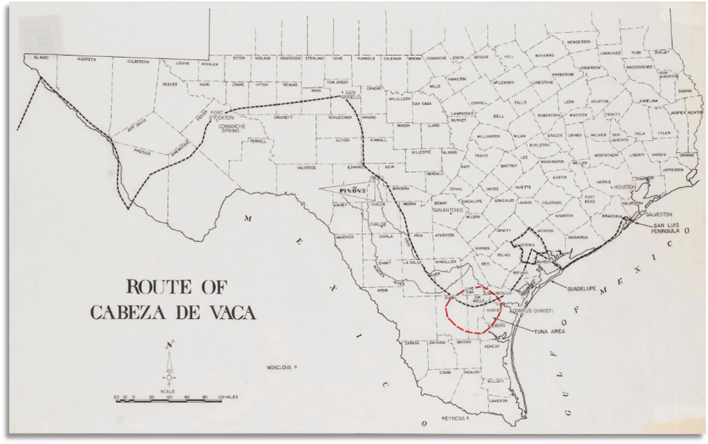
The Route of Cabeza de Vaca
The Portal to Texas History, University of North Texas

Francisco Vázquez de Coronado
Francisco Vázquez de Coronado was a wealthy governor of a province of New Spain. In 1540, he set out in search of Cíbola, or “the seven cities of gold” that Cabeza de Vaca had written about in his book.
He made the journey with three hundred other Spaniards, approximately 1000 American Indians, and various livestock. He and his men searched for two years. They encountered numerous American Indian tribes including the Tigua and the Zuni Pueblo people. He is credited as the first European to explore the American southwest and to see the Grand Canyon.
During his expedition, an American Indian, who the conquistadors referred to as “The Turk,” led Coronado and his men on their quest for gold. When Coronado ultimately failed to find any gold, he had “The Turk” executed. He eventually returned to New Spain, having failed to find any gold north of Mexico.
Key Information
- Explored the American southwest in search of gold.
- First European to see the Grand Canyon.
Significance
His expedition was considered a failure because he found no gold.
Essential Question
What are some possible reasons an American Indian might lead the Spanish in search of gold?

Map of Coronado’s Route, 1540 – 1542
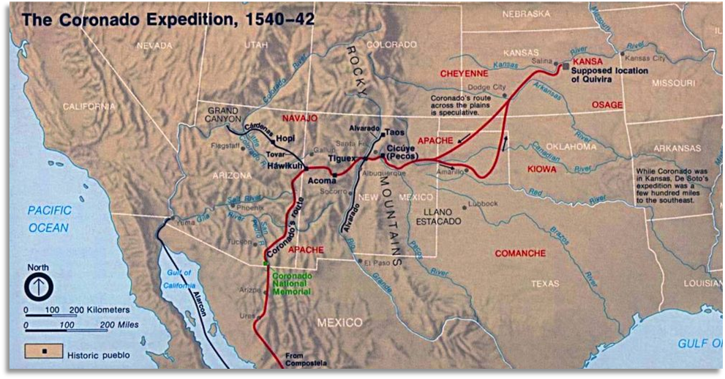

Exit Ticket
Follow the directions to complete your warm-up
Consider the significant effect of three of the events we discussed in class today.
Write your response on your warm-up.
Discuss with a partner

Share with the class 3
One effect of Pineda’s map of the Gulf of Mexico is (blank).
One effect of Cortez conquering the Aztecs is (blank).
One effect of Cabeza de Vaca’s claims of a city of gold is (blank)

