God, Gold, and Glory Advanced
Unit 2: Age of Contact

Name: |  | Date: |  | Period:

Alonso Álvarez de Pineda

Key Information: | Significance:
Essential Question – Your Response: | Image of Pineda’s Map  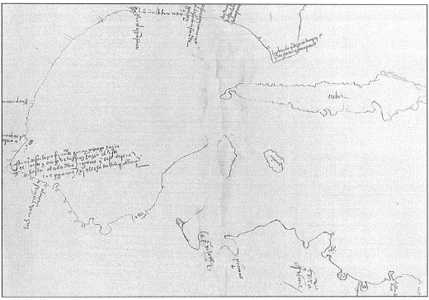

Hernán Cortés

Key Information: | Significance:
Essential Question – Your Response: | Label the Map of Cortés’ Expedition  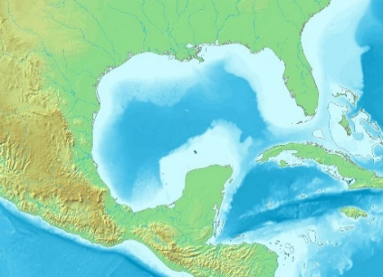

Cabeza de Vaca

Key Information: | Significance:
Essential Question – Your Response: | Trace Cabeza de Vaca’s route through TX  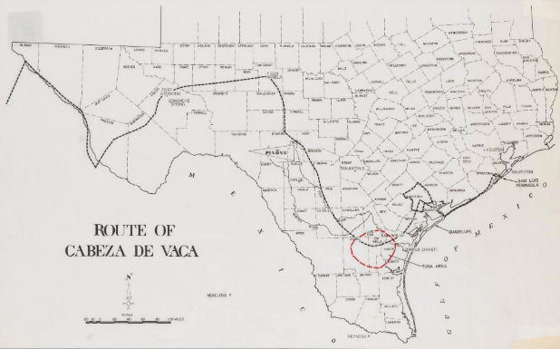

Francisco Vázquez de Coronado

Key Information: | Significance:
Essential Question – Your Response: | Map of Coronado’s Route through the Southwest  