The Search for Gold: Foundations
Unit 2: Age of Contact

Name: |  | Date: |  | Period:

Alonso Álvarez de Pineda

Key Information:  - ______________  - Created the 1st known ___________ of the ___________________________ | Significance:  Provides more information about the __________________________ of the Americas.
Essential Question – Your Response:  Without modern technology like GPS, I think Pineda made his map by _____________ ________________________________________________ ________________________________________________ | Image of Pineda’s Map  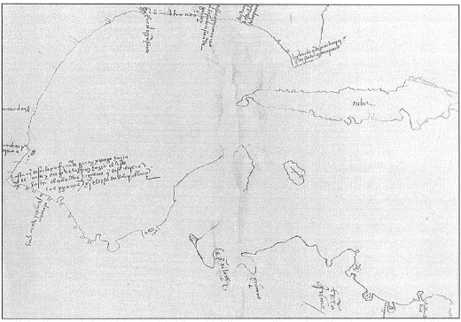

Hernán Cortés

Key Information:  - Conquered the _____________ – 1519  - Established ___________________________  - Claimed the land for Spain: “________ _____________________” | Significance:  Aztec gold made Cortés and _________________ wealthy. Other conquistadors want the same ____________________________.
Essential Question – Your Response:  Cortés was / was not successful at accomplishing Spain’s primary goal for exploration because _________________________ _________________________________________________ _________________________________________________ | Label the Map of Cortés’ Expedition  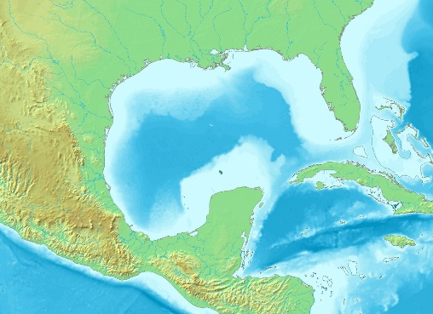

Cabeza de Vaca

Key Information:  - Lost from Florida to ________________.  - Lived with ___________________________ for 8 years  - Explored and escaped to ______________________________________ | Significance:  Cabeza de Vaca’s claims of __________________ ________________ inspired more conquistadors to explore ______________________
Essential Question – Your Response:  I think / I don’t think it was reasonable for the conquistadors to believe there were “Cities of Gold” in Texas because ___________ __________________________________________________ __________________________________________________ _________________________________________________ | Trace Cabeza de Vaca’s route through TX  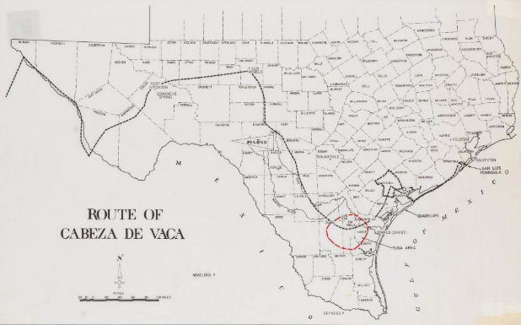

Francisco Vázquez de Coronado

Key Information:  - Explored the American southwest in search of _________.  - 1st European to see the _________________________________ | Significance:  His expedition was considered a __________________ because of he found no ___________________.
Essential Question – Your Response:  One possible reasons an American Indian might lead the Spanish in search of gold is _______________________ __________________________________________ __________________________________________  __________________________________________ | Map of Coronado’s Route through the Southwest  