The Search for Gold: Grade Level
Unit 2: Age of Contact

Name: |  | Date: |  | Period:

Alonso Álvarez de Pineda

Key Information: | Significance:
Essential Question – Your Response:  Without modern technology like GPS, I think Pineda made his map by _____________ ________________________________________________ ________________________________________________ | Image of Pineda’s Map  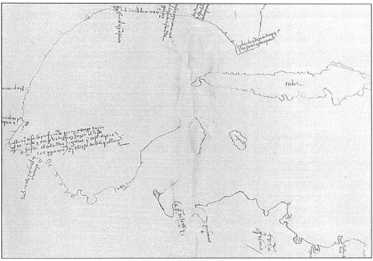

Hernán Cortés

Key Information: | Significance:
Essential Question – Your Response:  Cortés was / was not successful at accomplishing Spain’s primary goal for exploration because _________________________ _________________________________________________ _________________________________________________ | Label the Map of Cortés’ Expedition  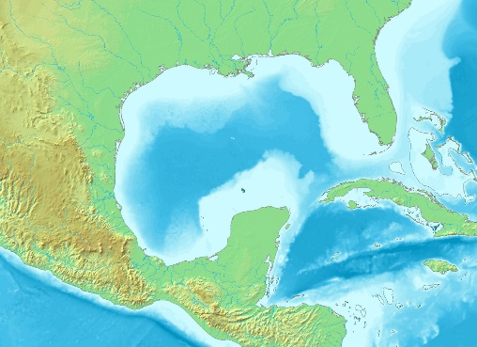

Cabeza de Vaca

Key Information: | Significance:
Essential Question – Your Response:  I think / I don’t think it was reasonable for the conquistadors to believe there were “Cities of Gold” in Texas because ___________ __________________________________________________ __________________________________________________ _________________________________________________ | Trace Cabeza de Vaca’s route through TX  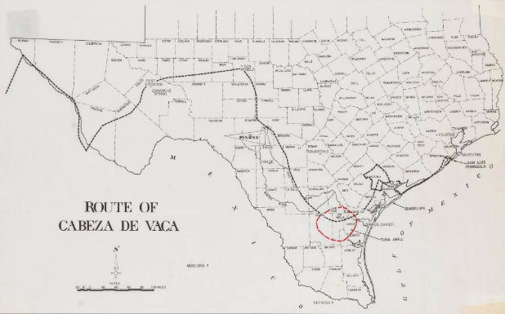

Francisco Vázquez de Coronado

Key Information: | Significance:
Essential Question – Your Response:  One possible reasons an American Indian might lead the Spanish in search of gold is _______________________ __________________________________________ __________________________________________  __________________________________________ | Map of Coronado’s Route through the Southwest  