Unit 2:

Age of Contact

Lesson 3:

Vocabulary
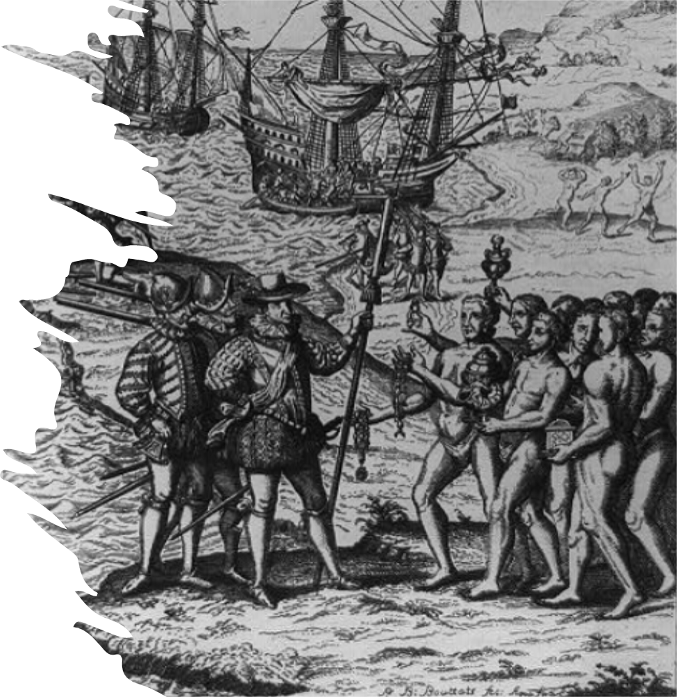

Warm-up
Follow the directions to complete your warm-up
What have you learned about our unit so far?
What kinds of vocabulary terms do you think we will see in this unit?
Write your response on your warm-up.
Discuss with a partner

Share with the class
One word or phrase I think we might learn about in this unit is (blank).

Essential Question
What key words and phrases do we need to know within the context of our unit to be successful?

In today’s lesson…

Day 1
1. We will identify the significant words and phrases that are connected to the major themes of our unit.
2. I will define, exemplify, and provide a visual representation of each vocabulary term.

Era (n.)
Studying history can be difficult for us today because there is so much of it! People have been recording their activities for thousands of years.
One thing we do to help us better understand the past is to divide it into different eras, or periods of time that share similar characteristics.
When Spanish explorers arrived in the Americas, it began a period of new trade routes, new encounters between different cultural groups, new achievements, and new problems. This era is often referred to as the Age of Contact.
The Age of Contact is an era of historical changes brought about primarily because of European exploration and contact between European explorers and American Indians.
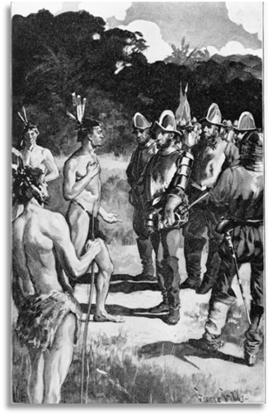
A painting of the Spanish explorer Hernando de Soto with the American Indian, Vitachuco.
Library of Congress.

Exploration (n.)
One characteristic of the Age of Contact is Spain’s continued desire to explore the Americas. Exploration is traveling in order to discover new places, people, or resources.
When the Spanish arrived in the Americas, the land was totally unknown to them. Many European explorers called the Americas “The New World” because they had never even heard of it before Christopher Columbus landed in the Caribbean in 1492.
Spanish exploration was driven by the desire to spread their religion, bring glory to their country, and most of all, to gain wealth and resources from the new lands they explored.
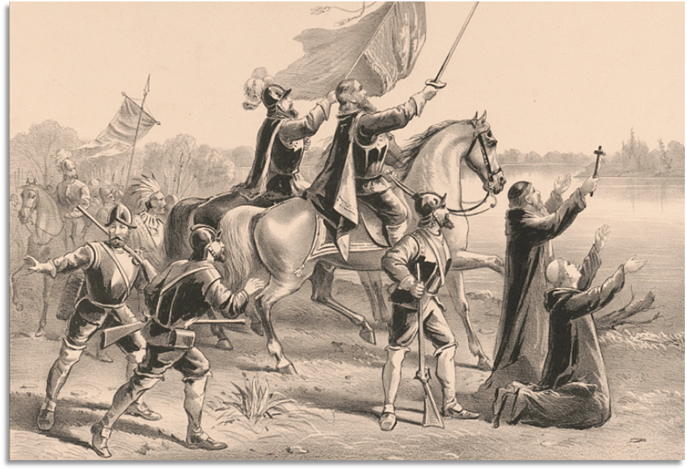
A painting depicting Spanish explorers reaching the Mississippi River.
Library of Congress

Expedition (n.)
The Spanish explorers arriving in “The New World” undertook* many expeditions as they searched the Americas for wealth and resources.
An expedition is a journey undertaken* by a group of people, especially a journey with a purpose like exploration, research, or war.
The Spanish carried out expeditions throughout North and South America. In modern-day Mexico and South America, they gained a lot of wealth from gold and other resources that they typically seized* from the Indigenous people. These discoveries made Spain rich and drove the Spanish to continue their expeditions to new areas like Texas.
Undertake: to carry out
Seize: Take by force
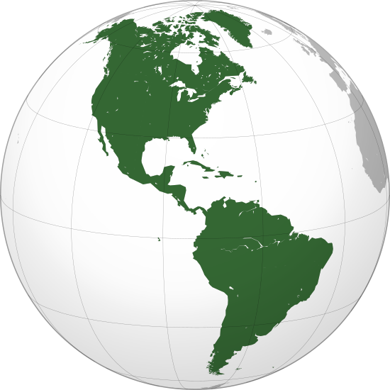

Columbian Exchange (n.)
Before Christopher Columbus’ unexpected arrival in the Americas, there had been almost no contact between the western and eastern hemispheres in history. There were plants, animals, and food available in the Americas that Europeans had never seen before, and vice versa.
During the Age of Contact, a system of trade began between the Americas in the west, and Europe in the East. This was known as the Columbian Exchange, because the trade that occurred began after Columbus’ journeys to the Caribbean.
While the Columbian Exchange was beneficial in bringing new items to people on both sides of the Atlantic Ocean, the Spanish also unknowingly brought something else with them: diseases. European diseases were deadly to American Indian populations, who had never encountered these diseases before.
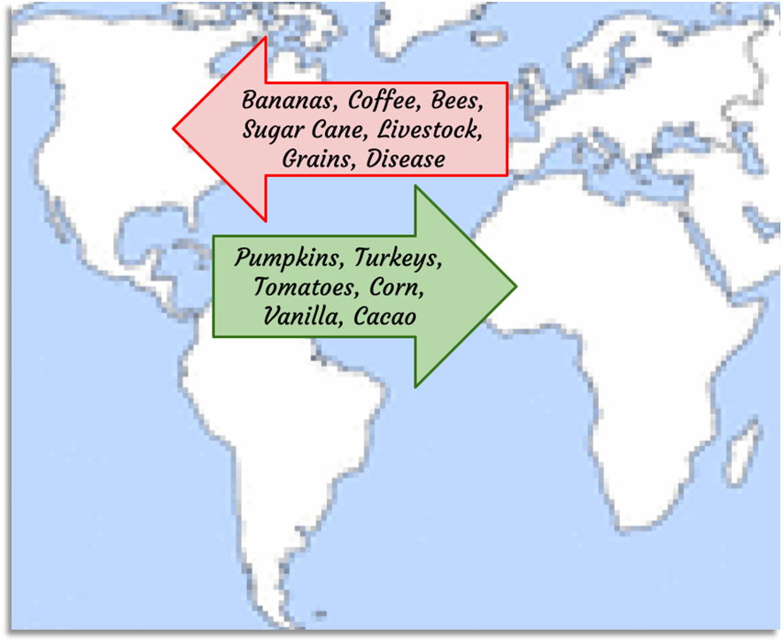
A Map of the Columbian Exchange

Conquistador (n.)
The Spanish explorers who undertook expeditions in the Americas often had limited opportunities back home in Spain. They traveled to “the New World” primarily in search of riches.
Many of these Spanish men not only explored the Americas, but also claimed the land and took control of the Indigenous people they encountered through violence. For these reasons, they are called conquistadors, or conquerors.
The conquistadors led expeditions across the Americas, conquering different Indigenous groups like the Inca people of South America and the Aztecs of present-day Mexico. In both cases, they seized enormous amounts of gold and resources from the Indigenous people, making themselves and Spain very rich. The conquistadors would continue north into Texas, hoping to find wealth and resources there also.
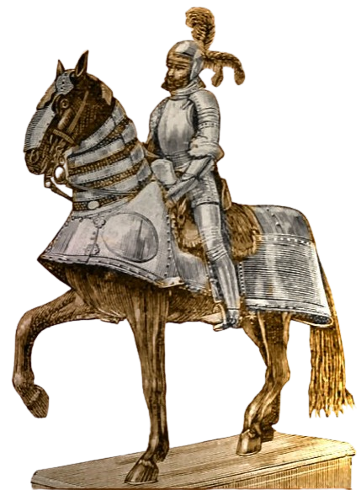
A depiction of a conquistador named Hernan Cortes, who conquered the Aztecs.

Colonization (n.)
When the Spanish conquistadors led their expeditions throughout the Americas in search of wealth and resources, they didn’t always return home to Spain afterward. Many stayed in the lands they had explored. They claimed control of the land, the resources, and the Indigenous people in the name of Spain. This is known as colonization.
The Spanish colonized places in the Americas where they had the most success locating and seizing resources. For example, a Spanish explorer named Hernán Cortés and his men colonized present-day Mexico when they conquered the Aztec people. He established Mexico City where the Aztec capital of Tenochtitlan had been.
Colonizing land in the Americas was part of Spain’s goals of “God, Gold, and Glory.” They intended to spread their religion to the American Indians, bring glory to Spain, and most importantly of all, gain vast amounts of wealth.


Areas of Spanish colonization in the Americas

Viceroy (n.)
When Spain colonized lands in the Americas, the Spanish monarchy* appointed leaders to oversee* these new colonies. The official colonial leader was, of course, the king, but he was all the way across the Atlantic Ocean. The king needed leaders living in America to oversee his colonies.
The Spanish king and his council in the Indies (the islands that are now known as the Caribbean) appointed* viceroys, or governors, to oversee these colonies.
Spanish viceroys had many responsibilities while governing their colonies. They collected taxes, enforced laws, and were in charge of converting the American Indians to the Spanish religion – Catholicism.
*Monarchy: Government with a king or queen
*Oversee: Be in charge of
*Appointed: Officially chosen
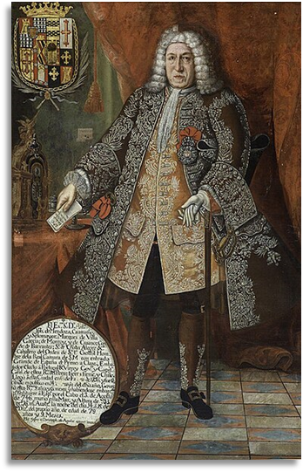
Antonio de Mendoza, Viceroy of Mexico City, National Museum of Archaeology, Anthropology, and History of Peru

Plantation (n.)
Although the Spanish had three goals for exploration and colonization of the Americas – God, Gold, and Glory – they were most focused on gold.
Spanish explorers were able to acquire gold in South America and modern-day Mexico, but that wasn’t the only way they gained wealth. Silver was also a very profitable resource. Spain established silver mines across South America and what is now Mexico as well.
Another way that Spain gained wealth from its American colonies was through plantation agriculture. Plantations are large farms that typically only grow one or two very profitable items known as cash crops. One very popular cash crop Spain grew on its plantations in the Americas was sugar cane.
Spain often forced American Indians to work on their plantations through a system of forced labor known as the Encomienda System. Forced Indigenous labor on plantations is one reason why Spain was able to grow incredibly wealthy during this era.
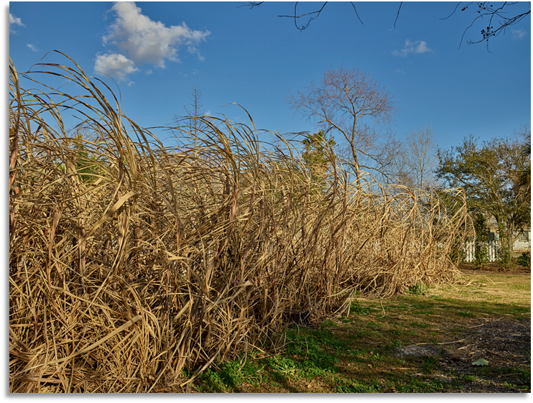
Sugarcane growing at a former plantation that is now a museum.
Library of Congress

Exit Ticket
Highlight or circle the terms in the chart that are most likely to be related to our unit themes.
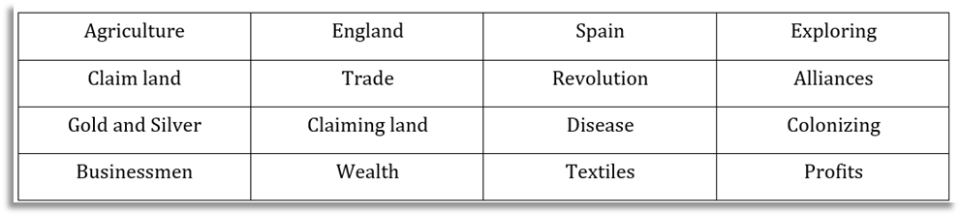
Discuss with a partner

Share with the class 2
Share one term that is related to the major themes of this unit with the class.
I think the term (blank) relates to our unit because (blank)

