|  |
| --- |
| **The Reconquista**  **732 – 1492 Advanced** |

Over 1,200 years ago, in the early 700s, an African group known as the Moors conquered Spain. At that time, Spain was not yet an official, unified country like we know it today. For almost the next 800 years, Spain was ruled by African kings and queens.

During that time, the Spanish people fought to regain control of their lands from the Moors. In the year 1492, the Spanish people finally succeeded in overthrowing Moorish rule.

Spain became unified under two Spanish rulers, King Ferdinand and Queen Isabella, who immediately started taking steps to make their kingdom wealthy and powerful.

They hired a man named Christopher Columbus to sail for the profitable markets of Asia. They promised him 10% of whatever profits he gained and leadership over the lands he claimed.

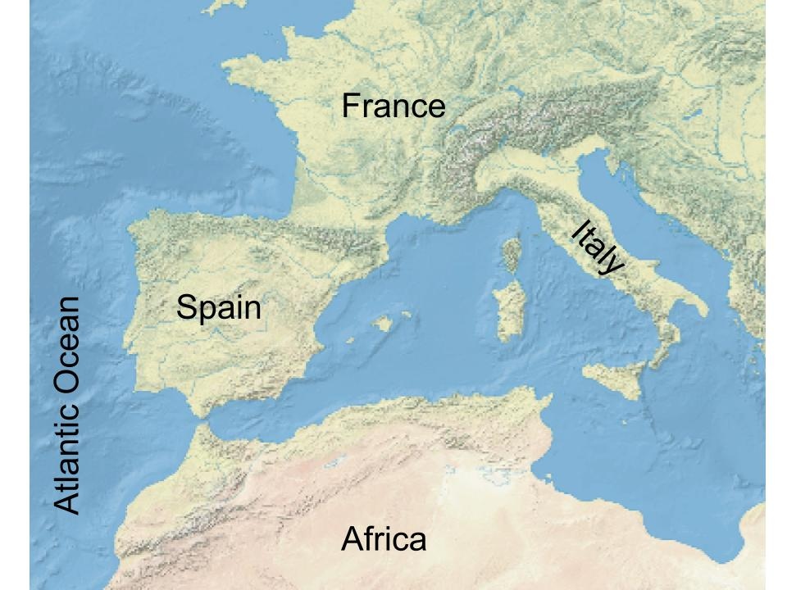

Figure 1 African Moors moved North into Europe to conquer modern-day Spain and Portugal. Like Spain, other European countries including France, and Italy were also not unified, official countries at the time.

|  |
| --- |
| **The Journeys of Christopher Columbus**  **1492 – 1504 Advanced** |

When the Spanish king and queen hired Christopher Columbus to travel to Asia for trade, he decided to travel by sea rather than go over land. Like others before him, he believed that if someone sailed west across the Atlantic Ocean, they would eventually land in Asia. He would have been right, too, if not for two unexpected continents that got in his way: North and South America.

When Columbus landed in what is now the Caribbean, he initially believed he had made it to India. He even mistakenly began calling the Indigenous people “Indians.” Eventually, he realized that he and his men were in lands that were completely new to them. What’s more, these lands seemed to promise immense wealth and resources.

Columbus’ voyage kicked off waves of other European explorers seeking wealth in the Americas for centuries. His journeys also began a system of trans-Atlantic trade known as the Columbian Exchange.

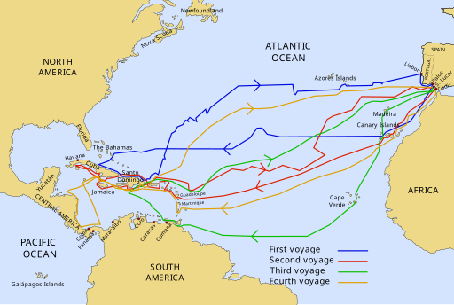

Figure 2 Columbus' four voyages to America.

|  |
| --- |
| **God, Gold, and Glory in the Americas**  **1519 – 1532 Advanced** |

The Spanish conquistadors who set off on expeditions in the Americas claimed three goals for their journeys: God, Gold, and Glory. For most conquistadors, however, there was really only one thing driving their exploration: Gold! They wanted to gain wealth and riches in these new lands.

In the beginning of the Age of Contact, several conquistadors were extraordinarily successful in this goal. In 1519, a conquistador named Hernán Cortés entered the capital city of a powerful American Indian civilization called the Aztecs. Within two years, Cortés had conquered the Aztec people, taken control of their capital city, seized incredibly large amounts of gold, and claimed the land for Spain.

About ten years later in 1532 in South America, another conquistador named Francisco Pizarro conquered a powerful American Indian civilization called the Incas. He also claimed the people, their land, and their wealth in the name of Spain. And, like Cortés, he also became wildly wealthy as a result.

Stories like those of Cortés and Pizarro gave other conquistadors hope that they could be just as successful. Many more conquistadors would set out to find their own wealth in the Americas. This included places like Texas. 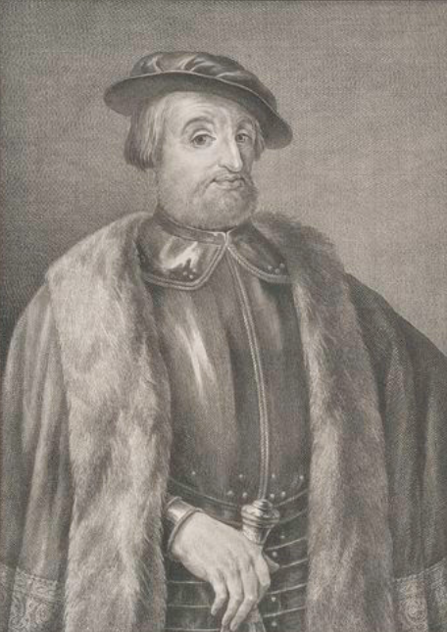

Figure 3 Hernán Cortés. The New York Public Library.

|  |
| --- |
| **Conquistadors Continue their Search for Gold**  **1528 – 1598 Advanced** |

After the success of Hernán Cortés and Francisco Pizarro, many other conquistadors tried their luck in the Americas. This time, many of them directed their attention to the lands north of modern-day Mexico. One man named Álvar Núñez Cabeza de Vaca landed in Florida, where he became lost. He then made his way to Texas, where he found himself stranded, captured, and starving for several years.

Following him, Francisco Vásquez de Coronado travelled all over the American southwest for approximately two years searching for legendary cities of gold. Hernando de Soto explored much of the American southeast from Florida to Texas before losing his life to disease on his expedition. Juan de Oñate searched the southwest and established New Mexico in the name of Spain.

Each of these men had one very important thing in common: none of them succeeded in locating gold or riches anywhere from Florida to Texas to New Mexico.

After so much success in present-day Mexico and South America, and so much failure in the lands farther north, Spain essentially gave up on the lands to the north, including Texas. The Spanish then focused their attention almost entirely on Mexico and South America for many decades.

|  |
| --- |
| **The Arrival of the French**  **1685 Advanced** |

After so many failed expeditions to the lands North of Mexico, Spain essentially gave up on places like Texas. There had been no gold there. In fact, for many conquistadors, the northern lands seemed to be filled with nothing but hardship.

Spain turned its full attention to the lands they had colonized in Mexico and South America. Gold and silver were abundant there. The Aztec and Inca people had established flourishing societies that the Spanish took control of and built upon. The Spanish called these lands “New Spain.” For the Spanish government, Texas appeared to be just a distant, unwanted frontier with little to offer.

Then, in February 1685, a French man named René-Robert Cavelier, Sieur de la Salle landed in Matagorda Bay, Texas, with 180 people.

This posed a problem for Spain. At that time, Spain and France had been enemies for much of their history. They had been engaged in wars and conflict off and on for centuries. While Spain did not think that Texas was worth much, the Spanish government certainly did not want their enemy taking it. And so, the question arose for Spain: What do we do about Texas?

A photograph of the remains of the wreckage of La Salle's ship, La Belle. 


Figure 4 A photograph of the remains of La Salle's wrecked ship, "La Belle." The ship was discovered and excavated in 1995. The Texas Historical Commission.

|  |
| --- |
| **The Significance of the Age of Contact**  **1492 – 1689 Advanced** |

The significance of the Age of Contact is not just one date or event. It is the total impact and importance – both good and bad – that the events of this era caused. When the Spanish arrived in the “New World,” the course of history changed forever.

With the arrival of the Spanish, American Indians gained access to horses, which they did not have before the Spanish arrived. Horses transformed the cultures of many tribes and changed the power relationships between tribes across the Americas.

Spanish diseases decimated Indigenous populations across two continents, killing millions of people. There was also a significant transfer of wealth and resources from American Indian communities to the Spanish government as conquistadors conquered the Americas. The Aztecs and the Incas, two of the most powerful American Indian civilizations in the history of the Americas, were defeated and colonized.

A massive system of trade was established across the Atlantic. Over time, more and more Europeans would arrive in North and South America. They claimed and colonized lands that would eventually become countries we know today, like the United States of America and Mexico. Over time, Texas would call both of these countries ‘home.’