The Reconquista

732 – 1492

Foundations
More than 1,200 years ago, in the early 700s, a group from Africa called the Moors took control of Spain. At that time, Spain was not yet one country like it is today. For almost 800 years after that, African kings and queens ruled Spain.
During this time, the Spanish people fought to get their lands back from the Moors. In 1492, they finally succeeded in defeating the Moorish rulers.
Spain then became one country under two Spanish rulers, King Ferdinand and Queen Isabella. They wanted to make their kingdom rich and powerful right away.
They hired a man named Christopher Columbus to sail to Asia. There were many valuable things to trade there. They promised Columbus a portion of whatever he earned and said he could be in charge of any new lands he found.
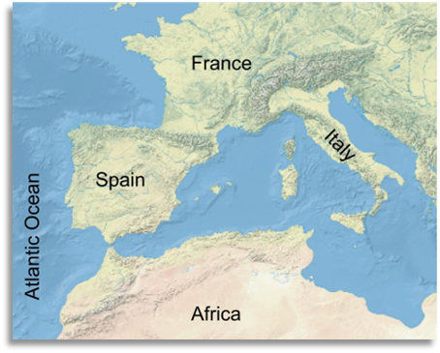
Figure 1 African Moors moved North into Europe to conquer modern-day Spain and Portugal. Like Spain, other European countries including France, and Italy were also not unified, official countries at the time.

The Journeys of Christopher Columbus

1492 – 1504

Foundations
Christopher Columbus was hired by the Spanish king and queen to travel to Asia for trade. Columbus sailed west across the Atlantic Ocean, thinking he would eventually reach Asia. He would have been right, except for two surprise continents that got in his way: North and South America.
When Columbus landed in what is now called the Caribbean, he first thought he had arrived in India. He even started calling the people there "Indians." Later, he realized that he and his men were in new lands that they had never seen before. These lands seemed to have lots of riches and resources.
Columbus’ journey started big changes. For hundreds of years after, many other European explorers came to the Americas looking for wealth. Columbus's trips also began a system of trade across the Atlantic Ocean. This trade was called the Columbian Exchange.
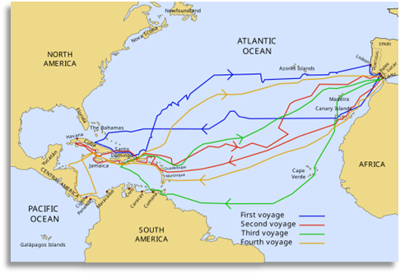
Figure 2 Columbus' four voyages to America

God, Gold, and Glory in the Americas

1519 – 1532

Foundations
The Spanish explorers who went to the Americas had three main goals: God, Gold, and Glory. But for most of them, there was really only one thing they wanted: Gold! They hoped to get rich in these new lands.
At the start of exploring the Americas, some explorers were very successful. In 1519, a man named Hernán Cortés went to the capital city of a powerful American Indian civilization called the Aztecs. In just two years, Cortés took over the Aztec people and their city. He took a lot of gold and resources and claimed the land for Spain.
About ten years later, in 1532, another explorer named Francisco Pizarro conquered a different powerful American Indian civilization called the Incas in South America. He also took their land and wealth for Spain. He became very rich too.
Stories about Cortés and Pizarro made other explorers think they could be just as successful. Many more explorers set out to find their own wealth in the Americas. They would eventually go to places like Texas.
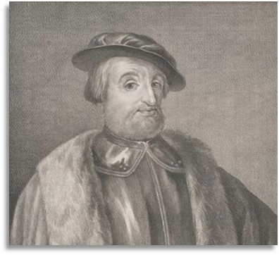
Figure 3 Hernán Cortés

Conquistadors Continue their Search for Gold

1528 – 1598

Foundations
After Hernán Cortés and Francisco Pizarro’s success, other conquistadors tried to find riches in America too. Many of them decided to go north of Mexico.
Álvar Núñez Cabeza de Vaca had a hard time on his expedition. He started out in Florida and ended up in Texas. He got lost, was often hungry, and was even captured by American Indians.
After him, Francisco Vásquez de Coronado explored the American southwest for two years. He was looking for cities made of gold, but he had no luck.
Hernando de Soto explored a lot of the American southeast from Florida to Texas. He died of sickness during his trip. Juan de Oñate searched the southwest and established New Mexico for Spain.
All these men had one thing in common: none of them found gold or riches anywhere from Florida to Texas to New Mexico.
Spain had done well in Mexico and South America. But after so many failed trips in the north, Spain gave up on the northern lands. This included Texas. For many years after that, Spain focused mostly on Mexico and South America.

The Arrival of the French

1685

Foundations
Spain tried many times to explore the lands north of Mexico, like Texas, but they found no gold there. The explorers only faced hard times.
Spain decided to focus on the lands they had colonized in Mexico and South America. These places had lots of gold and silver. The Aztec and Inca people had built great societies there. Spain took control of these lands and called them "New Spain." They didn't focus on Texas anymore.
Then, in February 1685, a French man named René-Robert Cavelier Sieur de la Salle arrived in Texas with 180 people. This was a problem for Spain.
At that time, Spain and France had been enemies for a long time. They had fought many wars over the years. Spain didn't want Texas, but they also didn't want their enemy to have it. Spain had to decide: What should we do about Texas? How do we keep France out of Texas?
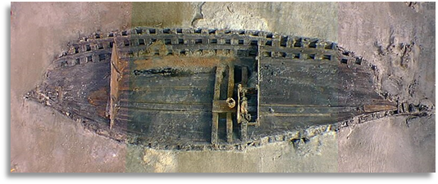
Figure 4 A photograph of the remains of La Salle's wrecked ship, "La Belle." The ship was discovered and excavated in 1995. The Texas Historical Commission.

The Significance of the Age of Contact

1492 – 1689

Foundations
The Age of Contact was a time that changed history forever. It began when the Spanish came to the "New World." This era had both good and bad effects on history.
When the Spanish arrived, they brought horses. Horses didn’t exist in America before the Spanish arrived. Many American Indians got horses from the Spanish. Having horses changed the way many tribes lived and how they dealt with other tribes.
Sadly, Spanish diseases killed millions of American Indians across two continents. The Spanish also took a lot of wealth and resources from American Indian communities. They took over two of the most powerful American Indian civilizations: the Aztecs and the Incas. A large system of trade started across the Atlantic Ocean. Over time, more Europeans came to North and South America. They took lands that would later become countries we know today, like the United States of America and Mexico. Texas would be part of both these countries at different times.
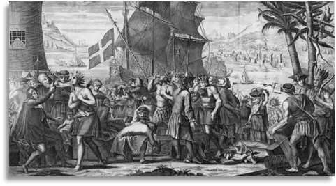
Figure 5 A painting showing trade between American Indians and Europeans. Library of Congress.

