Unit 2:

Age of Contact

Lesson 4:

What’s the story?
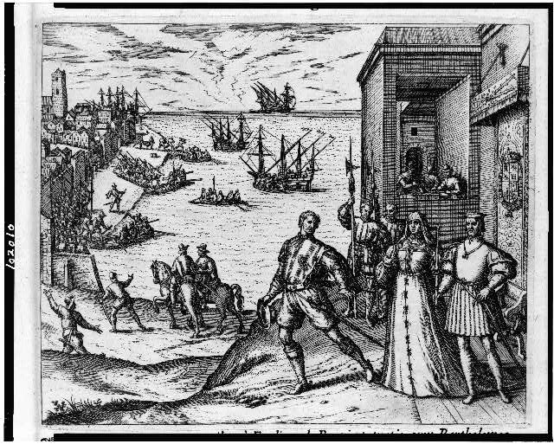

What’s the Story?

Warm-up
Use the map on your warm-up to make predictions about the unit
In which two modern-day locations on the map do you predict the Spanish will find gold?
Explain your answer.

Share your response
I predict the Spanish will find gold in (blank) because (blank)

Essential Question
What is the cause-and-effect relationship between the most significant chronological events of the Unit 2: Age of Contact?

In today’s lesson…
1. We will identify cause and effect between the most significant chronological events that occur during the Age of Contact.
2. I will read a series of short passages showing significant events in the Age of Contact. I will summarize each passage and explain its significance to the Age of Contact.

What’s the Story?

Lesson

Directions for the Lesson
1. Read each short passage for information about an event or events from the Age of Contact.
2. Record information about each reading in the correct place on your timeline assignment.
Read the specific, step-by-step directions on your paper.

Let’s do the first one together!
Start with the reading passage titled, “The Reconquista 732 - 1492”

Breaking Down Each Reading
Title & Date
Pay attention to people, places, events, and cause and effect relationships
How does the picture help us understand the reading?
What important information is in the caption?
What are the most important events?
Why are they significant?

Read & Record Your Notes
1. Read the passage.
2. Record the title, date, the most important events, and the significance:
a. Why is this important in history?
b. How did it change things for the better or worse?
c. What did it cause to happen next?
Tip: Determine the significance of each passage, then determine which key events support that significance.

Share one topic with the Class
The title of this topic is (blank)
It occurred from (blank) to (blank)*
The most significant events of this topic are (blank)
This topic is significant to the Age of Contact because (blank)
*Some events take place in only one year.
Continue with the next readings to complete your timeline.

Significance of the Age of Contact

The Final Reading
I think one of the most significant changes that came about because of the Age of Contact was (blank)

What’s the Story?

Exit Ticket
Follow the instructions to complete your Exit Ticket
1. Put the events listed in the correct chronological order.
2. Example: Write “1” beside the event that came first.
3. Discuss with a partner

Share with the class 2
The first / second / etc. event is (blank)

