Warm-up: What’s the Story?

Unit 2: The Age of Contact
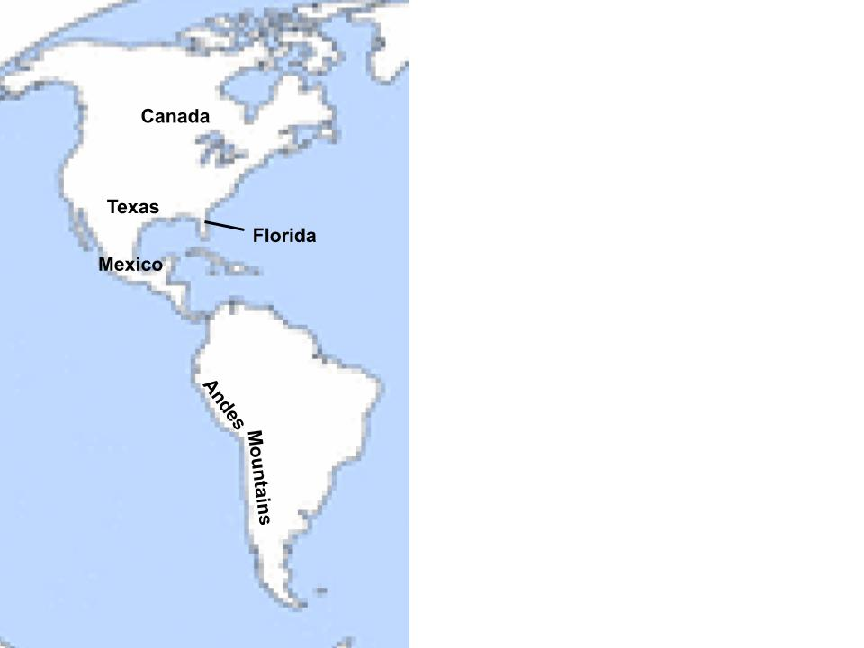
The map to the left is labeled with the location of several modern-day states, countries, and one geographic landform.
Make a prediction:
The Spanish successfully acquire gold in two of the locations labeled on the map. In which two locations do you think they will find gold?
Explain your reasoning: Explain why you chose those two locations.

