From Student to Stateswoman:

The Life and Legacy of Barbara Jordan: Accommodated Hook Exercise

Name: | Date: | Class/Period:
Directions: With a partner, examine the speech below and answer the questions that follow.

Document A: Transcript of Dr. Thomas Freeman’s Speech about Barbara Jordan at her funeral.

As an auditory support for students, consider showing the clip of Dr. Thomas Freeman speaking at Barbara Jordan’s funeral.
https://www.c-span.org/video/?c4887620/user-clip-dr-freemans-speech-barbara-jordans-funeral

When I last saw Barbara, it was at the Martin Luther King concert by the Chicago Symphony conducted by Paul Freeman, where Barbara served as the narrator. Following the introduction Barbara said, “I am pleased to be here not only with Tom’s brother Paul, but just to hear Tom introduce me. In fact, I always like to hear him introduce me because he always makes me feel as though I am somebody.”

It was not necessary to make Barbara feel like somebody. She was somebody. When she appeared on campus at the forensic tournament named after her, she said, “the one thing that I shall never be able to forgive Tom for is inflicting on me a pattern of speech which I have not been able to eradicate.” She did her teacher an honor when she went on further to say “and when I return to Washington, I shall recommend to President Jimmy Carter that he spend three weeks with Tom Freemen, and I guarantee that he will not be the same thereafter.”

Not for three weeks, but for four years, it was my privilege to assist in the nurture of Barbara, in the most plastic years of her life. As teacher, debate coach, counselor, and friend, I had many opportunities to interact with her so that now I have precious and pleasant memories that will linger with me forever.

She was a student who learned her lesson well. So well, that without my further tutelage she catapulted into national imminence.

On this day when so many have gathered to pay tribute to this great lady, indulge me as I share the emotion of Mark Anthony at the funeral of Julius Caesar: Friends, Romans, and Countrymen… Lend me your ears. I come here to speak at Caesar's funeral. He was my friend. Faithful and true to me. I speak not to disprove what Brutus spoke. I speak only what I know, bear with me.

My heart is there in the coffin with Barbara. I must pause and let it come back to me. Barbara, Barbara, Barbara, we thank you for just being Barbara.

- What can you infer about the relationship between Dr. Thomas Freeman and Barbara Jordan?

Reflect on the words and tone of the speech. Based on those details, finish the statement to explain the relationship between Dr. Freeman and Barbara Jordan:

“Based on the speech by Dr. Freeman, I can tell ____________________
because ___________________________”

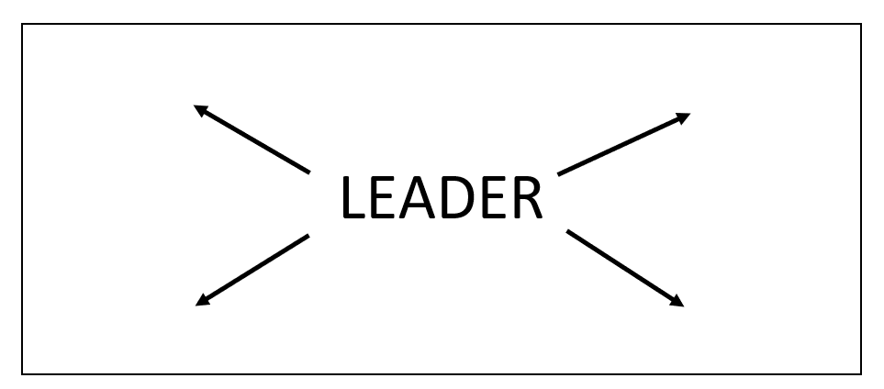
Hook Activity: After reading the speech, create a word splash on the space below. Include descriptive words that capture characteristics, personality traits, or adjectives that would accurately describe a good leader. Once students have generated a few words to describe a leader, conduct a small group share out where students complete the following prompt: I think a good leader is described as ____________________ because _____________________.
Following the lesson, revisit your wordsplash to confirm your words, revise, or add additional descriptive words that describe Barbara Jordan specifically.

