Name: | Date: | Class/Period:
From Student to Stateswoman: The Life and Legacy of Barbara Jordan: Accommodated Primary Source Analysis

The Fifth Ward – Then, Now, Future

Instructions: Directions: With a partner, examine the original primary source document and answer the following questions. This document is handwritten notes written by Barbara C. Jordan for a speech she gave about the history, present state, and future of Houston's Fifth Ward.

All text used for document analysis in this worksheet is from: Jordan, Barbara C. Then Now Future, text, Date Unknown; (https://texashistory.unt.edu/ark:/67531/metapth611512/ : accessed January 26, 2023), University of North Texas Libraries, The Portal to Texas History, crediting Texas Southern University.
Summary: The speech was written by Barbara Jordan expressing gratitude to Texas Commerce Bank for developing a bank branch in her community of Fifth Ward, Houston, TX. She describes reasons why she feels Fifth Ward is deserving of the business and her pride in her home community. The images of the letter are below the questions as well as transcript.
Analysis Questions for The Fifth Ward – Then, Now, Future:

- Who is the intended audience for this speech?

- What words did Jordan use to describe Fifth Ward in the past?

- How would you describe Fifth Ward and Barbara Jordan’s feelings about the community, based on the text of the letter?
Based on the letter about Fifth Ward, I can tell that Barbara Jordan ______

- What predictions can you make about the role that Fifth Ward will play in Barbara Jordan’s leadership?

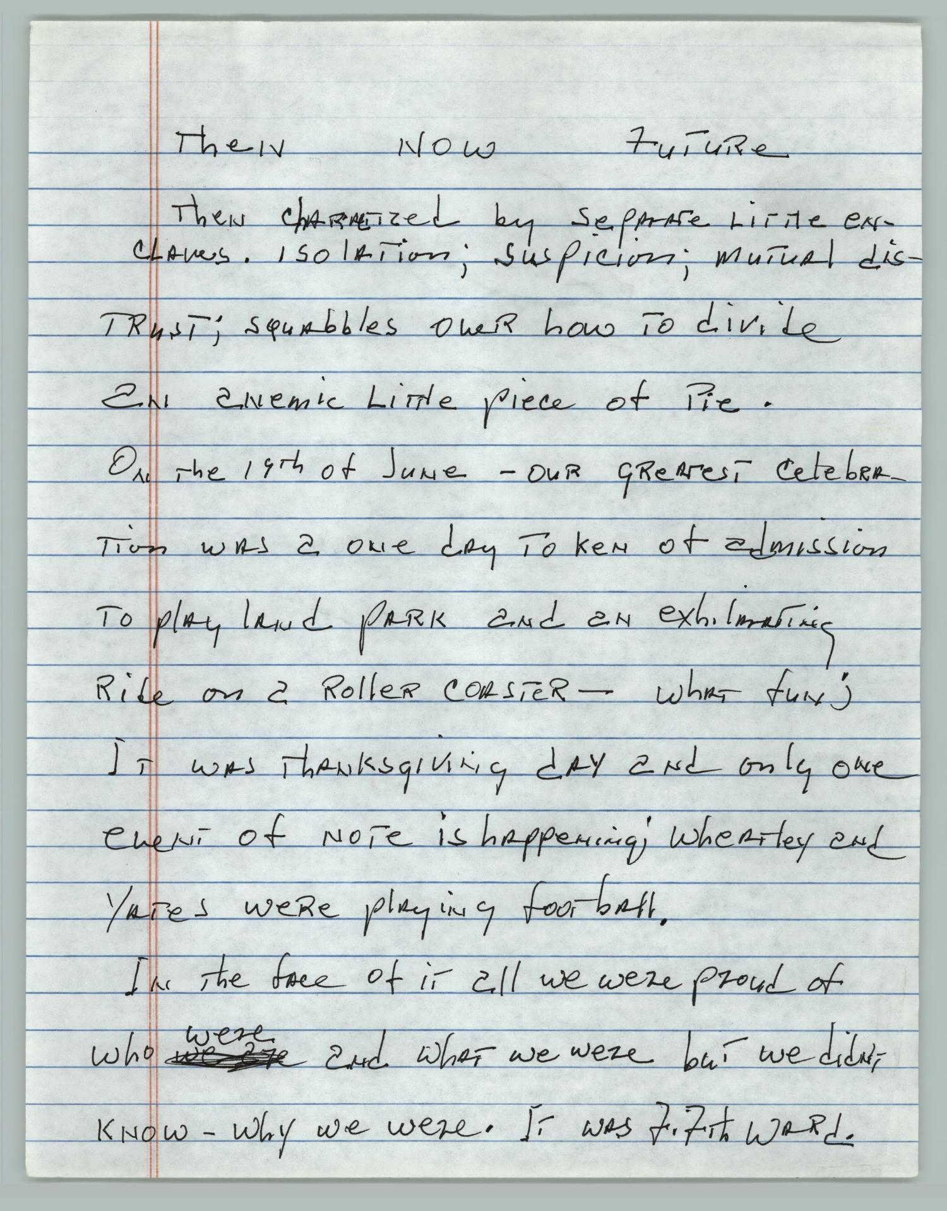

Then Now Future

Then characterized by separate little enclaves. Isolation; suspicion; mutual distrust; squabbles over how to divide an anemic little piece of pie. On the 19th of June – our greatest celebration was a one day token of admission to playland park and an exhilarating ride on a roller coaster – what fun;
It was Thanksgiving day and only one event of note is happening; Wheatley and Yates were playing football. In the face of it all we were proud of who were and what we were but we didn’t know – why we were. It was Fifth Ward

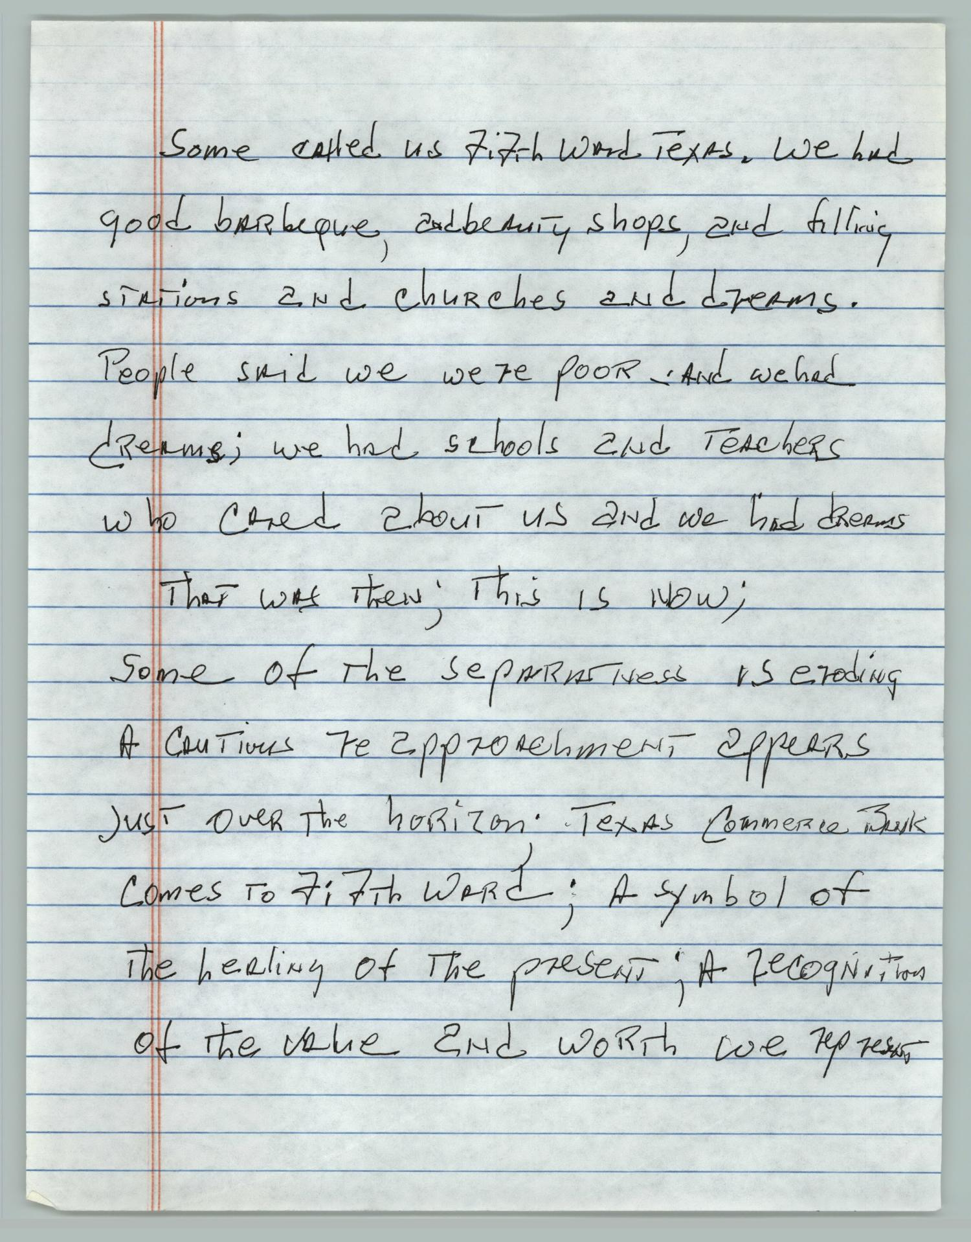

Some called us Fifth Ward, Texas. We had good barbeque, and beauty shops, and filling stations and churches and dreams. People said we were poor and we had dreams; we had schools and teachers who cared about us and we had dreams
That was then; this is now;
Some of the separateness is eroding a cautious re rapprochement appears just over the horizon; Texas Commerce Bank comes to Fifth Ward; a symbol of the healing of the present; a recognition of the value and worth we represent

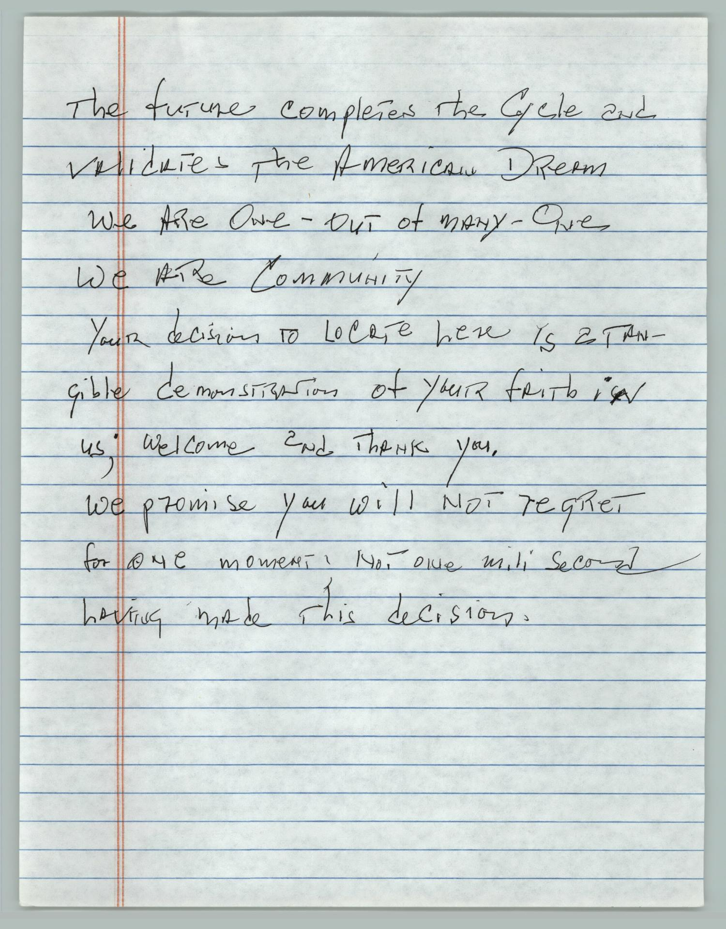

The future completes the cycle and vindicates the American dream
We are one – out of many – one
We are community
Your decision to locate here is a tangible demonstration of your faith in us; welcome and thank you.
We promise you will not regret for one moment, not one millisecond having made this decision.

