Instructions: Use this graphic timeline to outline key points in the life of Barbara Jordan. For each point on the graphic, include key dates and major events as your gather information about Barbara Jordan. Feel free to use bullet points or complete this organizer as a mental mapping tool.

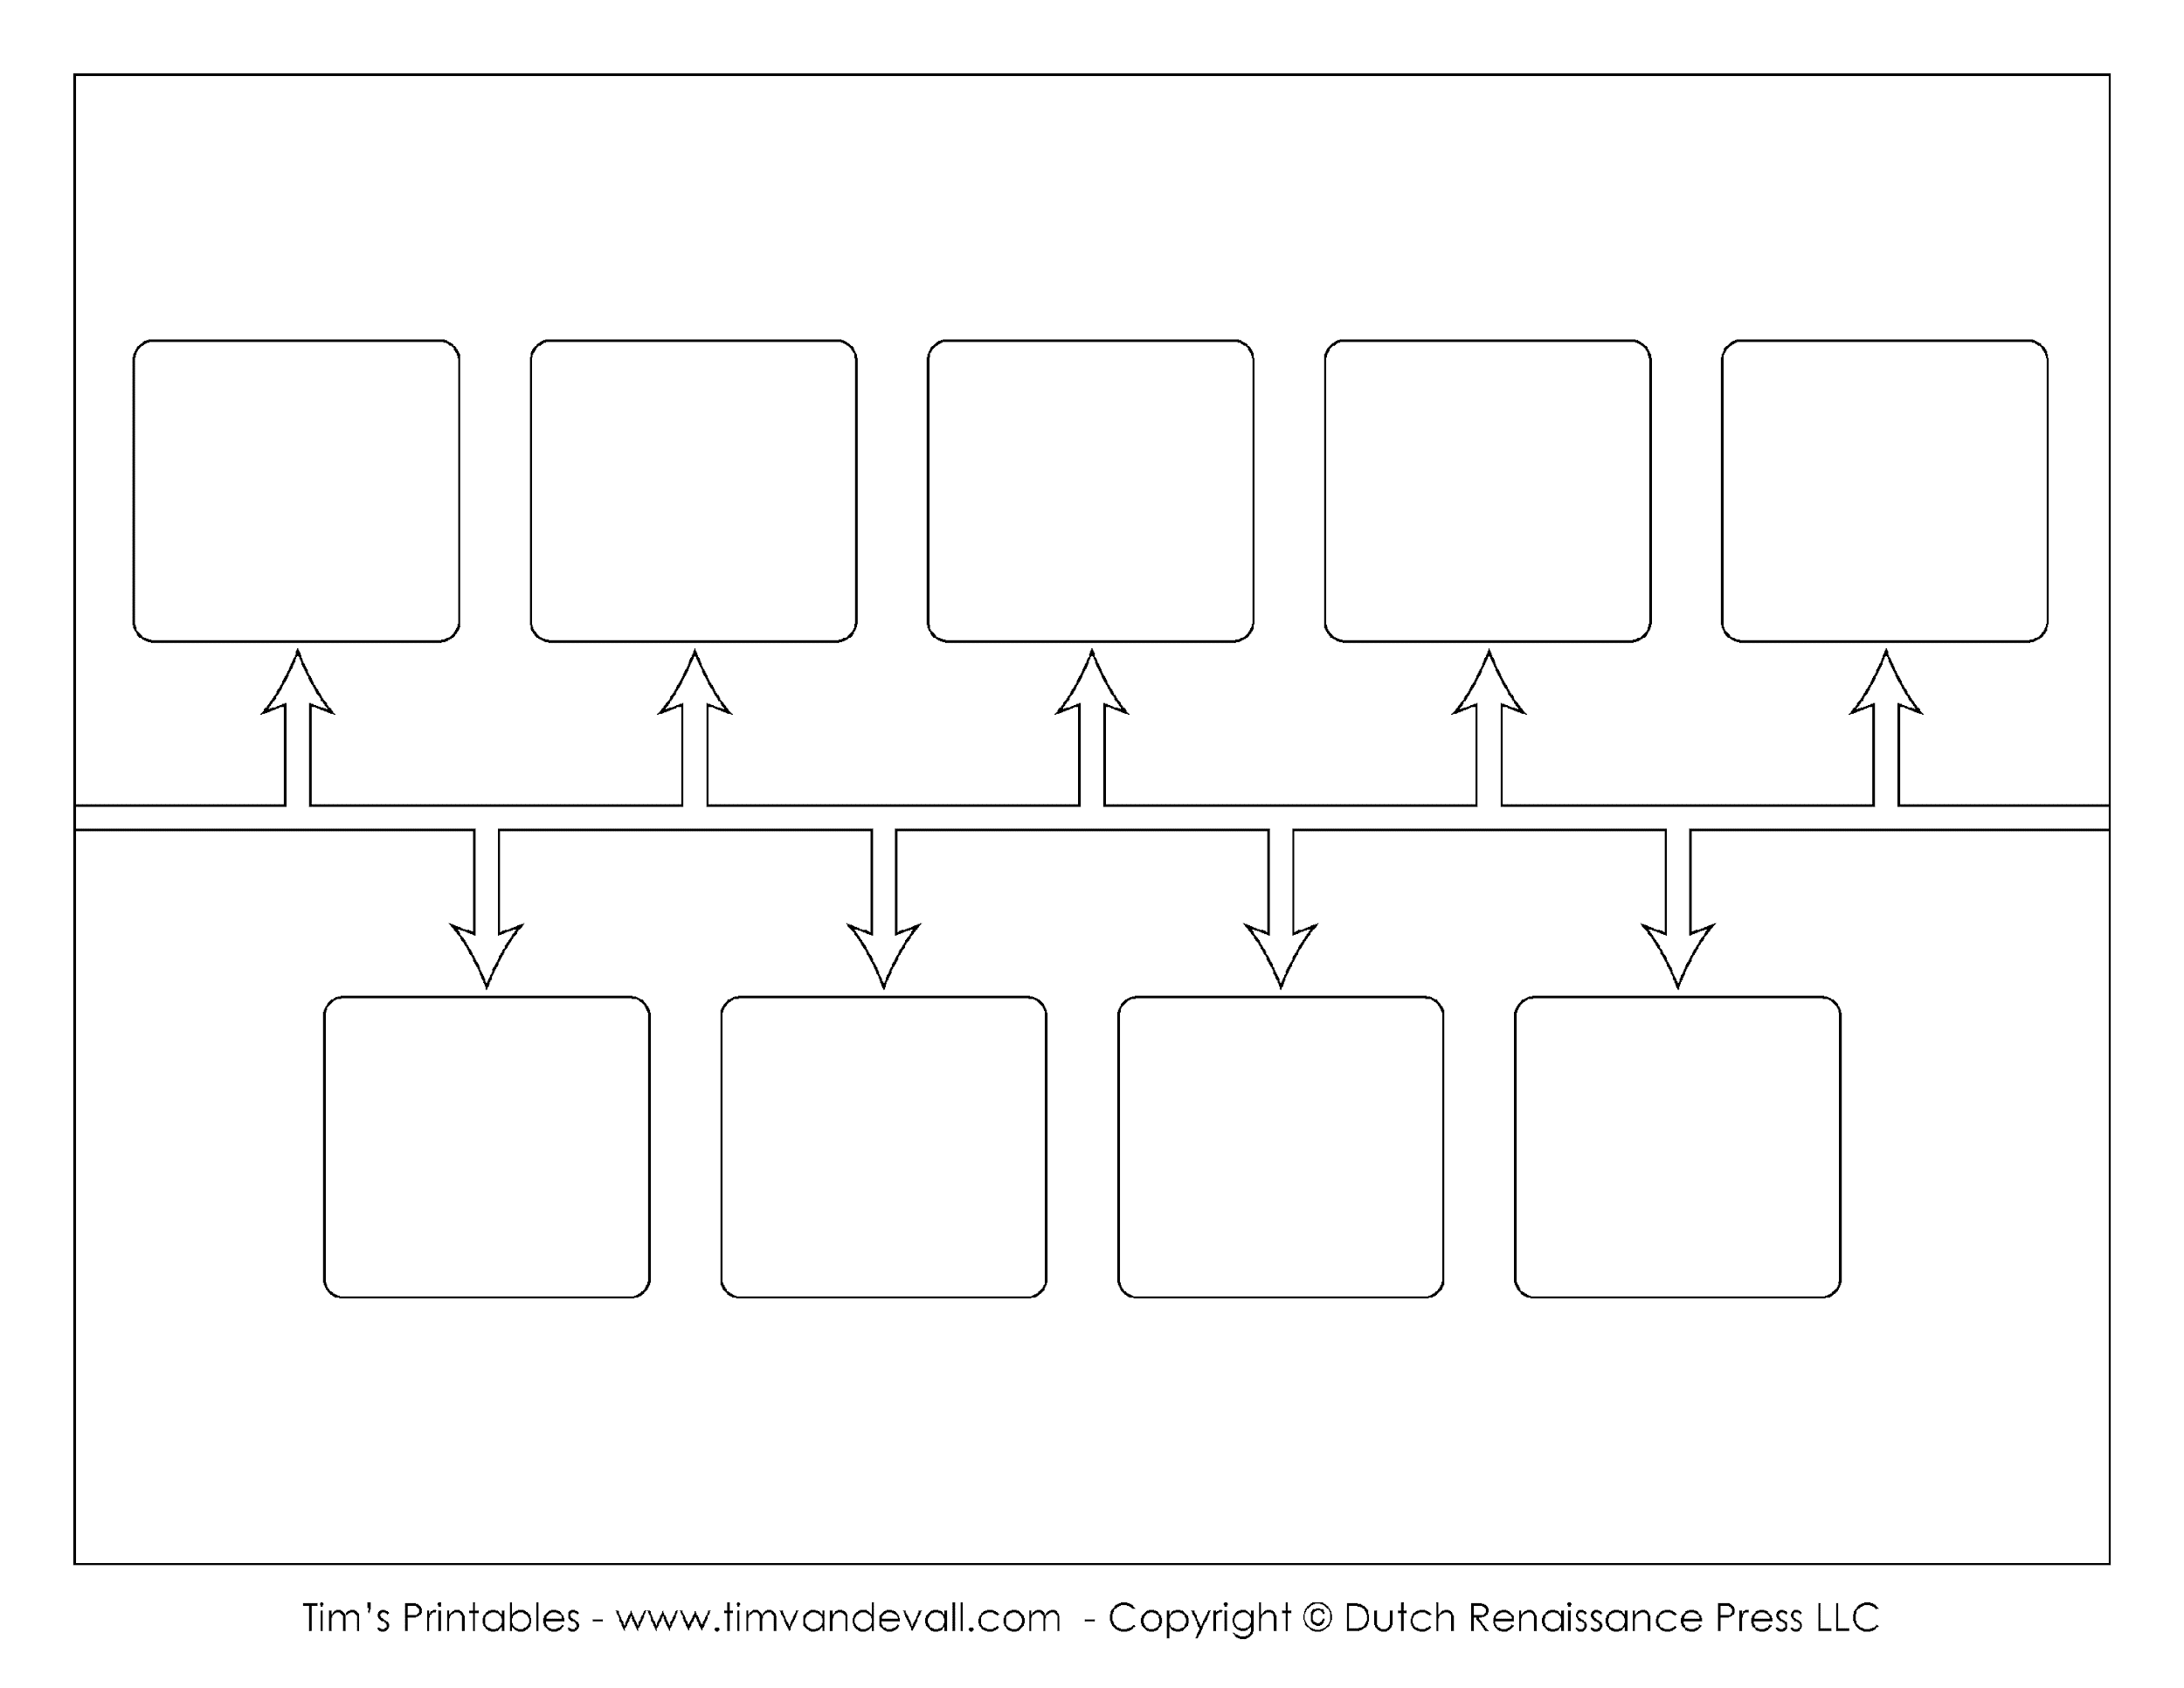
Early Career
Childhood and Upbringing
Barbara Jordan Death
Key Career Event
Key Career Event
Key Career Event
Key Career Event
Education & Training
Barbara Jordan Birth

