Causes of the Civil War Guided Notes Advanced
Unit 8: Civil War

Name: |  | Date: |  | Period:

Part I: Slavery, Sectionalism, and States’ Rights
On April 12, 1861, Confederates opened fire on Union troops at Fort Sumter off the coast of Charleston, South Carolina. This action began the Civil War, which would last four long years, destroy miles of land including entire towns, and take 750,000 American lives.
The Civil War was caused by increasing sectional divisions between the free states of the North and the slave states of the South over the issue of slavery. As the country expanded westward, both the North and South worked to increase the political power of their own region, with both sections of the country viewing the other as harmful to their own region’s interests and way of life.
By the 1850s, sectionalism in the U.S. was at an all-time high, and a series of events throughout the decade brought the nation to the brink of war. In this lesson, we will examine several of the most significant events that led to the outbreak of the Civil War.

What was the Civil War, and what was the primary cause of the war? Explain your answer in complete sentences.

The Missouri Compromise

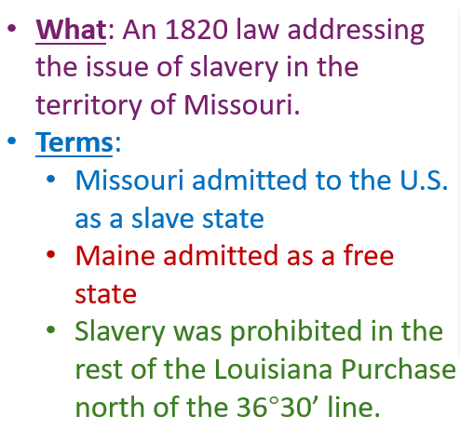 | Which part(s) of the Missouri Compromise attempted to appease the Southern states? Explain  Which part(s) attempted to appease the Northern states? Explain

The Compromise of 1850

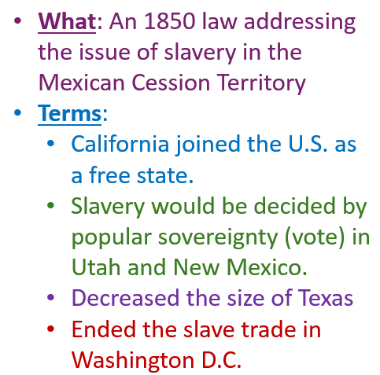 | Which part(s) of the Compromise of 1850 appeased the South? Explain.  Which part(s) appeased the North? Explain.

The Kansas Nebraska Act

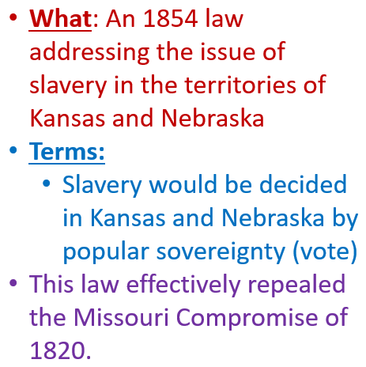 | Which part(s) of the Kansas Nebraska Act appeased the South? Explain  Which part(s) appeased the North? Explain.

Bleeding Kansas

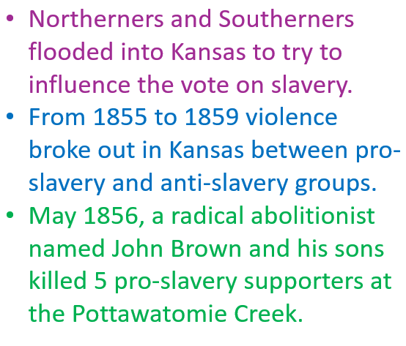 | How did this event demonstrate the growing sectional division in the U.S.?

The Dred Scott Case

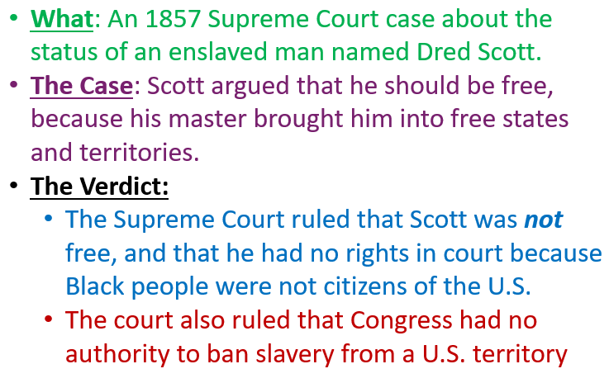 | Do you think Northerners or Southerners were more satisfied with the outcome of this case? Explain.

John Brown’s Raid on Harper’s Ferry

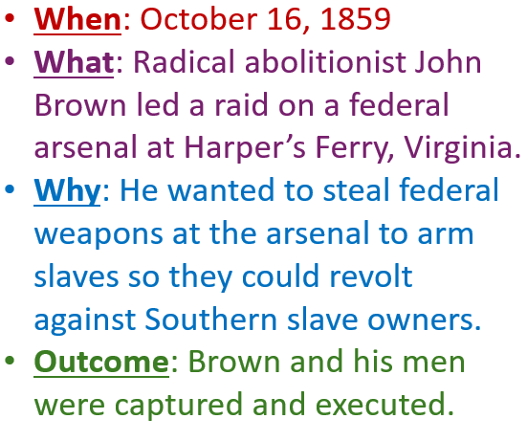 | How do you think this event likely influenced sectional tensions and divisions?

The Presidential Election of 1860

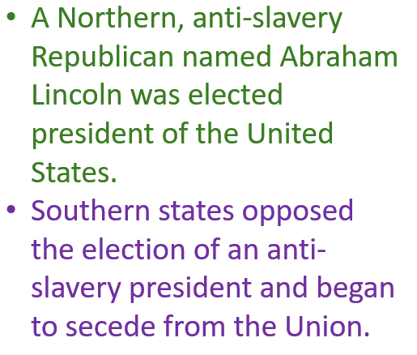 | Why do you think Southern states began to secede after THIS event, and not any earlier one?

Additional Activity:
Make a Timeline of the Road to the Civil War
Directions: Using the events covered in this lesson, create a timeline of the “Road to the Civil War,” demonstrating the chronological events leading to the war.

Your timeline should be accurate, neat, well-organized, clearly written, with good spelling and grammar, colorful, and creative. Include images (drawn or printed) when possible.

Your timeline should include a TITLE for the complete timeline. Each event should also have a title for the event, as well as the date of the event, and a three to five sentence description of each event.

