Causes of the Civil War Guided Notes Foundations
Unit 8: Civil War

Name: |  | Date: |  | Period:

Part I: Slavery, Sectionalism, and States’ Rights
On April 12, 1861, Confederates opened fire on Union troops at Fort Sumter off the coast of Charleston, South Carolina. This action began the Civil War, which would last four long years, destroy miles of land including entire towns, and take 750,000 American lives.
The Civil War was caused by increasing sectional divisions between the free states of the North and the slave states of the South over the issue of slavery. As the country expanded westward, both the North and South worked to increase the political power of their own region. Many people in both sections of the country viewed the other as harmful to their own region’s interests and way of life.
By the 1850s, sectionalism in the U.S. was at an all-time high. A series of events throughout the decade brought the nation to the brink of war. In this lesson, we will examine several of the most significant events that led to the outbreak of the Civil War.

Place a checkmark next to each TRUE statement about the Civil War. Choose FOUR.

- The North and the South shared essentially the same economic systems, which caused a great deal of competition between the two sections.
- Southerners wanted their system of slave-based plantation agriculture to be permitted to expand into new western territories.
- Northerners supported slavery because it kept wages for White workers high.
- New states in the West could increase political power for the North or the South, depending on whether the new Western states allowed slavery or not.
- The North and the South fought the Civil War because of the issue of Texas annexation.
- Sectional divisions increased during the 1850s, which ultimately led to a deadly war between the North and the South.

The Missouri Compromise

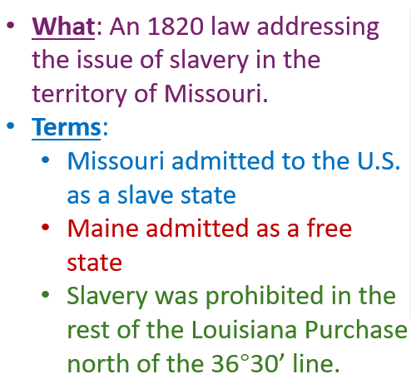 | The Northern / Southern states were probably happy that (choose all that apply)  - Missouri was a slave state  - Maine was a free state  - Slavery was not allowed in the rest of the Louisiana territory.

The Compromise of 1850

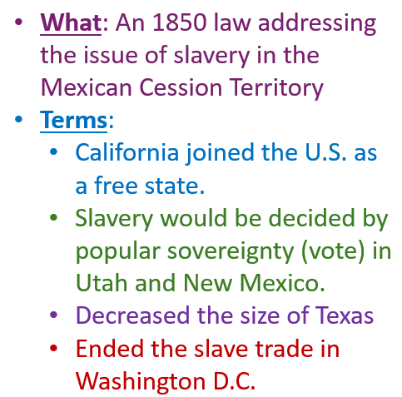 | The Northern / Southern states were probably happy that (choose all that apply)  - California outlawed slavery  - People in Utah and New Mexico could vote on slavery  - Texas was smaller  - People couldn’t trade slaves in Washington D.C. anymore

The Kansas Nebraska Act

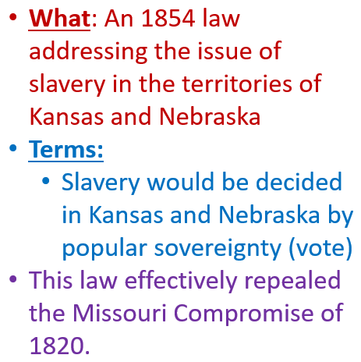 | The Northern / Southern states were probably happy that (choose all that apply)  - People in Nebraska and Kansas could vote on slavery  - The rest of the Louisiana territory was now open to slavery

Bleeding Kansas

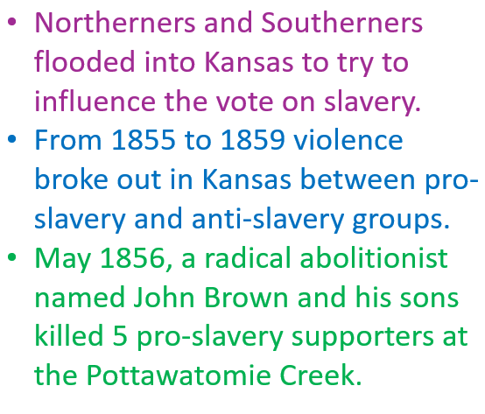 | This event proves that sectionalism was increasing / decreasing because (choose ONE)  - People are attempting to solve sectional issues via legal compromise.  - People are resorting to violence to try to accomplish their goals.  - People are taking are pushing for secession of Southern states.

The Dred Scott Case

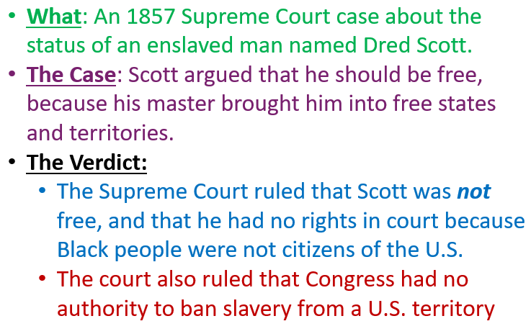 | The Northern / Southern states probably supported this ruling because (choose all that apply)  - The courts ruled that the government can’t stop slavery.  - The courts ruled that enslaved people did not have the right to bring a case to court.  - The court ruled that even free Black people were not citizens.

John Brown’s Raid on Harper’s Ferry

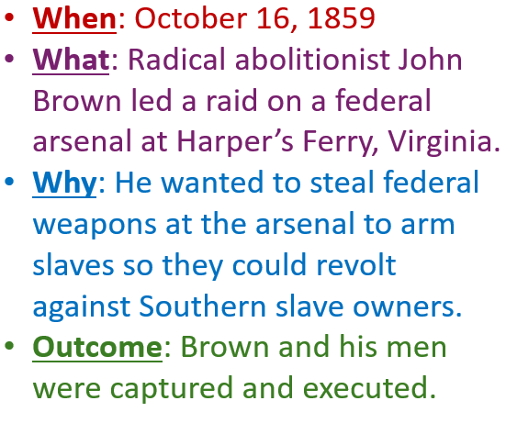 | This event probably increased / decreased sectionalism because (choose ONE)  - It demonstrated the pro-slavery Southerners wanted to abolish slavery in the South.  - It demonstrated that all Northerners were unwilling to compromise on slavery.  - It demonstrated that more people were turning to violence in support of their goals.

The Presidential Election of 1860

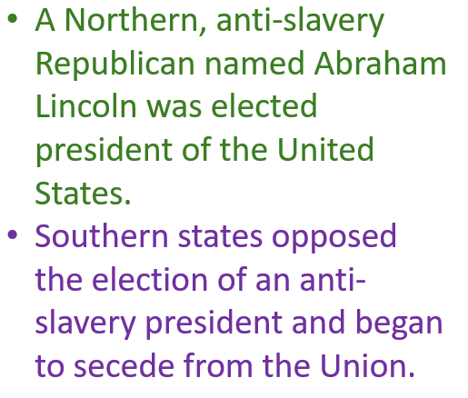 | Why do you think Southern states began to secede after THIS event, and not any earlier one?

