Causes of the Civil War Guided Notes Grade Level
Unit 8: Civil War

Name: |  | Date: |  | Period:

Part I: Slavery, Sectionalism, and States’ Rights
On April 12, 1861, Confederates opened fire on Union troops at Fort Sumter off the coast of Charleston, South Carolina. This action began the Civil War, which would last four long years, destroy miles of land including entire towns, and take 750,000 American lives.
The Civil War was caused by increasing sectional divisions between the free states of the North and the slave states of the South over the issue of slavery. As the country expanded westward, both the North and South worked to increase the political power of their own region. Many people in both sections of the country viewed the other as harmful to their own region’s interests and way of life.
By the 1850s, sectionalism in the U.S. was at an all-time high. A series of events throughout the decade brought the nation to the brink of war. In this lesson, we will examine several of the most significant events that led to the outbreak of the Civil War.

Place a checkmark next to each TRUE statement about the Civil War.

- The North and the South shared essentially the same economic systems, which caused a great deal of competition between the two sections.
- Southerners wanted their system of slave-based plantation agriculture to be permitted to expand into new western territories.
- Northerners supported slavery because it kept wages for White workers high.
- New states in the West could increase political power for the North or the South, depending on whether the new Western states allowed slavery or not.
- The North and the South fought the Civil War because of the issue of Texas annexation.
- Sectional divisions increased during the 1850s, which ultimately led to a deadly war between the North and the South.

The Missouri Compromise

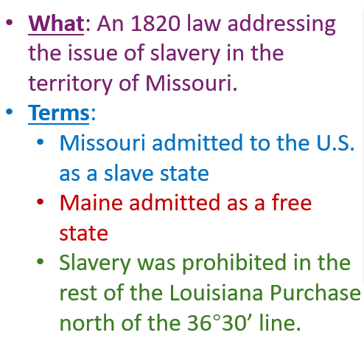 | The Northern states were probably happy that _____________________________ __________________________________________ __________________________________________  The Southern states were probably happy that ______________________________ ___________________________________________ ___________________________________________

The Compromise of 1850

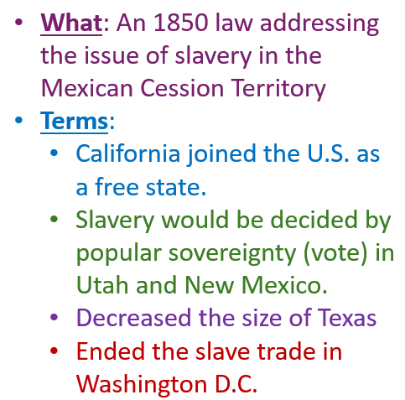 | The Northern states were probably happy that _____________________________ __________________________________________ __________________________________________  The Southern states were probably happy that ______________________________ ___________________________________________ ___________________________________________

The Kansas Nebraska Act

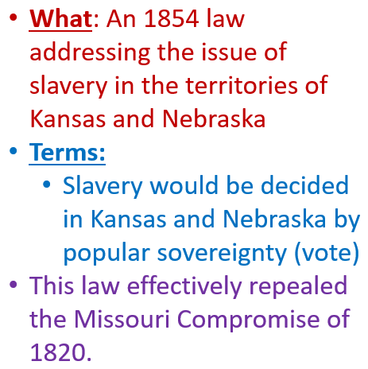 | The Northern states were probably happy that _____________________________ __________________________________________ __________________________________________  The Southern states were probably happy that ______________________________ ___________________________________________ ___________________________________________

Bleeding Kansas

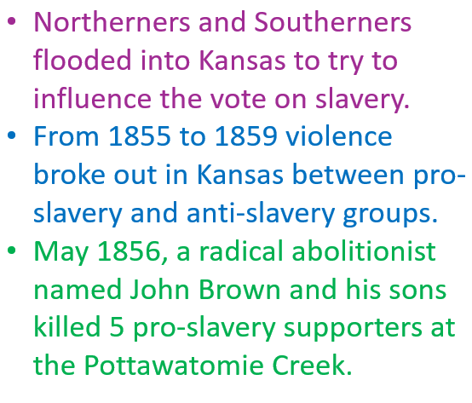 | This event demonstrates that sectional divisions between the North and the South were increasing / decreasing. One piece of evidence that supports this claim is ________________________ ______________________________________ ______________________________________ ______________________________________ ______________________________________ ______________________________________

The Dred Scott Case

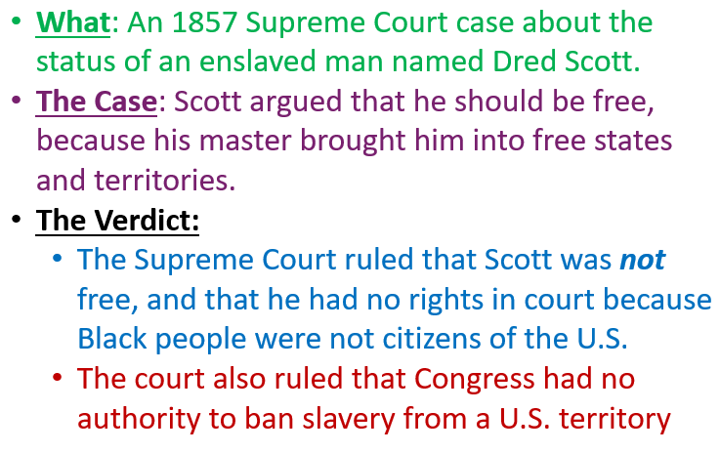 | I think that Northerners / Southerners were probably more satisfied with the Dred Scott ruling because ___________________________________ _____________________________________________ _____________________________________________

John Brown’s Raid on Harper’s Ferry

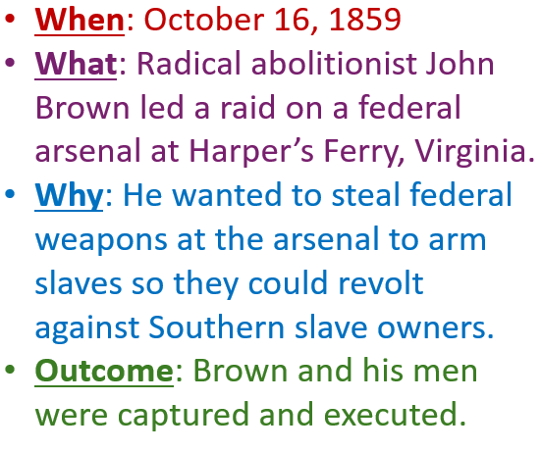 | I think John Brown’s raid on Harper’s Ferry probably increased / decreased sectional divisions between the North and the South because _______________________________________ __________________________________________________ __________________________________________________

The Presidential Election of 1860

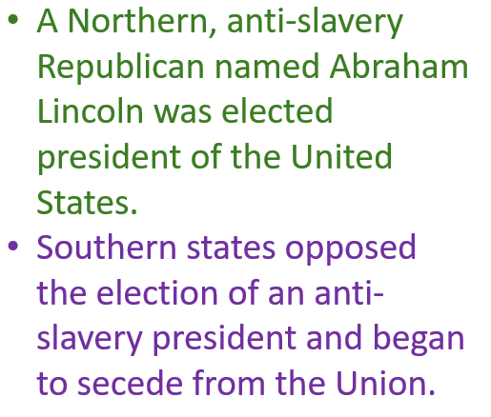 | Why do you think Southern states began to secede after THIS event, and not any earlier one?

