
Warm-up: The Emancipation Proclamation Extension
Unit 8: Civil War
Name: |  | Date: |  | Period:

- What observations do you notice about slavery in the U.S. based on this map? | 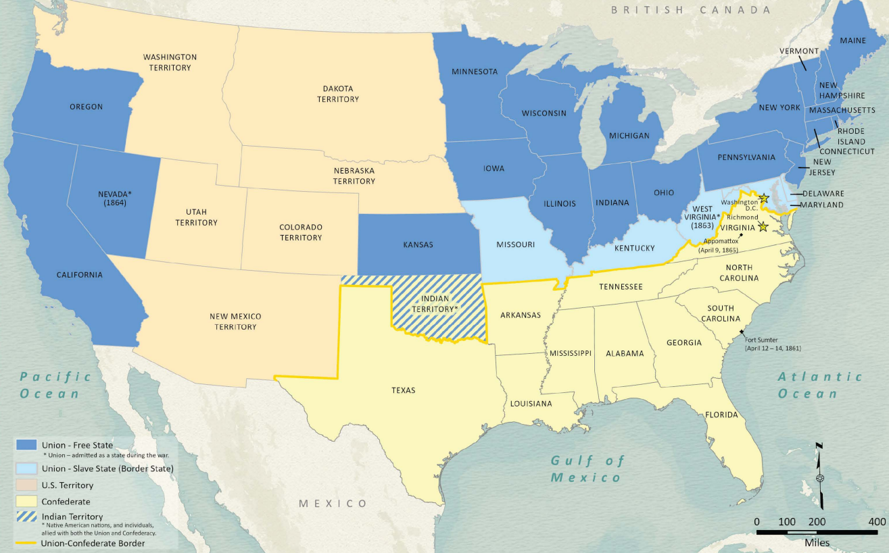  Figure 1: American Civil War Political Loyalties. The Texas General Land Office.

Warm-up: The Emancipation Proclamation Extension
Unit 8: Civil War
Name: |  | Date: |  | Period:

- What observations do you notice about slavery in the U.S. based on this map? | Figure 1: American Civil War Political Loyalties. The Texas General Land Office.

The Emancipation Proclamation Extension Exit Ticket

“Old Abe for a long time refused to issue his emancipation proclamation. Being called on one day by a couple of abolitionists, urging him to the measure, he said: “You have doubtless heard of the man who asked another, ‘if I should call a sheep’s tail a leg, how many legs would he have?’ ‘Five.’ ‘No, only four, for my calling a tail a leg would not make it so.’ Now, gentlemen, if I saw to the slaves, ‘you are free,’ they will be no more free than before.” But old Abe was overcome, and he is now in the interesting business of making a falsehood come true, because he has told it.”
- The Tri-Weekly Telegraph (Houston, TX.) Monday, November 10, 1862. The Portal to Texas History.

What do you think is the meaning of the story in this article? How do you think this story relates to the emancipation proclamation?

The Emancipation Proclamation Extension Exit Ticket

“Old Abe for a long time refused to issue his emancipation proclamation. Being called on one day by a couple of abolitionists, urging him to the measure, he said: “You have doubtless heard of the man who asked another, ‘if I should call a sheep’s tail a leg, how many legs would he have?’ ‘Five.’ ‘No, only four, for my calling a tail a leg would not make it so.’ Now, gentlemen, if I saw to the slaves, ‘you are free,’ they will be no more free than before.” But old Abe was overcome, and he is now in the interesting business of making a falsehood come true, because he has told it.”
- The Tri-Weekly Telegraph (Houston, TX.) Monday, November 10, 1862. The Portal to Texas History.

What do you think is the meaning of the story in this article? How do you think this story relates to the emancipation proclamation?

