 Warm-up: Mind Map Review
Unit 8: Civil War
Name: |  | Date: |  | Period:

Look at the word bank below. Complete the mind map diagram by putting each term where you think it fits best.

- Cause  - Significance  - Civil War  - Slavery  - Emancipation | 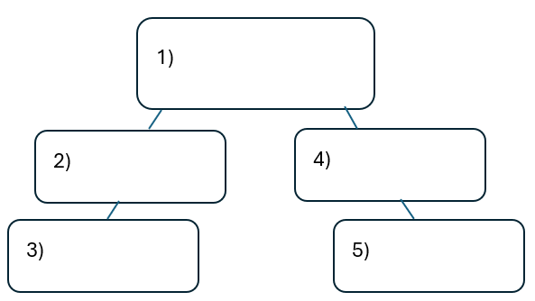

Warm-up: Mind Map Review
Unit 8: Civil War
Name: |  | Date: |  | Period:

Look at the word bank below. Complete the mind map diagram by putting each term where you think it fits best.

- Cause
- Significance
- Civil War
- Slavery
- Emancipation

Exit Ticket: Mind Map Review
Unit 8: Civil War
Name: |  | Date: |  | Period:

Directions: Complete the sentence by choosing the best answer for each blank from the chart below.
The (1)____________ era is primarily characterized by (2)____________

Answer choices for blank (1)  Circle the best answer | Answer choices for blank (2)  Circle the best answer
- Slavery  - Westward expansion  - Civil War  - Early Statehood | - … a violent conflict between the North and the South over slavery in the United States.  - … the growth of the United States as the country expanded westward with the acquisition of the Mexican Cession.  - … the Republic of Texas’ struggles as a young nation and its attempts at annexation to the United States.  - … the Confederate States of America’s attempts to abolish slavery and institute a manufacturing economy.

Exit Ticket: Mind Map Review
Unit 8: Civil War
Name: |  | Date: |  | Period:

Directions: Complete the sentence by choosing the best answer for each blank from the chart below.
The (1)____________ era is primarily characterized by (2)____________

Answer choices for blank (1)  Circle the best answer | Answer choices for blank (2)  Circle the best answer
- Slavery  - Westward expansion  - Civil War  - Early Statehood | - … a violent conflict between the North and the South over slavery in the United States.  - … the growth of the United States as the country expanded westward with the acquisition of the Mexican Cession.  - … the Republic of Texas’ struggles as a young nation and its attempts at annexation to the United States.  - … the Confederate States of America’s attempts to abolish slavery and institute a manufacturing economy.

