Study Guide Advanced
Unit 8: Civil War

Name: |  | Date: |  | Period:

Part I: Significant Terms
Directions: Write the term from the word-bank below in the numbered box next to the best definition or description in the chart below. You will not use TWO terms.
Secession | Confederacy | Union | Unionists
Election of 1860 | Abraham Lincoln | Slavery | Rio Grande Trade
Sam Houston | South Carolina | Emancipation | Blockade

The Southern states who rebelled against the United States are often referred to as this term.
This Texas governor opposed secession and refused to support the Confederate government when Texas seceded.
The North and the South fought over this primary issue in the Civil War.
The Union navy placed warships along the Confederate coast to prevent the South from being able to take part in shipping and trade.
This anti-slavery Northerner was elected president in 1860, which angered Southern states leading many to secede.
The act of officially separating or breaking political ties with a country.
The state or act of being free. One of the most significant outcomes of the Civil War was that the enslaved population of the South was freed from slavery.
Texans were able to get around the Union blockade of the Gulf of Mexico by moving its goods through Mexico. This was the name often given to this action at the time.
This term was used to refer to all the states that remained in the U.S. during the war. It included free Northern and Western states, and some border slave states.
This single event was what caused Southern states to begin to secede from the Union.
Part II: Cause and Effect Matching
The left column contains significant events of the Civil War era. The right column provides the effect of each event. Match each cause on the left with its correct effect on the right

- Both Northern free states and Southern slave states wanted more power in the U.S. Congress to enact laws that were beneficial to their specific region.
- The Federal government and free states of the North wanted to limit the expansion of slavery into new territories in the American West.
- Abraham Lincoln, an anti-slavery Northern Republican was elected president on November 6, 1860.
- The majority of fighting during the Civil War took place in the Eastern Theater, devastating the land and economies of Southern states like Virginia, Maryland, and Georgia.
- The Union established a blockade of the Confederate coast to prevent Southern states from taking part in shipping and trade.
- Some Texas generals were determined to continue fighting, even after Robert E. Lee surrendered his Army of Northern Virginia to the Union at Appomattox in 1865.
- Abraham Lincoln issued the Emancipation Proclamation in 1863.
- Union Major General Gordon Granger delivered General Order Number 3 to the people of Texas at Galveston on June 19, 1865.
- Southern states began to secede from the Union, beginning with South Carolina in December, 1860.
- Texans moved their goods through Mexico, allowing the state to avoid the Union blockade and continue its shipping and trade.
- This focus on individual regions especially over the issue of slavery led to growing sectionalism and divisions in the United States.
- Texas’ distance from the majority of the war allowed its economy to continue with little interruption in order to help supply the war effort, and led to many Southerners fleeing the South to seek refuge in Texas.
- Approximately 250,000 Black Texans were freed in Texas on this date, which has become a national holiday called Juneteenth.
- Southern slaves in rebelling states were declared free, however Southern states of the Confederacy did not follow the Proclamation.
- The Battle of Palmito Ranch was fought one month after the Civil War had officially ended.
- Laws like the Compromise of 1850 were passed allowing California to join the Union as a free state, reduced the size of Texas, and ended the slave trade in Washington D.C.

Part III: Practice Test Questions
Answer the following practice test questions about the Civil War. Questions are based on the 8th grade Social Studies STAAR question types.
- Which of the following headlines would you have been likely to see in a newspaper article in April, 1861?
  - “Southern Troops Fire on Fort Sumter, the Civil War Has Begun!”
  - “Abraham Lincoln Issues Emancipation Proclamation, the Slaves are Free!”
  - “Union Troops Forced Out of Galveston, Texas Claims Important Port!”
  - “Confederate General Robert E. Lee Surrenders, the Civil War is Over!”

- Write the number of each location on the map below next to its correct description.
______ Slave states who seceded and  formed the Confederacy  ______ Free states in the Union  ______ Slave states who remained in  the Union  ______ U.S. Territories that were not  yet states. | 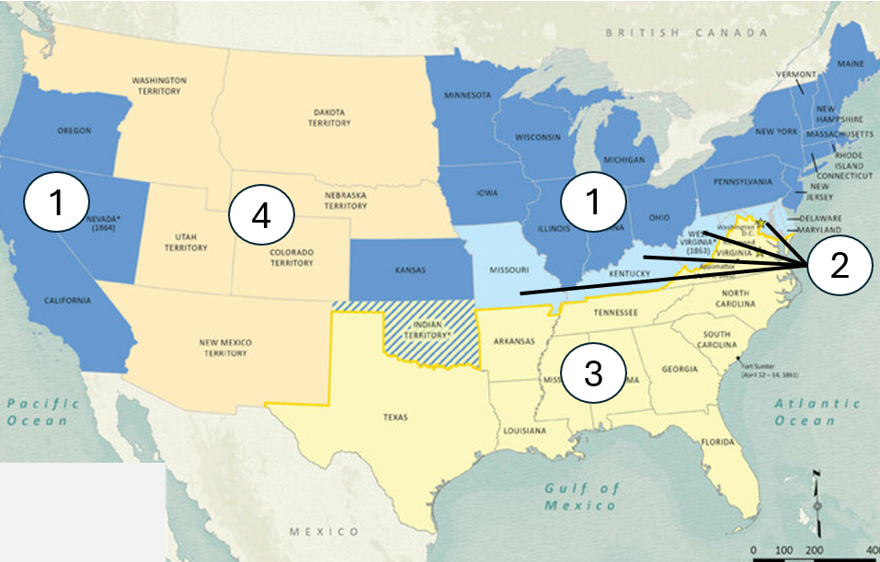

- Which of the answer options below best completes the information in the graphic?

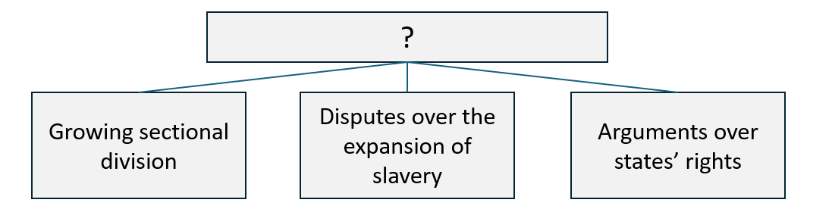

  - Goals of the Union Army during the Civil War.
  - Reasons for Texas’ secession from the Union.
  - Causes of the American Civil War.
  - Significance of the Surrender of the Confederacy.

- Which of the following best describe the unique role Texas and Texans played during the Civil War as a result of the state’s distance from the majority of the fighting and destruction? Choose THREE correct answers.

Texas farmers supplied corn and cotton to the Confederate Army. | Texas provided Southern refugees with a safe place to escape the violence. | Texas was able to continue shipping its goods via Mexican ports.
Texas supplied the most Confederate soldiers to the Eastern Theater. | Texas was the only state in which the Confederacy did not surrender. | The first and last battles of the Civil War were fought on Texas soil.

- Read the excerpt below and answer the question that follows.

Mexican factories annually consume about 40,000 bales of cotton, which has been mainly obtained through the market of New Orleans and shipped thence through the ports of Matamoros, Tampico, &c., to the places required; and about 2000 bales of this needed supply have for several years past been purchased directly from our planters on the Guadalupe and its tributaries, and hauled in carts overland to Mexico…

- Texas State Gazette. (Austin, Tex.)Saturday, October 26, 1861. The Portal to Texas History.

How does the excerpt above exemplify Texas’ unique economic experience during the Civil War?
  - Texan agricultural workers and planters increased production in cotton during the Civil War years due to the growing need for the product not only to produce military uniforms but also to use bales as protection from gun fire.
  - Texans were able to maintain the cotton trade with Mexico by overland trade while other Southern states were unable to do likewise because of the Union naval blockade.
  - Texans began to concentrate on the more profitable trade with New Orleans markets during the war because planters in New Orleans were unable to meet the demands of the Louisiana markets.
  - Mexican factories began to trade directly with planters in New Orleans rather than in Texas as a result of the policy of high tariffs instituted by the Texas government to help cover the cost of the war.

- Determine whether each characteristic applied MOST to the Union or the Confederacy during the Civil war. Place an X or checkmark in the correct category.

Characteristic | Union | Confederacy
Mostly Northern and Western states in the U.S.
Border slave states including Kentucky and Maryland.
States like New York, Massachusetts, and California.
Southern states including South Carolina, Mississippi, Florida, and Texas.
Largely supported the Republican presidential candidate, Abraham Lincoln.
Economic activity included small farms, businesses, manufacturing, and trade.
Largely supported and depended on plantation agriculture using enslaved labor.

- What was the Civil War, who were the opposing sides in the fight, and what was the primary cause of the war? Write your response in three to five complete sentences, and give details and examples when possible.

