
Warm-up: Texas & Secession
Unit 8: Civil War
Name: |  | Date: |  | Period:

Read the excerpt to the right.  In one short sentence, paraphrase the excerpt in modern language. | “By the secession of six of the slave-holding States, and the certainty that others will speedily do likewise, Texas has no alternative but to remain in an isolated connection with the North, or unite her destinies with the South.”  - Texas’ Declaration of the Causes for Secession. February 2, 1861. The Portal to Texas History

Warm-up: Texas & Secession
Unit 8: Civil War
Name: |  | Date: |  | Period:

Read the excerpt to the right.  In one short sentence, paraphrase the excerpt in modern language. | “By the secession of six of the slave-holding States, and the certainty that others will speedily do likewise, Texas has no alternative but to remain in an isolated connection with the North, or unite her destinies with the South.”  - Texas’ Declaration of the Causes for Secession. February 2, 1861. The Portal to Texas History


Texas & Secession Exit Ticket

Observe the political cartoon about secession.  Do you think the illustrator supported or opposed secession? Explain. | 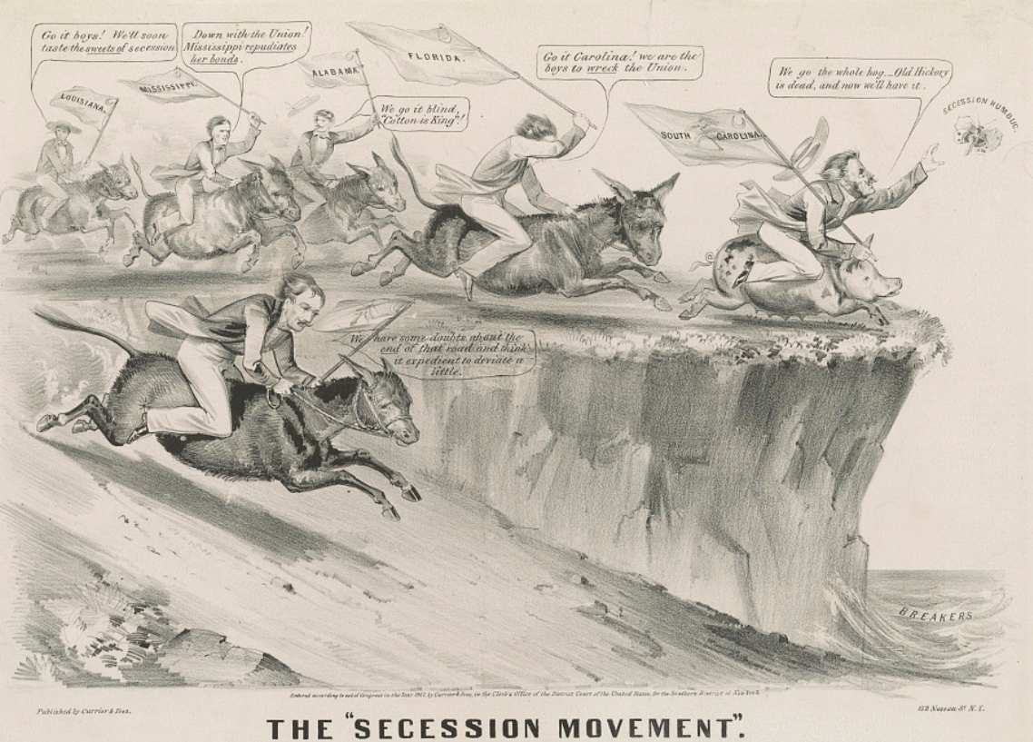

Texas & Secession Exit Ticket

Observe the political cartoon about secession.
Do you think the illustrator supported or opposed secession? Explain.

