Station 1: Civil War Battles in Texas

The Battle of Galveston
The Union had established a blockade of key Confederate port cities, including Texas’ most important port at Galveston. On October 4, 1862, troops from the Union blockade demanded the surrender of Galveston. At the time, Galveston’s defenses were too weak to prevent the Union from taking the port, so Union soldiers captured Galveston with little resistance. | 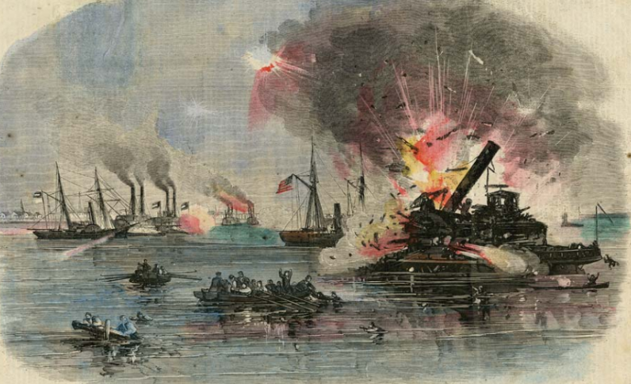  Figure 1: “Attack of the Rebels Upon Our Gun Boat Flotilla at Galveston, TX, January 1, 1863. Texas State Library and Archives Commission.
Then, just before sunrise on January 1, 1863, Confederate troops under John B. Magruder launched an attack on the Union Army occupying Galveston. The Confederates forced the Union military out of Galveston, sinking an important Union warship, the Harriet Lane. Galveston remained under Confederate control for the remainder of the war.
Interesting Fact: Confederate ships often used stacked bales of cotton to protect against enemy fire. Many warships were made of iron, called “ironclads.” The Confederates sometimes referred to their cotton-protected ships as “cottonclads.”
The Battle of Sabine Pass
On September 8, 1863, a Union force of 4,000 soldiers on four navy gun boats attempted to enter the Sabine River from the Gulf of Mexico on Texas’ eastern border with Louisiana.  The Confederates had recently constructed Fort Griffin at the opening of the Sabine River, called the Sabine Pass. | 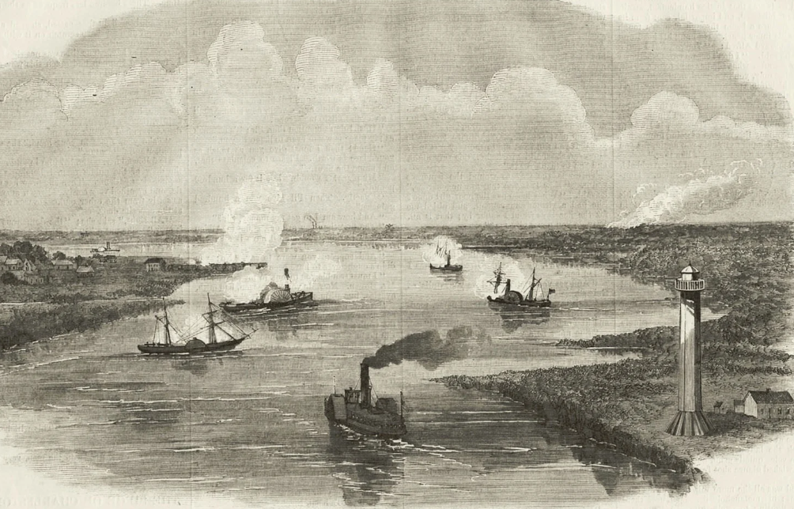  Figure 2: The Battle of Sabine Pass. Texas State Historical Association

The Confederate artillery at Fort Griffin bombarded the Union ships as they moved up the river. The bombardment destroyed one of the Union ships, killing and wounding many Union soldiers aboard. Two more ships were disabled and the fourth was forced to retreat under heavy Confederate fire. The Confederates captured 300 Union soldiers as prisoners of war along with the two disabled union ships without suffering any casualties.
The Battle of Palmito Ranch
On April 9, 1865, Confederate General Robert E. Lee surrendered the Army of Northern Virginia to Union troops. With this action, the Civil War was effectively over. Yet the Commander of the Trans-Mississippi Theatre, Edmund Kirby Smith, refused to surrender and ordered his army to continue fighting. | 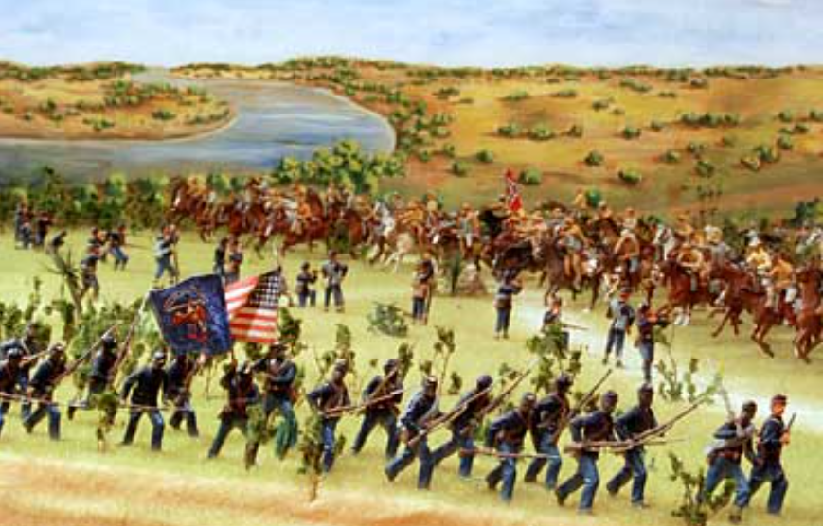  Figure 3: The Battle of Palmito Ranch, Texas Military Forces Museum

“There is no doubt now that Lee has surrendered, which is a severe blow at this time. But not near so serious as a great many suppose. There is nothing left to us but to fight. We will show them that we are not subjugated should our armies be disbanded.”

- May 8, 1865 A letter from Confederate cavalryman near Brownsville, George Robertson, to his sister. Texas Military Forces Museum.

Despite Kirby Smith’s encouragement to continue the fight, several hundred Texas soldiers left the army to return to their homes. A little over a month later on May 13, 1865, Union troops at Brazos Island in South Texas began moving toward Brownsville in order to occupy the city. Confederate troops who had remained in the army, including John “Rip” Ford, Santos Benavides, and some of Terry’s Texas Rangers, fought the Union Army on their way to Brownsville. The Texas troops overwhelmed the Union Army near Palmito Ranch, forcing them to retreat.
Despite the Confederate victory at the final Battle of Palmito Ranch, the Civil War was over, and the Confederacy was defeated. The United States was reunited, and the country now faced the challenge of how to heal and move forward.
Station 2: Texans on the Home Front

Camp Ford, 1863 – 1865
Camp Ford was a prisoner-of-war (POW) camp to detain Union prisoners captured during the Civil War. During the war, approximately 6,000 Union troops were detained at Camp Ford, making it the largest POW camp for Union soldiers west of the Mississippi River during the war.  Camp Ford was built near Tyler, Texas, which was also home to a Confederate draft office, ammunition factory, and supply depot that made wagons for the Confederate Army. | 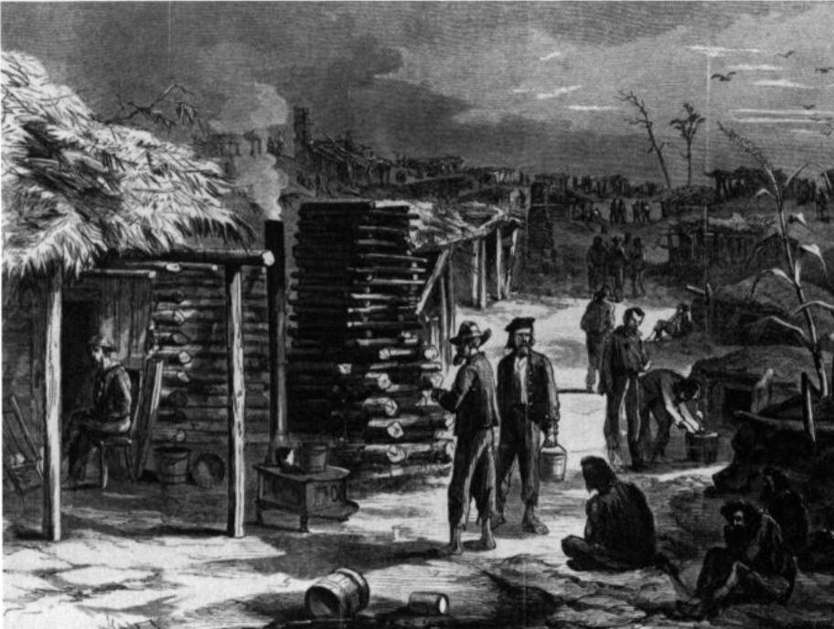  Figure 4: The harsh conditions at Camp Ford. The Portal to Texas History.

Refugees
Thousands of Southerners fled to Texas during the Civil War to escape the violence and destruction that was taking place in eastern states like Virginia, South Carolina, and Mississippi.  People who are forced to escape their homes due to violence, war, or natural disasters are often referred to as refugees. Many of these Southern refugees brought their slaves with them when they fled to Texas. While it’s difficult to know the exact numbers, estimates range from 30,000 to 150,000 enslaved people were brought to Texas during the Civil War. | “The roads leading from Louisiana to Eastern Texas are said to be still filled with wagons coming into Texas. These wagons belong to refugees from Louisiana who are bringing with them their families and negroes and all the effects they have left. As many as 50 or 60 wagons are often seen in a train. Many of the Louisiana planters were compelled to leave their crops in the field, in their haste to save their families.”  - The Semi-Weekly News. (San Antonio, Tex.) Monday, December 22, 1862. The Portal to Texas History.

Texas Unionists
The majority of Texans had voted in favor of secession and supported Texas joining the other Southern states that made up the Confederate States of America. Some Texans, however, remained loyal to the Union and opposed secession and the Confederate war effort. These Texans were often referred to as Unionists. | 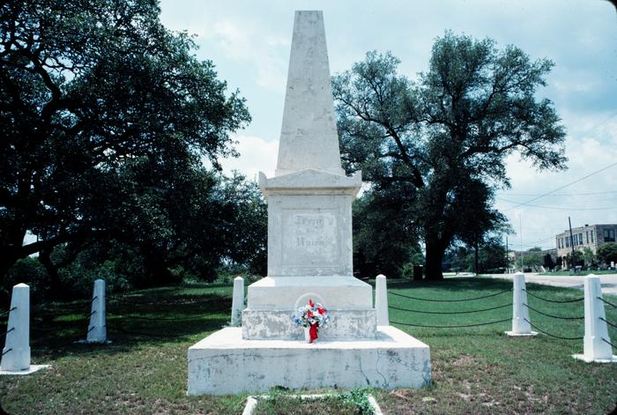  Figure 5: The monument honoring the Germans who were killed for their loyalty to the United States. The Portal to Texas History.
In Spring 1862, Confederates in Texas burned the homes of German Unionists who refused to sign up for the draft. Germans in the Hill Country formed a Union Loyal League and established their own military. Later that year, sixty-one German Unionists fled south to Mexico hoping then to travel to New Orleans and join the Union Army stationed there.
On the night of August 10, 1862, Confederate troops attacked the fleeing Germans who were camped near the Nueces River on their way to Mexico. Nearly all of the Germans were killed. A few of the survivors eventually managed to escape and join the Union Army occupying New Orleans. This event is often referred to as the Nueces Massacre.
Another instance of violence against Texas Unionists occurred in October, 1862 when a pro-Union group in Gainesville in north Texas established a Peace Party. | 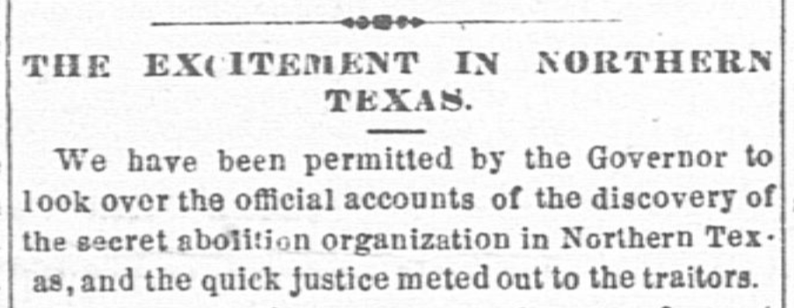  Figure 6: The Weekly Telegraph (Houston, Tex.) October 29, 1862. The Portal to Texas History

Confederates arrested 150 Unionists who they claimed were organizing a rebellion. They held unofficial “citizens trials” for the accused, and mobs attacked many others. In all, Confederates killed forty-two Texans in what is often referred to as the “Great Hanging at Gainesville.”

Station 3: Texas’ Economic Advantages during the War

Most the major battles of the Civil War took place outside of Texas in other Southern states like Virginia, Georgia, Louisiana, and Tennessee. Cities, towns, and farmland across the South were destroyed. Cotton production fell dramatically, and the Union blockade of Southern ports prevented most shipping and trade. | 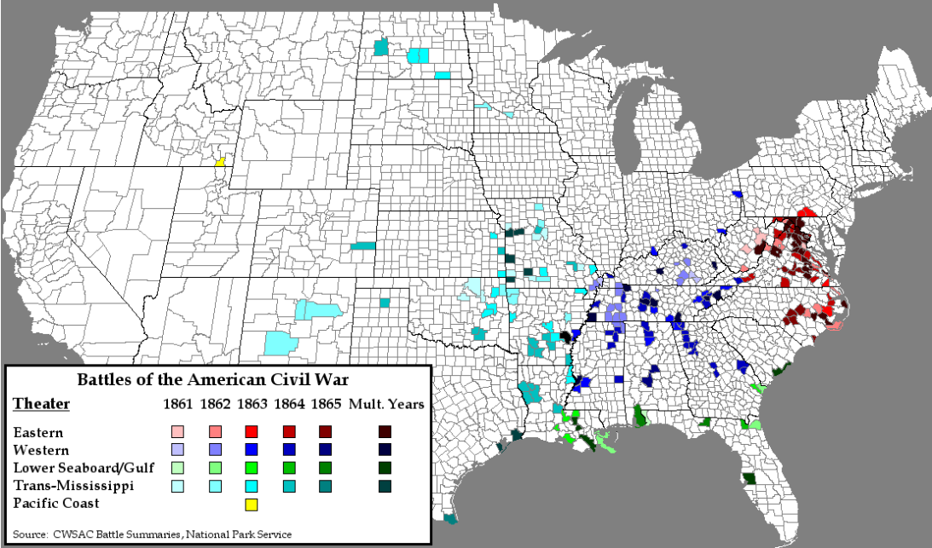

In contrast, only a few small battles took place in Texas. Most Texans were able to continue growing their most valuable cash crop, cotton. While most Southerners were unable to ship their goods, Texans got around the Union blockade by trading with from Mexican ports.  During the Civil War, Texans exported 320,000 bales of cotton. Additionally, As more and more Southern slave owners fled to Texas for safety, Texas never had the labor shortages that often occurred in other states.  Texans were also able to grow food and raise livestock, which allowed them to feed the Confederate Army and the Texas people at home. While other Southern states faced shortages of important supplies and food, Texans were able to take part in a successful “Rio Grande Trade” with Mexico to get items like coffee, liquor, and salt.  Texas’ distance from the major battles and access to trade with Mexico allowed Texas’ economy to continue with few disruptions during the Civil War. | “How to Keep up Supplies. – Now that our ports are … blockaded …, would it not be well for merchants to begin to look about and find out how and where they can keep up their supplies of foreign manufactured articles? We have it: By the [Treaty of Guadalupe Hidalgo] the waters of the Rio Grande are forever to be open to free and unobstructed navigation. A foreign vessel laden with goods for a Mexican market – for Matamoros, say – cannot be prevented from landing goods at the mouth of the Rio Grande and then enjoying the free … navigation of the river.… The ports of Mexico by land through Texas will remain open to American traders, who can bring their goods through the port of Brownsville, into Texas …”  - The Ranchero. (Corpus Christi, Tex.) June 1, 1861. The Portal to Texas History

Station 4: Texans at War

Terry’s Texas Rangers
The Eighth Texas Cavalry was a group of Confederate volunteers assembled by a man named Benjamin Franklin Terry in August, 1861. Though Colonel Terry would be killed only a few months later at the Battle of Woodsonville, Kentucky, the Eighth Texas Cavalry continued to be known as Terry’s Texas Rangers throughout the rest of the war. | 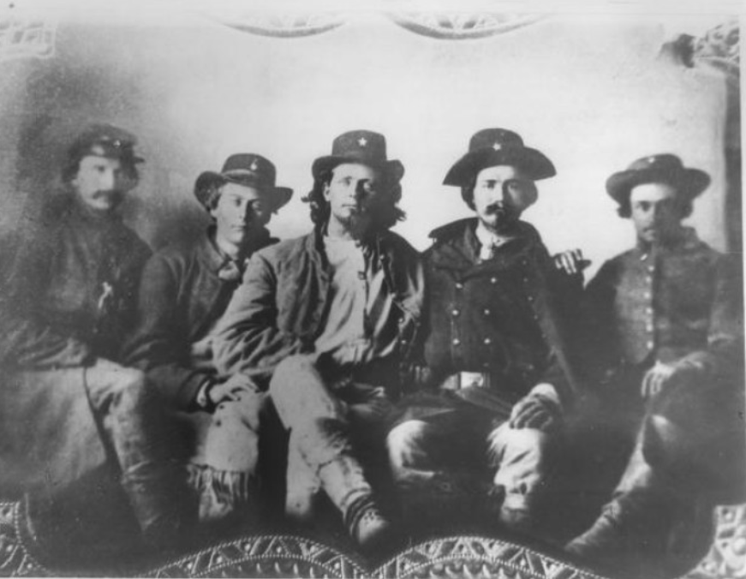  Figure 7: Five men who served in Terry's Texas Rangers. The Portal to Texas History.

Terry’s Texas Rangers took part in many significant battles in the Western Theater during the Civil War. They fought in the Battles of Shiloh, Perryville, Murfreesboro, Chickamauga, and Chattanooga.
Hood’s Texas Brigade
On October 22, 1861 a Confederate brigade was assembled composed of the First, Fourth, and Fifth Texas Infantry regiments. For a brief time, infantry units from South Carolina and Georgia were attached to the Texas regiments before being transferred to other units. An infantry unit from Arkansas joined the original Texas regiments in April 1662 and continued to serve alongside the Texas soldiers for the remainder of the war.  This regiment was originally under the command of a Texan named Louis T. Wigfall until he resigned, and a man named John Bell Hood was placed in command. | 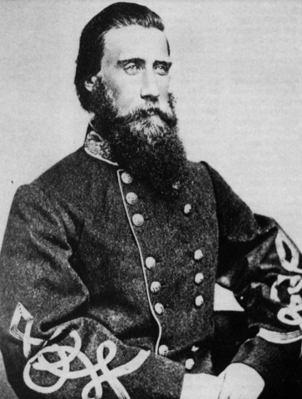  Figure 8: John Bell Hood. The Portal to Texas History

Hood only served as the commander of these forces for six months before being promoted once again, however his courageous leadership caused many to start calling the group “Hood’s Texas Brigade” even after he was no longer in command.
Hood’s Texas Brigade was the only Texas brigade to serve in the Eastern Theater of the war where the most intense fighting occurred. The Texas Brigade fought at the Battles of Gettysburg, the Wilderness, Fredericksburg, and Cold Harbor. | 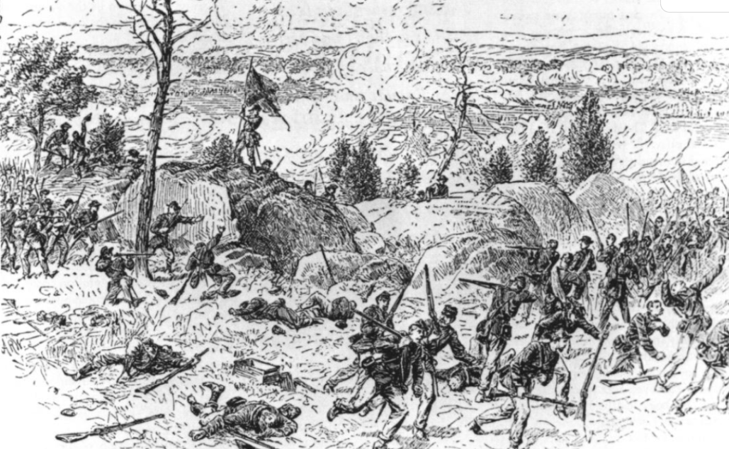  Figure 9: Hood's Brigade fighting at the Devil's Den, the Battle of Gettysburg. The Portal to Texas History
Hood’s Brigade also served during the twelve-hour Battle of Antietam, which caused 23,000 casualties, making it the single bloodiest day of the war.
Hood’s Brigade was with General Robert E. Lee’s Army of Northern Virginia when it surrendered to Union General Ulysses S. Grant at the Appomattox Court House in Virginia on April 9, 1865. Lee’s surrender ultimately led to the collapse of the Confederacy and the end of the Civil War.

