
Warm-up: Texas & the Civil War
Unit 8: Civil War
Name: |  | Date: |  | Period:

Observe the map to the right.  What inferences can you make about how the war affected Texas and Texans based on this map? | 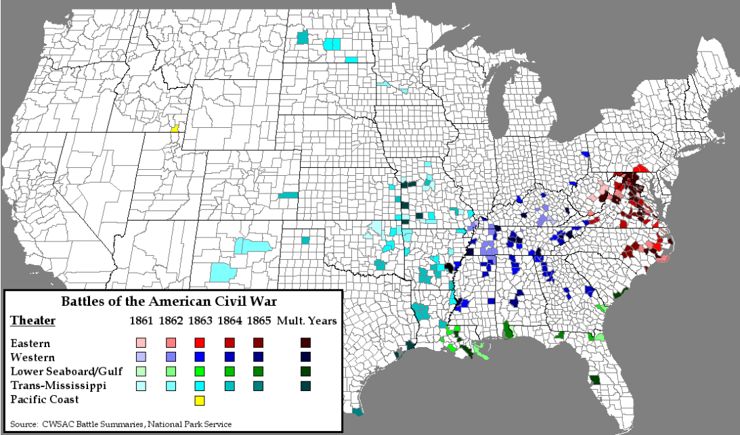

Warm-up: Texas & the Civil War
Unit 8: Civil War
Name: |  | Date: |  | Period:

Observe the map to the right.
What inferences can you make about how the war affected Texas and Texans based on this map?

Texas & the Civil War Exit Ticket

Writing Prompt: How was Texas’ role in the Confederacy unique during the Civil War? Give two examples of this unique role.
Texas role in the Confederacy during the Civil War was unique because… | One example of this unique role was… | A second example was…

Texas & the Civil War Exit Ticket

Writing Prompt: How was Texas’ role in the Confederacy unique during the Civil War? Give two examples of this unique role.
Texas role in the Confederacy during the Civil War was unique because… | One example of this unique role was… | A second example was…

