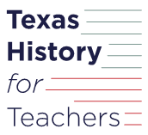
Warm-up: Texas Today
Unit 8: Civil War
Name: |  | Date: |  | Period:

- What observations and inferences can you make about the image to the right? How do you think this relates to the Civil War and Texas Today? | 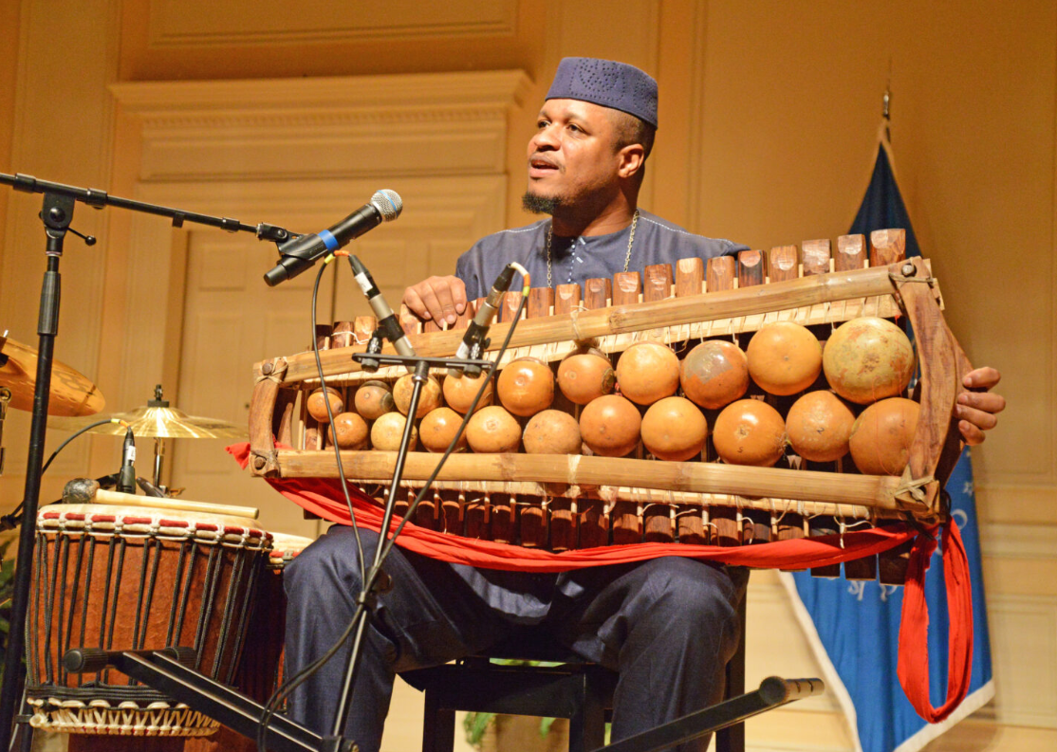  Figure 1: A musician from Washington D.C. named Uasuf Gueye plays a traditional West African instrument called a Bala for the Library of Congress' Juneteenth Celebration

Warm-up: Texas Today
Unit 8: Civil War
Name: |  | Date: |  | Period:

- What observations and inferences can you make about the image to the right? How do you think this relates to the Civil War and Texas Today? | Figure 1: A musician from Washington D.C. named Uasuf Gueye plays a traditional West African instrument called a Bala for the Library of Congress' Juneteenth Celebration

Texas Today Exit Ticket

Read each characteristic in the graphic organizer below. Choose FOUR characteristics that most closely relate to or represent the significance of Juneteenth.
The primary focus is on the lives lost during the Civil War. | Today, it is mostly recognized only in large cities in the South. | A celebration of the Emancipation of African Americans after the Civil War.
Celebrations include music, food, performances, picnics, and family reunions. | A Texas holiday that became a national holiday in 2021. | Abraham Lincoln signed a bill making it a federal holiday.
Early celebrations included educational programs about the rights of the freed people. | A celebration of the date of the amendment guaranteeing all citizens the right to vote. | Originally an important holiday, but not celebrated as much anymore.

Texas Today Exit Ticket

Read each characteristic in the graphic organizer below. Choose FOUR characteristics that most closely relate to or represent the significance of Juneteenth.
The primary focus is on the lives lost during the Civil War. | Today, it is mostly recognized only in large cities in the South. | A celebration of the Emancipation of African Americans after the Civil War.
Celebrations include music, food, performances, picnics, and family reunions. | A Texas holiday that became a national holiday in 2021. | Abraham Lincoln signed a bill making it a federal holiday.
Early celebrations included educational programs about the rights of the freed people. | A celebration of the date of the amendment guaranteeing all citizens the right to vote. | Originally an important holiday, but not celebrated as much anymore.

