**The Big Picture *Advanced***

*Unit 8: Civil War*

|  |  |  |  |  |  |
| --- | --- | --- | --- | --- | --- |
| Name: |  | Date: |  | Period: |  |

**Part I: Analyze an Image**

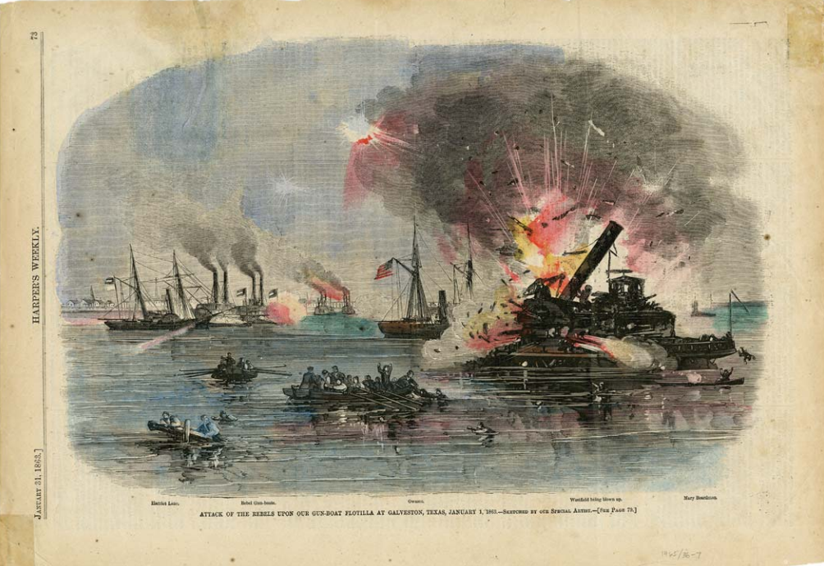

Figure : Harper’s Weekly, January 31, 1863, “Attack of the Rebels Upon Our Gun Boat Flotilla at Galveston. Texas State Library and Archives Commission

1. What are three things you observe about the image above?
2. What are two things you can infer about this era of Texas history based on the image?
3. What do you predict we will see in this unit based on the image?

**Part II: Essential Ideas Reading Passage**

In the previous unit, Early Statehood, Texas joined the United States and transitioned into a rapidly growing and developing state within the U.S. People flooded into Texas during the 1850s, primarily from other cotton-producing slave states in the South. As sectional tensions increased between the North and the South over the issue of slavery, the majority of Texans sided with the rest of the slave-holding Southern states.

When an anti-slavery Northern politician named Abraham Lincoln was elected president of the United States in 1860, many states in the South decided to secede from the U.S. and form their own country called the Confederate States of America, often referred to simply as the Confederacy. Texas was one of the eleven Southern states that seceded from the Union after Lincoln was elected president. The relationship between the North and the South quickly deteriorated until the two portions of the country were engaged in a bloody civil war that raged from 1861 to 1865.

The Civil War was the deadliest war in American history, killing more than 750,000 people. Approximately 70,000 Texans served in the war, mostly fighting for the South in the Confederate army, though a small number of Texans joined the war on the side of the North. The majority of the war was fought far from Texas in far-eastern states like Virginia, Maryland, and Pennsylvania. While some Texans served in the east at places like Gettysburg and Antietam, the majority of Texas soldiers fought in battles closer to Texas in western states like Kentucky, Tennessee, and Mississippi.

There were few battles that occurred in Texas, so the state did not experience the level of violence and destruction that devastated other Southern states. As a result, Texas was able to play a unique role during the Civil War by continuing to grow important crops like corn and cotton to help support the Confederate war effort. Texas’ southern border with Mexico also allowed Texans to continue to take part in international trade by moving their goods through Mexico. This allowed Texans to get around the Union navy’s blockade of southern ports. Additionally, Texas provided a safe haven for Southerners who hoped to escape the violence and destruction in the east.

On April 9, 1865, the main Confederate army officially surrendered to the Union, ending the Civil War. Two months later, Union troops arrived in Galveston, Texas, on June 19, 1865, to announce the end of the Civil War and declare that all enslaved people in the Texas were now free. After four years of deadly battles that devastated land, cities, homes, and lives, the United States faced the challenging task of how to move forward as a nation.

1. Consider the sectional division that divided the Northern and Southern states during this era of Texas history. What side of the sectional divide did the majority of Texans support, and why?
2. Complete the chart below to provide information from the reading about each of the two opposing sides who were fighting each other during the Civil War.

|  |  |
| --- | --- |
| **The Union** | **The Confederacy** |
|  |  |

1. In what ways was Texas significant to the war effort?
2. What was the outcome of the war? What important question or questions faced the United States after the war?